Hornet Pit Assembly and Disassembly

Table of Contents
Disassembly 1
Remove Skins 1
Remove Seat 3
Standby Instruments 4
Disconnect Cable 5
Remove Rear Support Cross Member 5
Remove Seat Base Screws 5
Remove Stick USB cable 5
Lower seat rollers 5
Slide Seat out 5
Remove UIP Cover 5
Remove Canopy Bow 8
UIP 10
Power Distribution Panel 10
Disconnect Starboard/Right Console 11
Disconnect Cables 11
Disconnect Port/Left Console 19
Disconnect Cables 19
Remove UIP 28
Remove ECM 44
Remove Standby Instruments 50
Removing the IFEI 52

Disassembly

To be incorporated later – the Fire Test panel must be removed before left aux panel. The Fire Test switch needs to be removed before the fire panel can be removed due to clearance issues.

Remove Skins
Remove screws from the bottom up, once on the top work from the edges towards the centre. Press against the skin to hold it in place while removing the last two screws.
Disconnect strobe and formation lights.
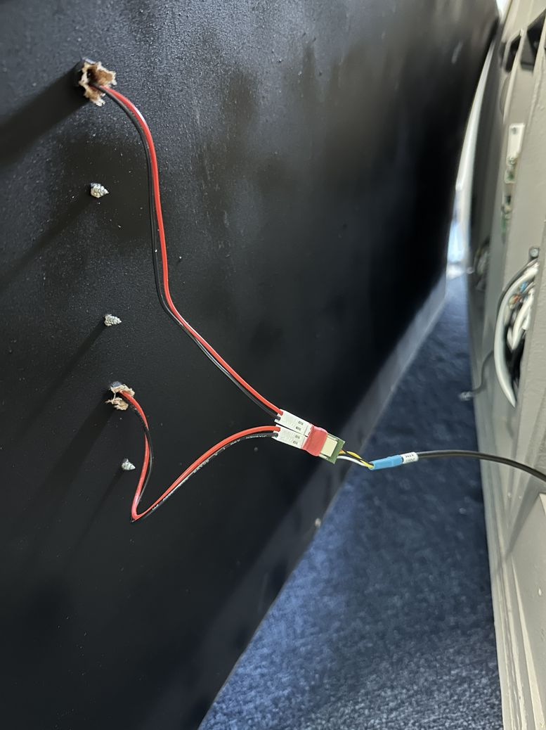Figure 1: Port Rear Skin | 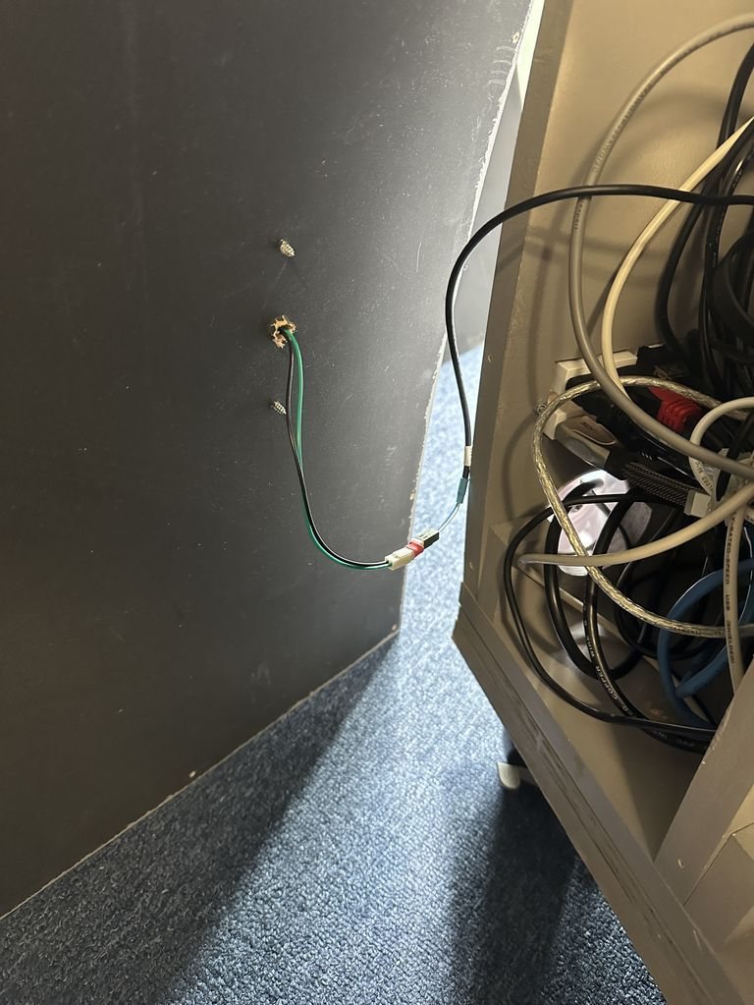Figure 2: Port Forward Skin
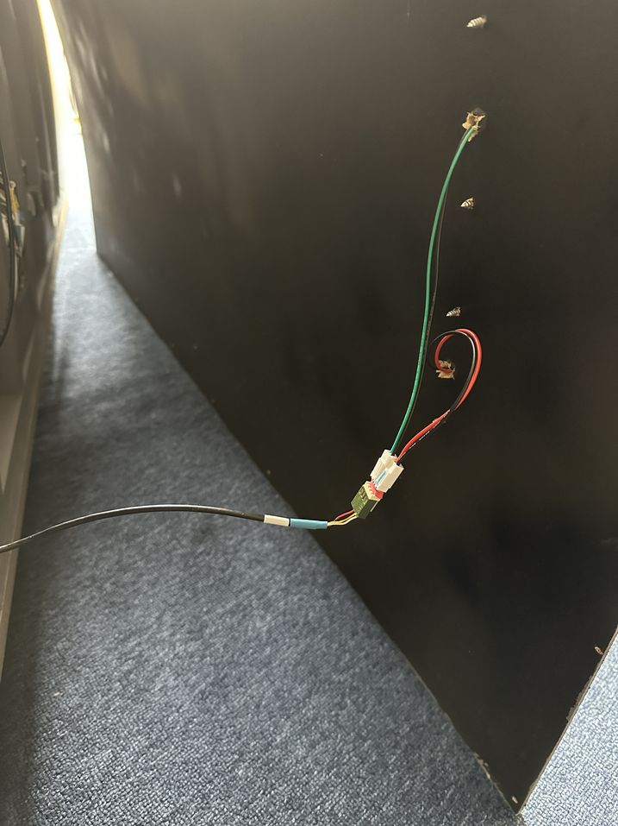Figure 3: Starboard Rear Skin | 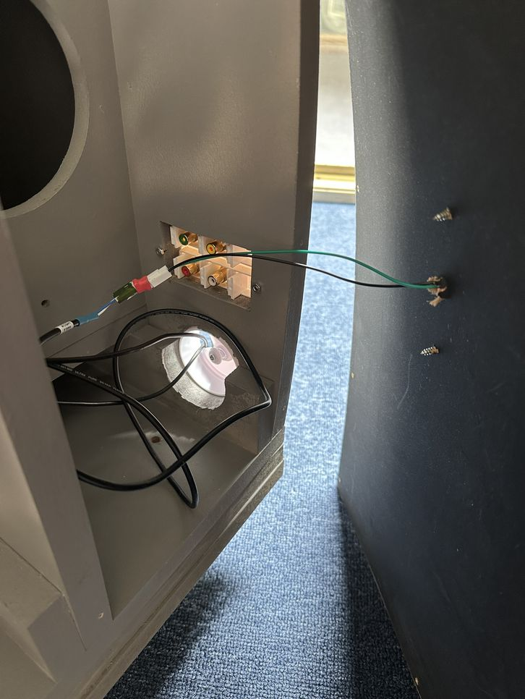Figure 4: Starboard Forward Skin

Remove Seat
Disconnect Cable and place it on seat cushion to prevent it becoming entangled.  Remove the port and starboard bolts which lock the extended support arms in place.  Remove the four screws (two forward, two aft) which attach the seat to the floor, an extension  shaft will make it easier to remove the two forward screws. | 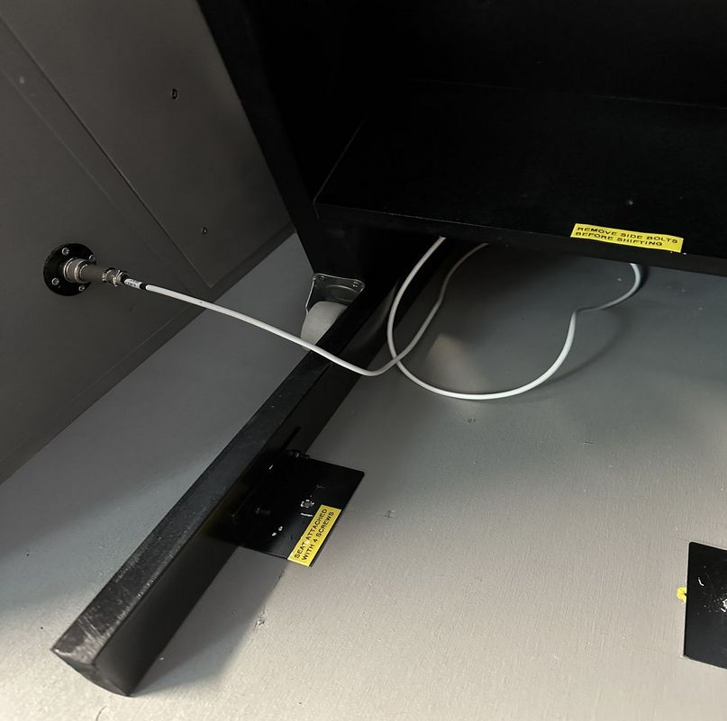
Unplug Stick USB connector.  Slid | 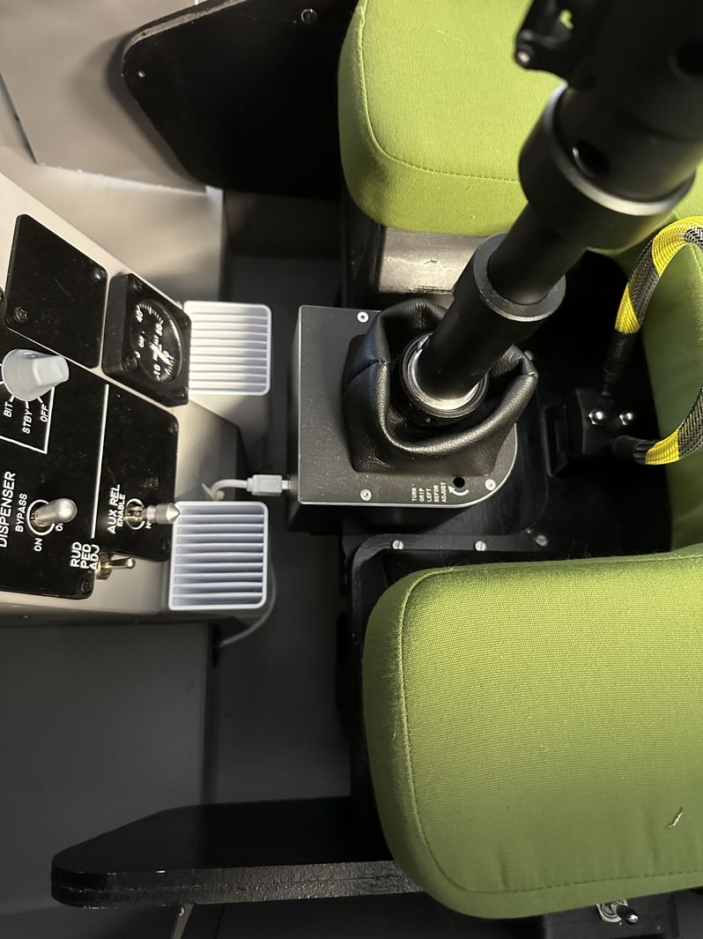
 | 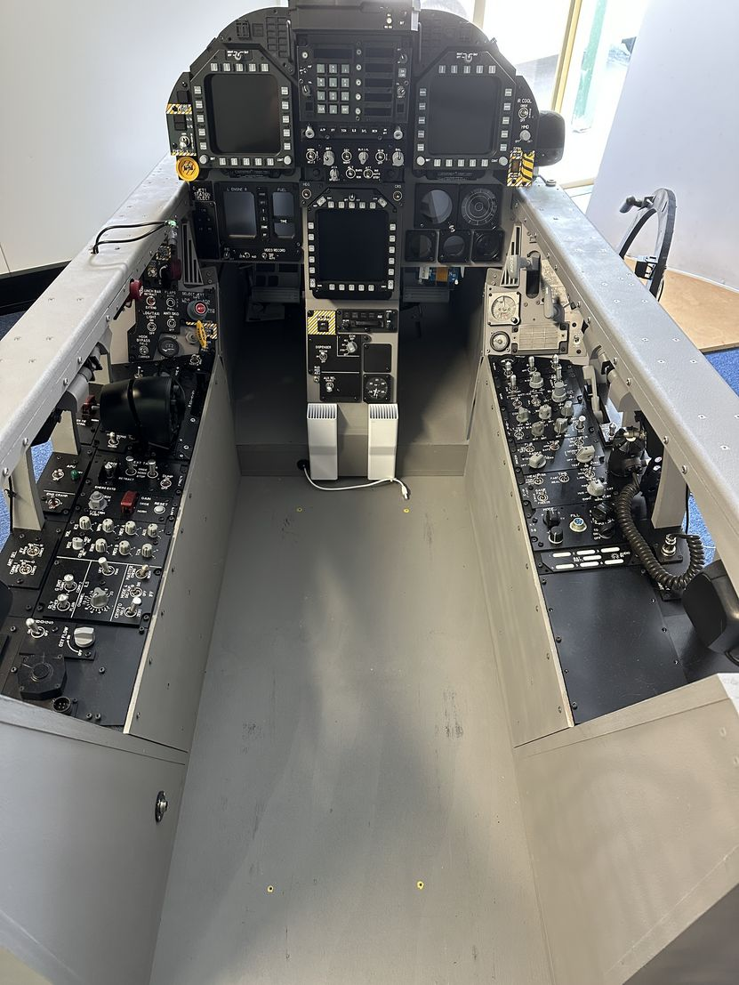

Standby Instruments
Remove Starboard Vent, 3 bolts.  Remove the two outer screws. |  | 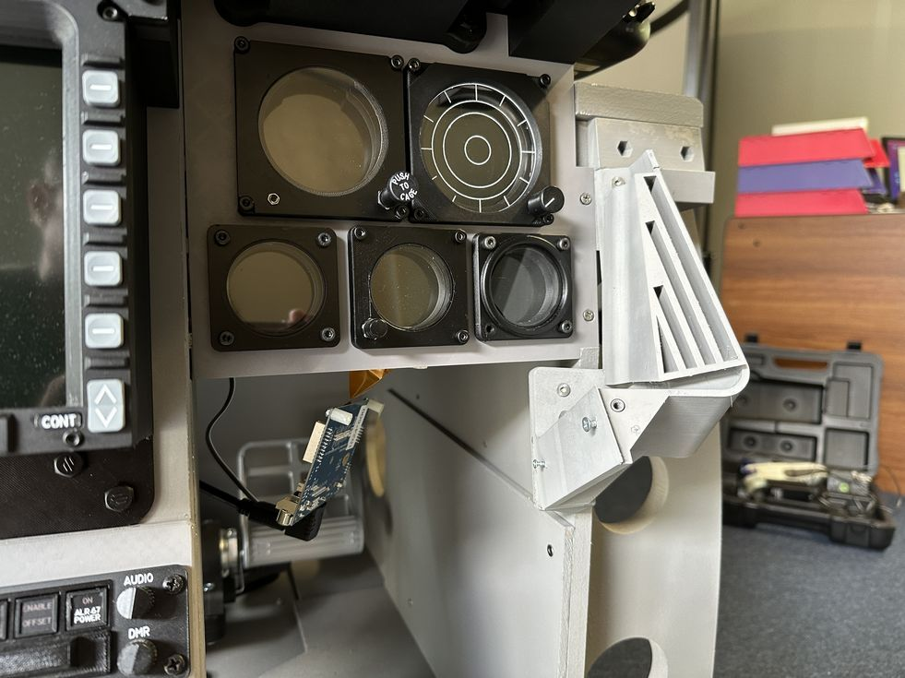

Disconnect Cable

Remove Rear Support Cross Member

Remove Seat Base Screws
Slide Seat Slightly back

Remove Stick USB cable

Lower seat rollers

Slide Seat out

Remove UIP Cover
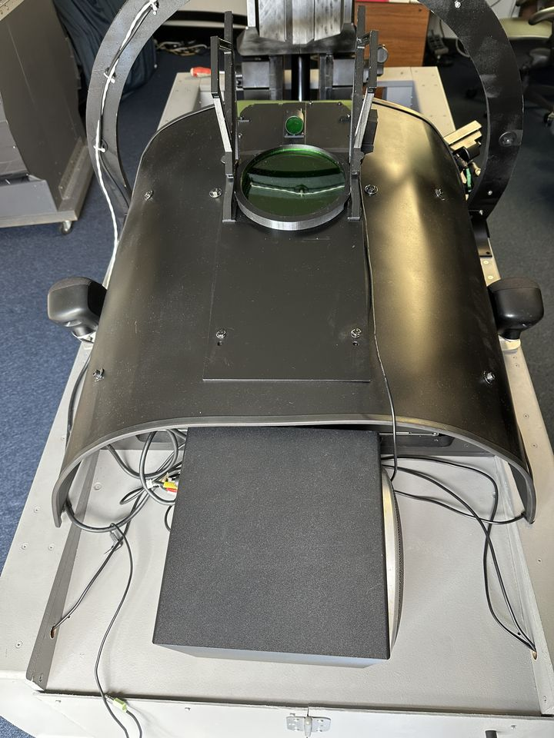Figure 5: UIP - Forward Section

Remove the two bolts for hud assembly, the AOA indicator is just sitting in its holder. Place AOA indicator forward shelf.
Place the port speaker on the forward shelf
Rotate the two positioning clips on the hud | 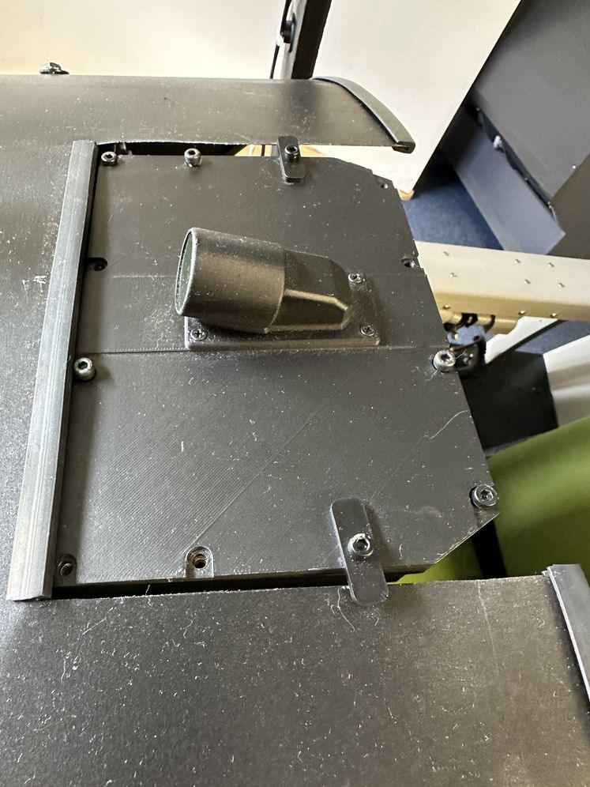
Remove the bolts holding the cover, starting from the port side working towards the starboard side. | 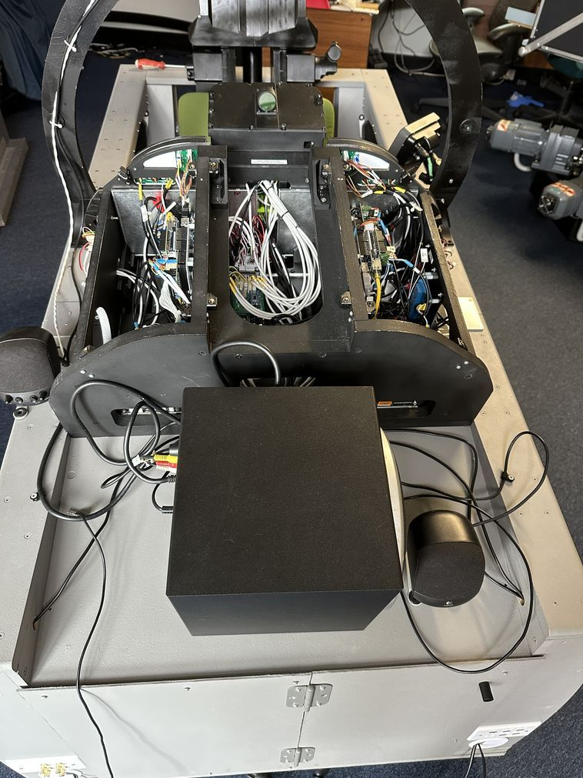
Remove port and starboard upper alignment plates | 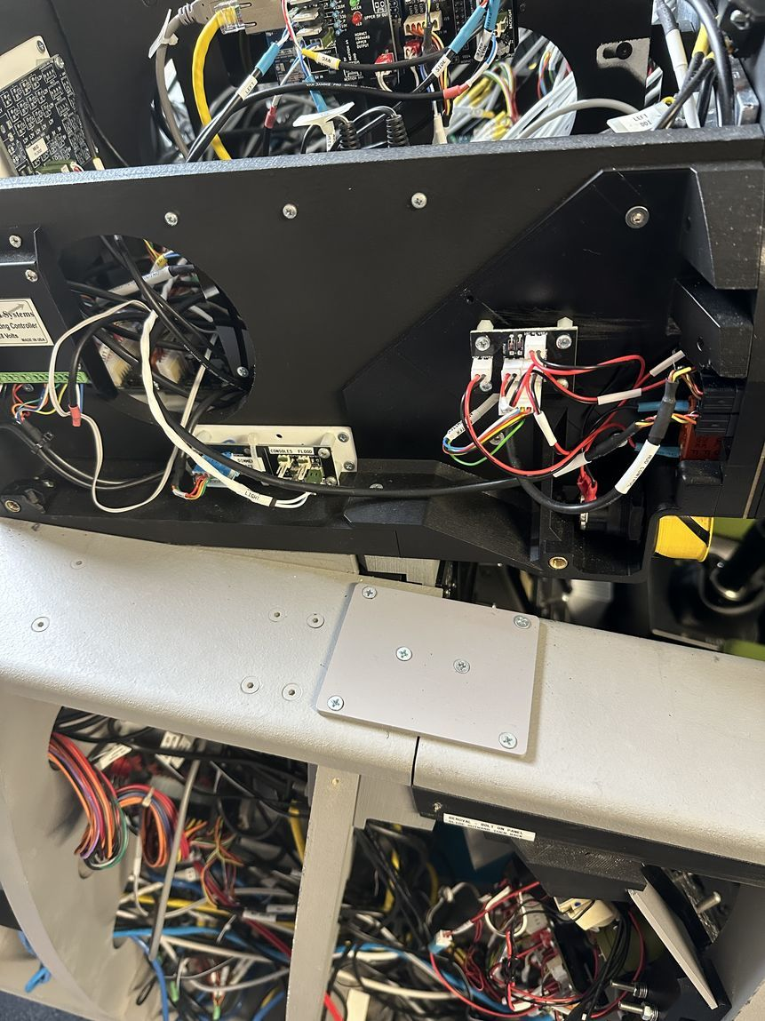

Remove Canopy Bow
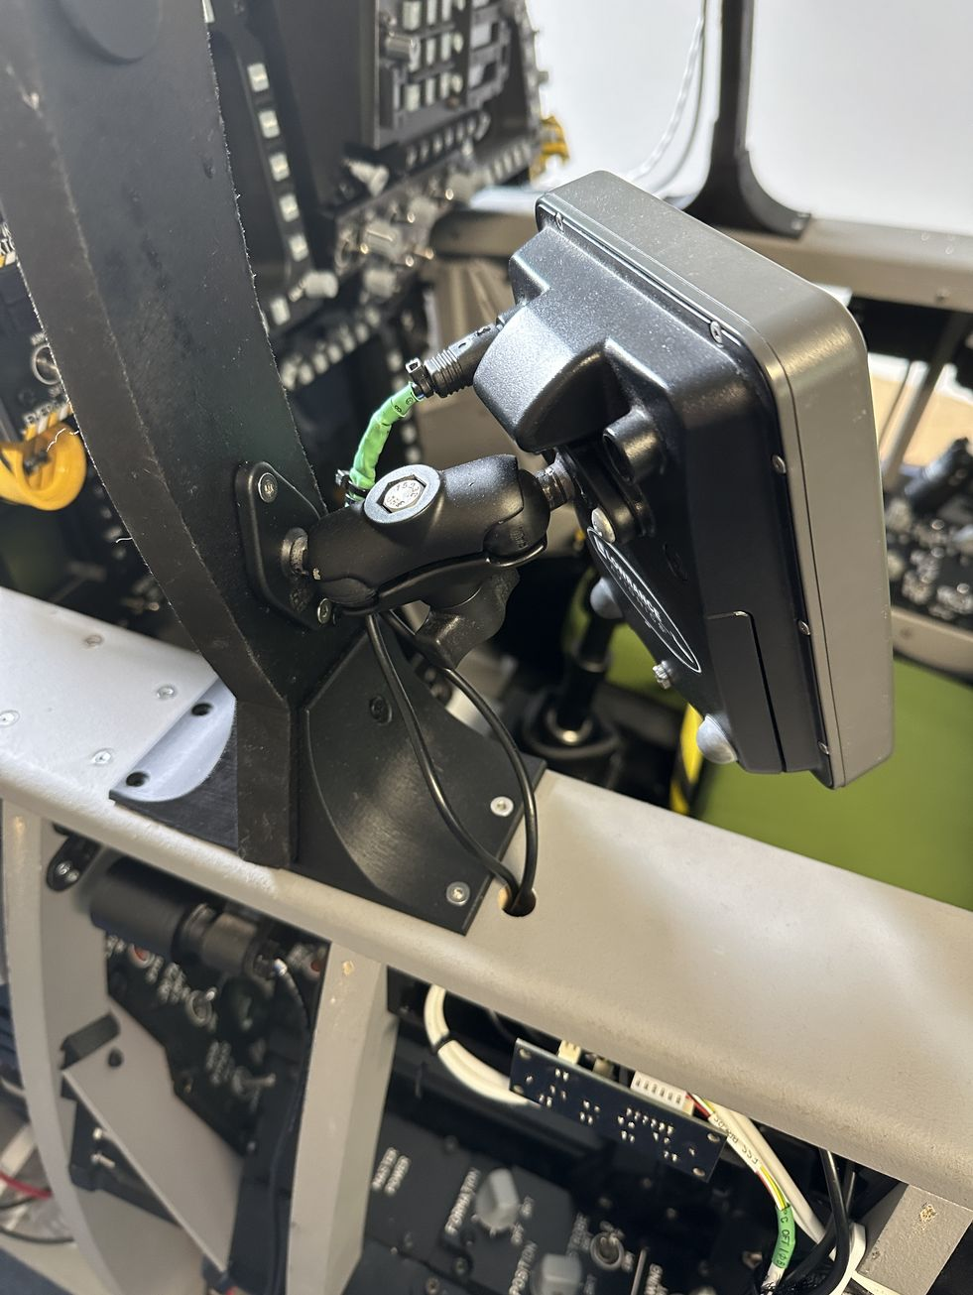 | 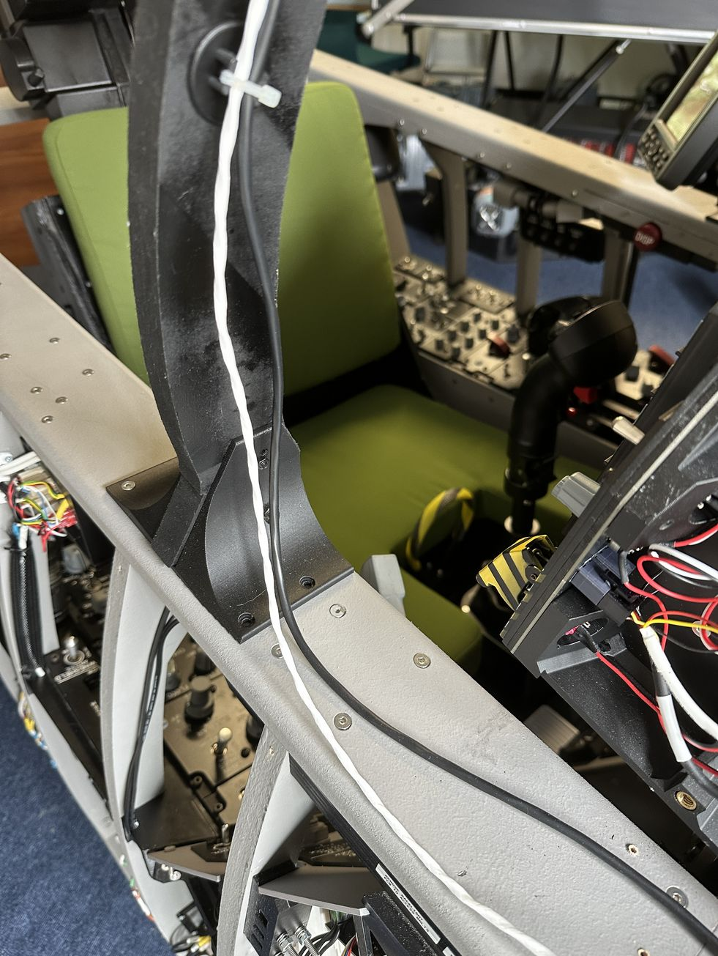
Unplug the connector to the GPS.  Remove the GPS.  Lift the cable glad to the Lock-Shoot and Bow Chart Light can be removed.  The cable path for the Lock-Shoot cable rises back into the LIP on the starboard side and traces directly to the LED distribution PCB. | 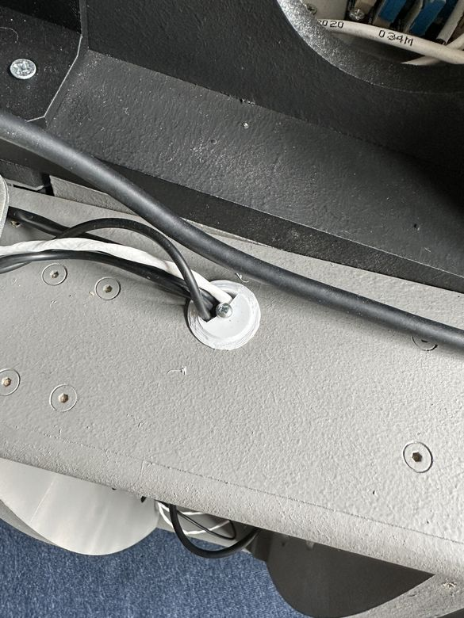
The chart light follows a similar path to the Lock-Shoot, terminating on the PWM distribution pane. | 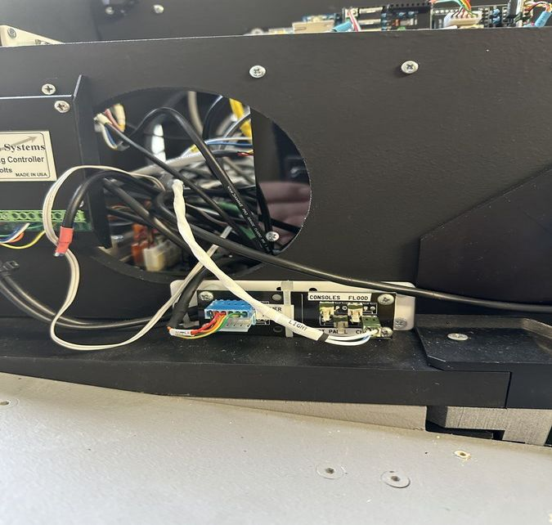
The cable slack for the chart light lives in the LIP | 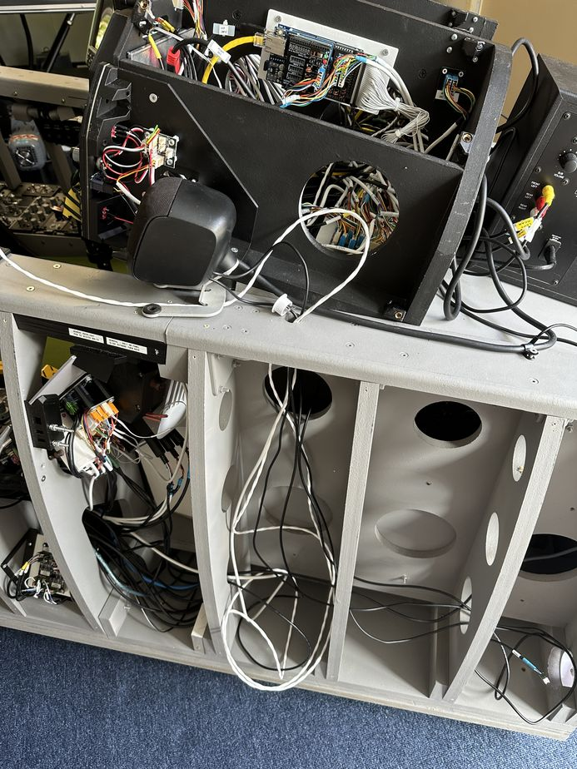

Disconnect cables from the LED distribution board
Disconnect the Map Light cable from the PWM light distribution panel in the UIP
Disconnect the Compass cables
Unscrew the Canopy bow itself
Remove the canopy bow support brackets

UIP

Power Distribution Panel
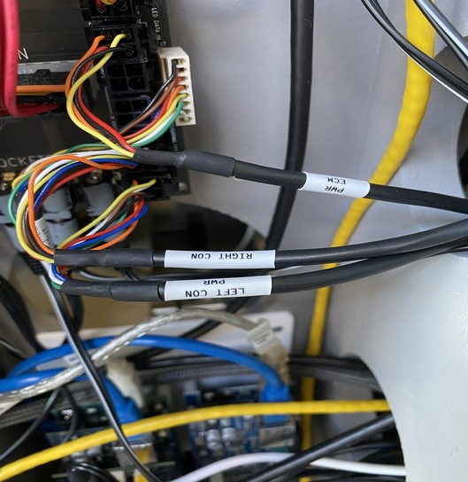

Disconnect Starboard/Right Console

Note the nuts sitting midway along bolts to hold the bolt in position
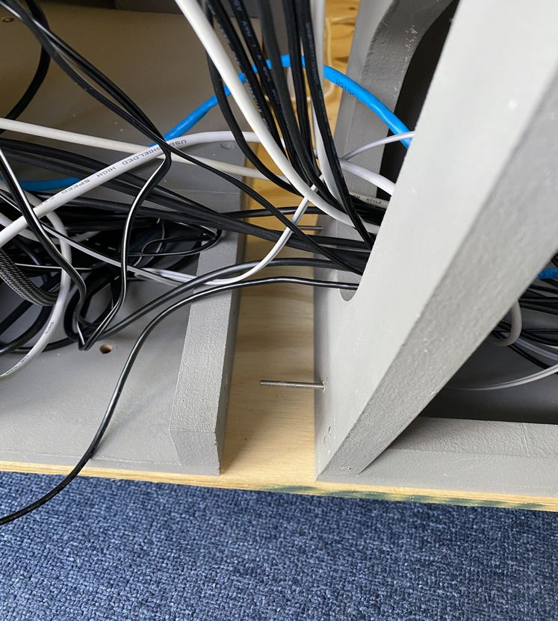

Disconnect Cables
The cables stay attached to the console
Role | Cable  Colour | Connector
Ethernet | Blue
Right Console Digital Power | Black | 6 way unpainted | 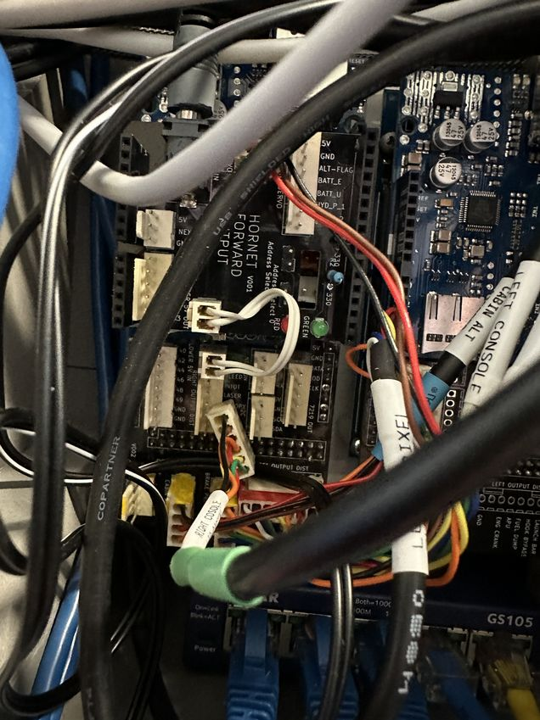
Starboard Side Dimmer  The cable path enters the underside starboard side of the UIP and takes a direct path to the PWM dimmer PCB. | Black | 4 way Green | 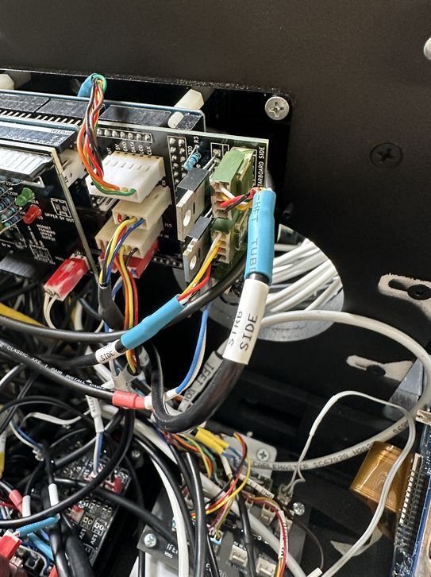
UFC Analog | White | Blue | 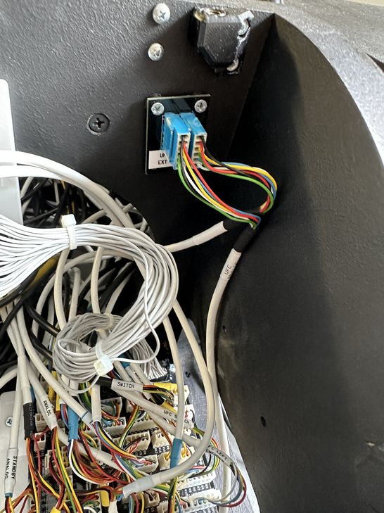
Right Rear Speaker | Black | White | 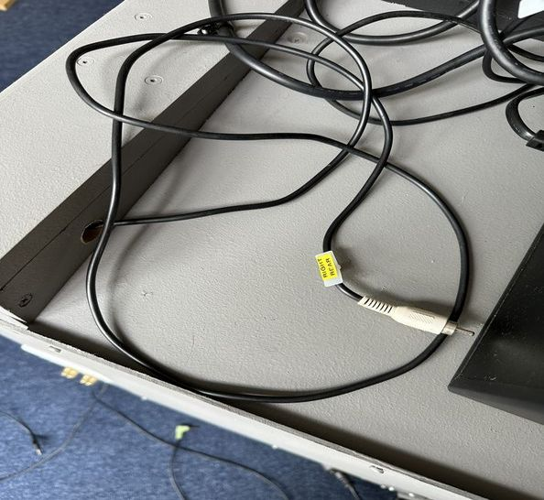
12V for Starboard. Disconnect from the power distribution PCB and leave it attached to forward console.  Note the Digital out 12V supply comes form the distribution PCB.  It connects to the second from the led on the primary power distribution PCB. | Black | Red. | 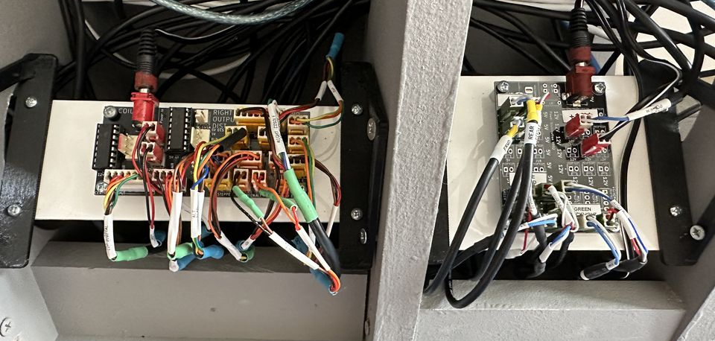  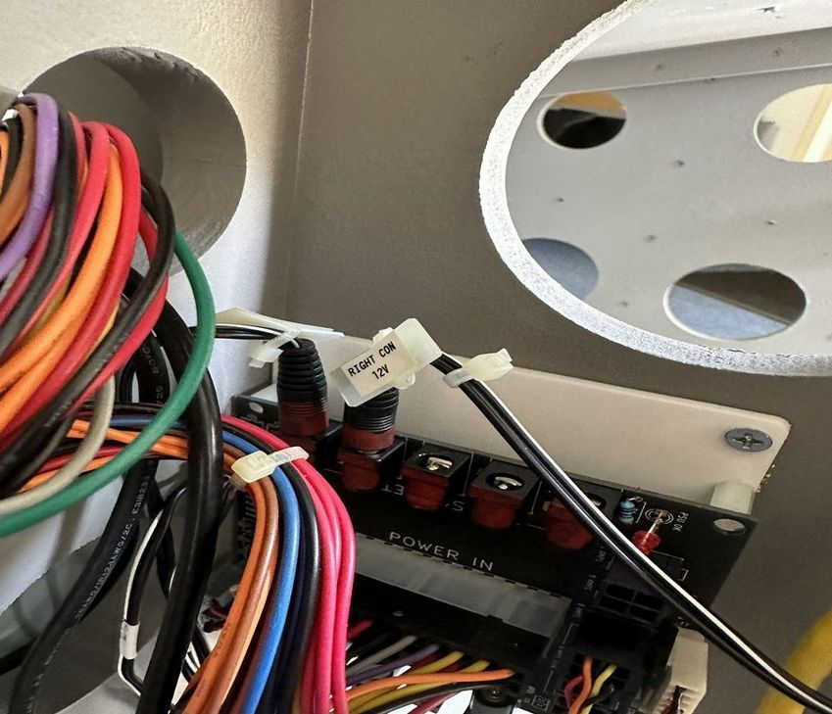
Right Console Steppers  Cable path under footrest to Left Hand PCB in lower third bay. | Black | 4 Way Yellow | 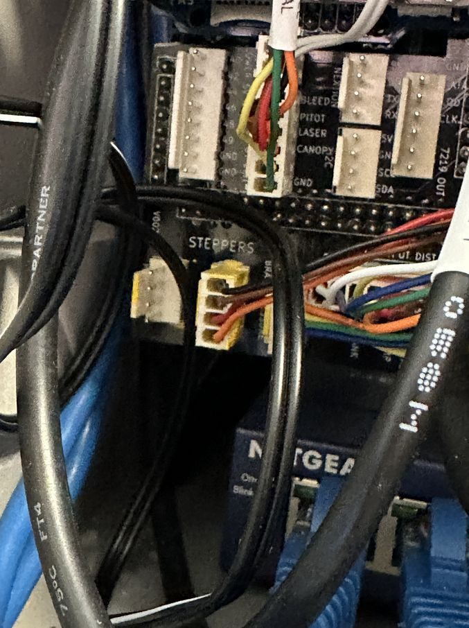
Right Console Servos  Cable path under footrest to Left Hand PCB in lower third bay. | Black | 6 Way Yellow | 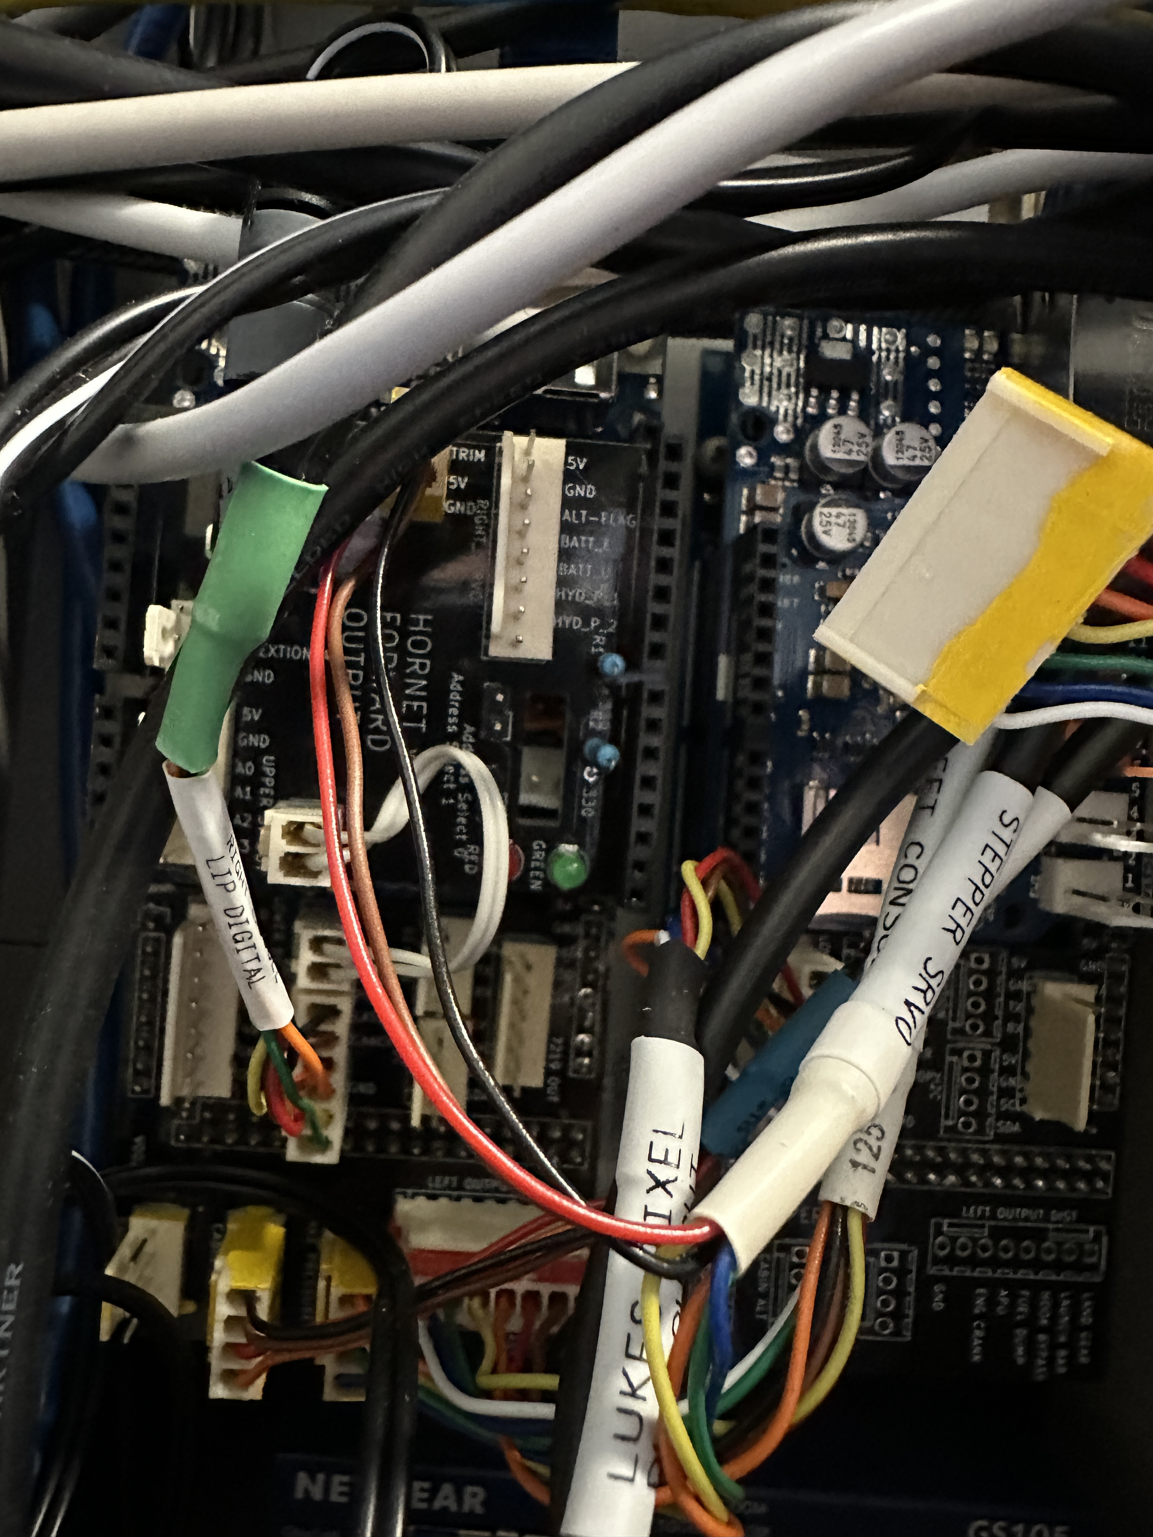
Right Console Panel backlighting.  Connects to the second from the bottom on the power distribution PCB. | Black | Black | 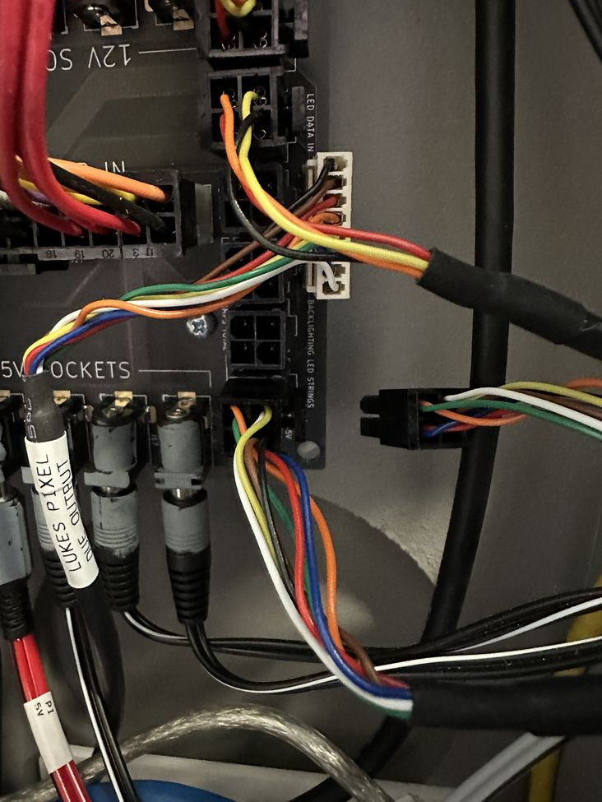
Right Console LIP Digital  Cable path under footrest to Left Hand PCB in lower third bay. | Back | 6 way unpainted | 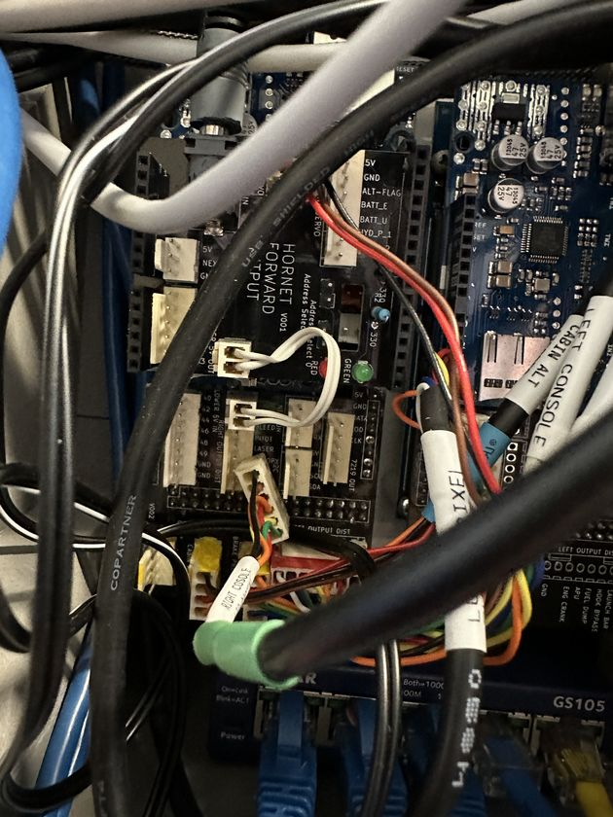
Right Console LED  Cable path is underneath the footrest, up through the top hole in the rib, and up through the floor of the lip ,to the J18 on the LED distribution PCB | Black? | 4 way Orange | 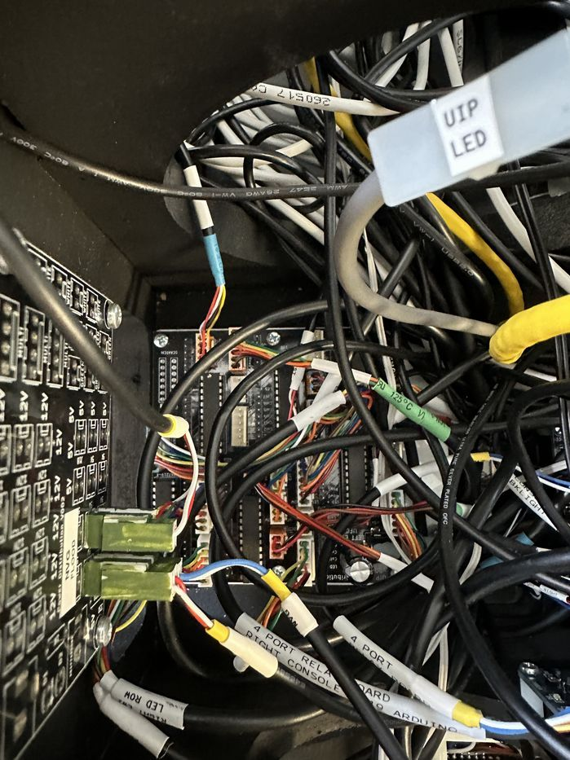
Dimmer Pots  Cable path is underneath the footrest, up through the top hole in the rib, and up through the floor of the lip ,to the | Black | Blue | 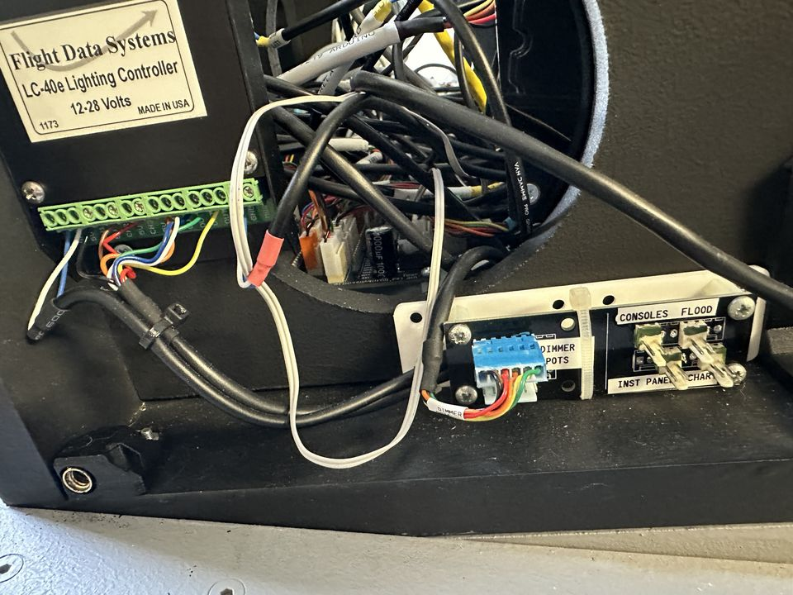
USB It is connected to a USB extension lead on the port side. | Blue |  | 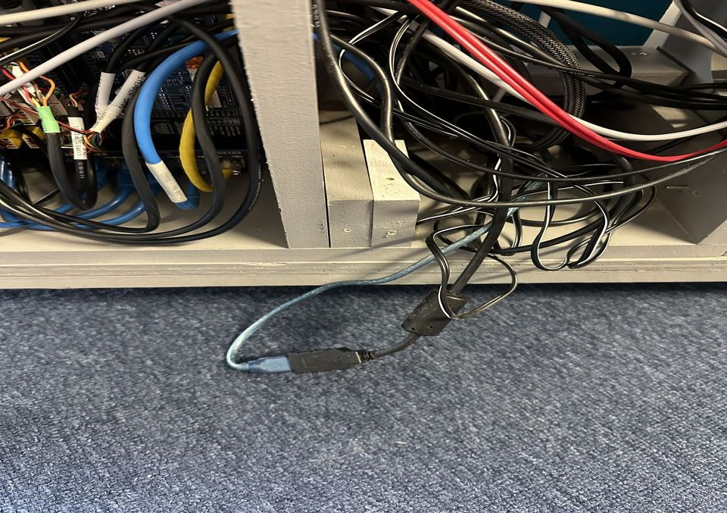
Right Console Flood and Backlighting (gauges mostly).  Cable path is underneath the footrest, up through the top hole in the rib, and up through the floor of the lip ,to the PWM distribution PCB | Black | Two by 2 way connectors on a single cable.c | 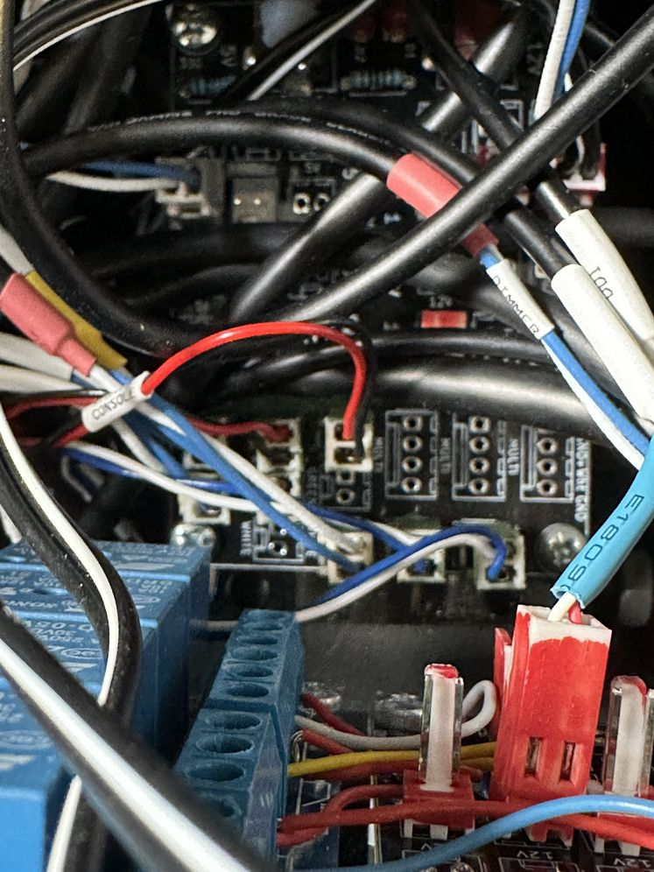
Right NVG Flood  Cable path is underneath the footrest, up through the top hole in the rib, and up through the floor of the lip, to the NVG distribution PCB mounted on rear of UIP. | Black | 2 Way Green | 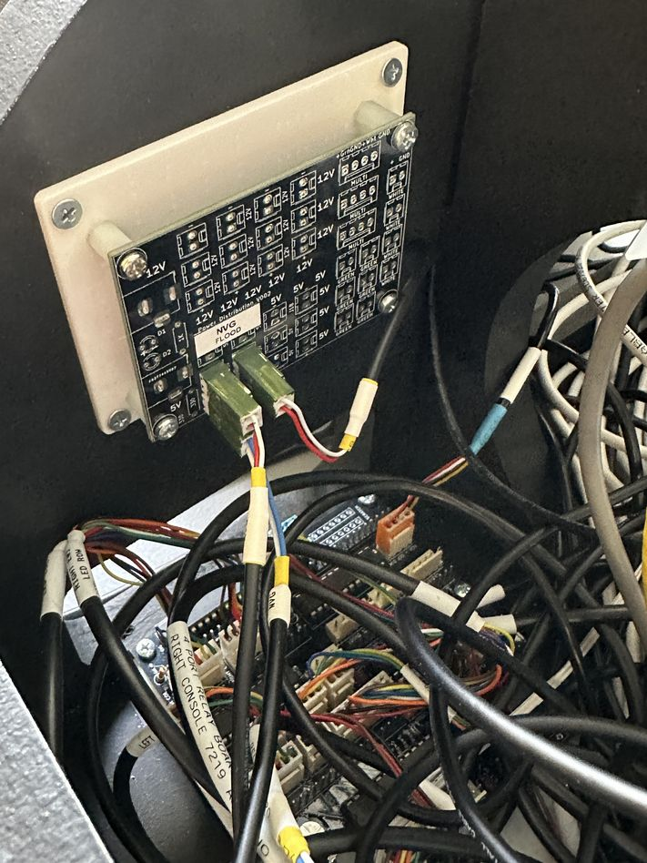

Remove starboard leg guard | 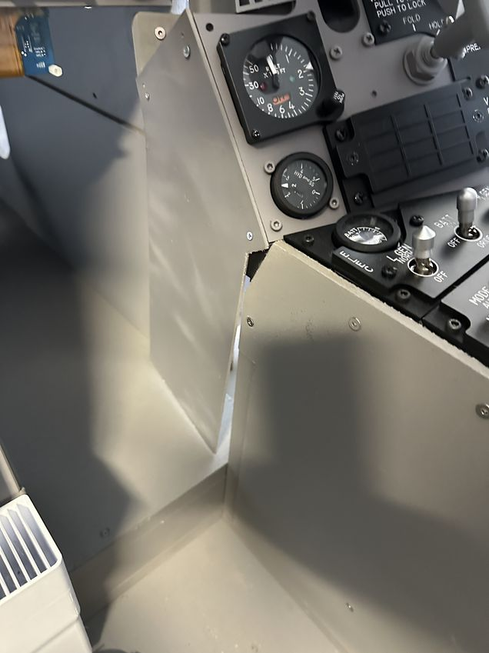
Remove the bolt that holds the vent to the panel (above and left of radar altimeter) | 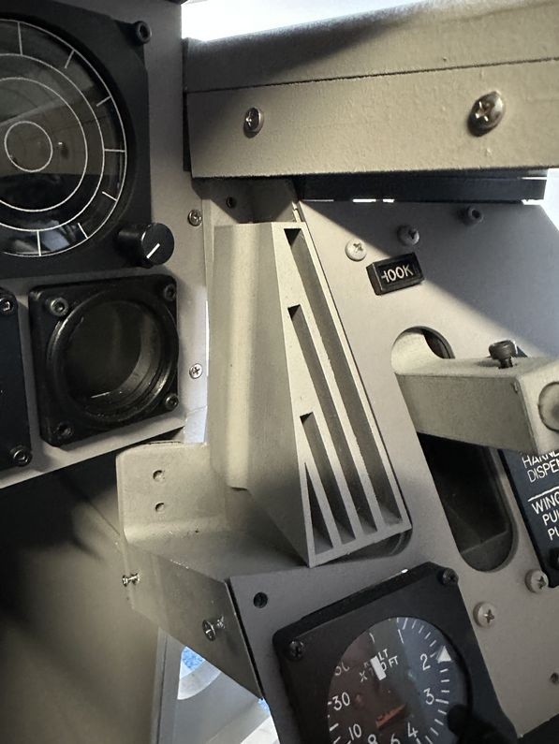
Remove lower two nuts from the bolts, the bolts stay in place. | 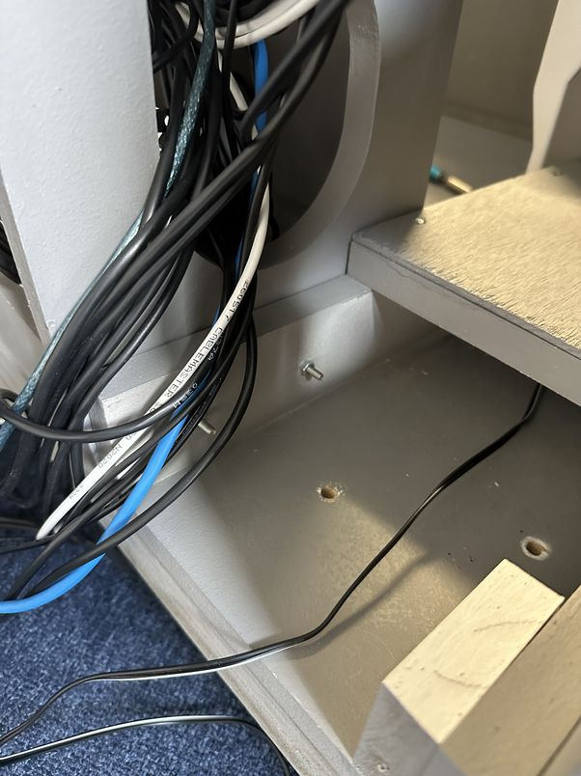
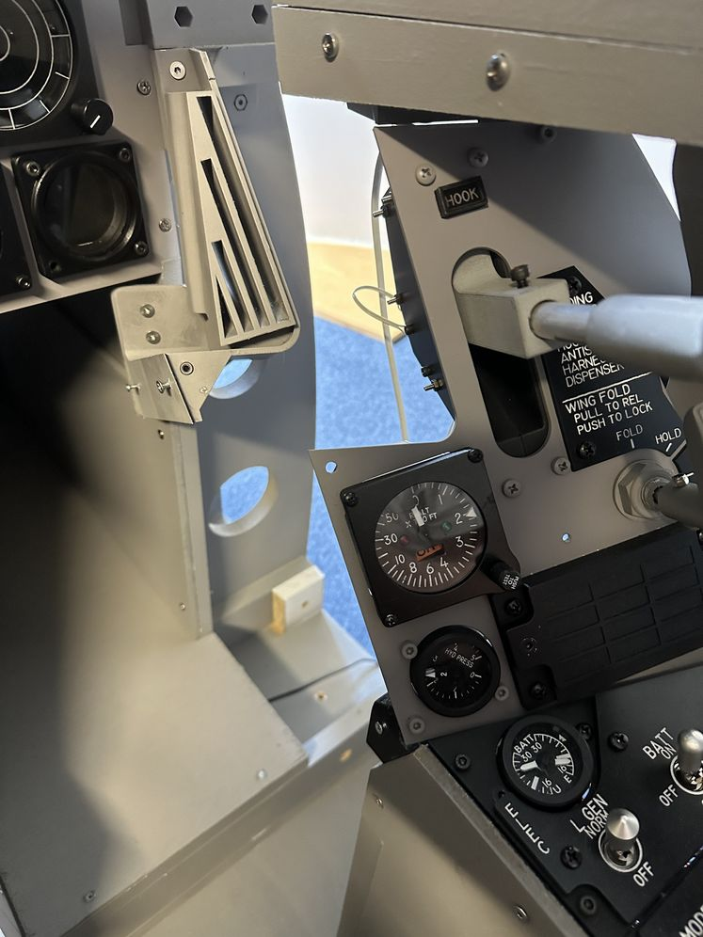 | 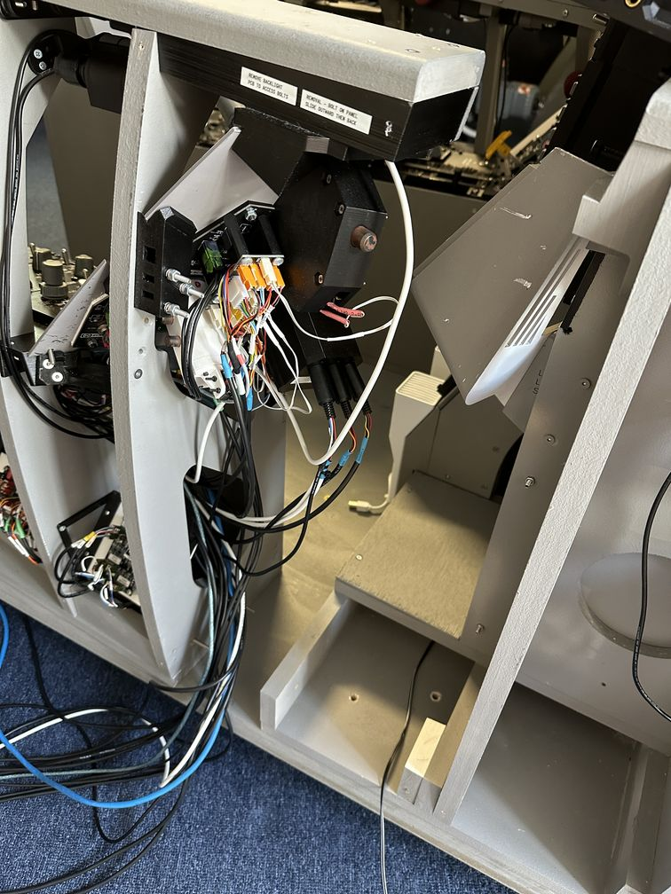

Disconnect Port/Left Console
Note there are nuts located midway along the bolt (between the console and UIP) that hold the bolt in place.
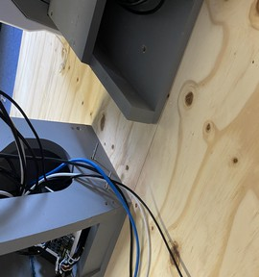

Disconnect Cables
USB | Bone | Bone
Port Side PWM | Black | Green
Left console Flood left console
12V | Black | Red
Left Console Stepper Servos | White | Yellow
Left Console Digital Out | White | Red
Left Console | Black | Orange

Ethernet  Port 3 of Bay 2 Ethernet Switch | Blue |  | 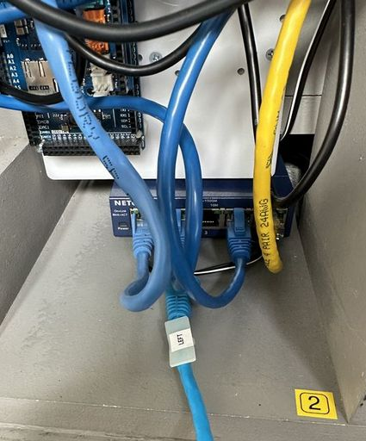
Raspberry Pi Power  2nd 5V port from the left hand side. The heavy cable was required as the thinner leads results in voltage loss that panicked the Raspberry Pi | Red | Grey | 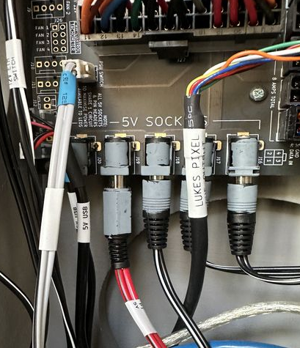
Winwing Throttle USB.  Forward USB Hub - 4th from the bottom. |  |  | 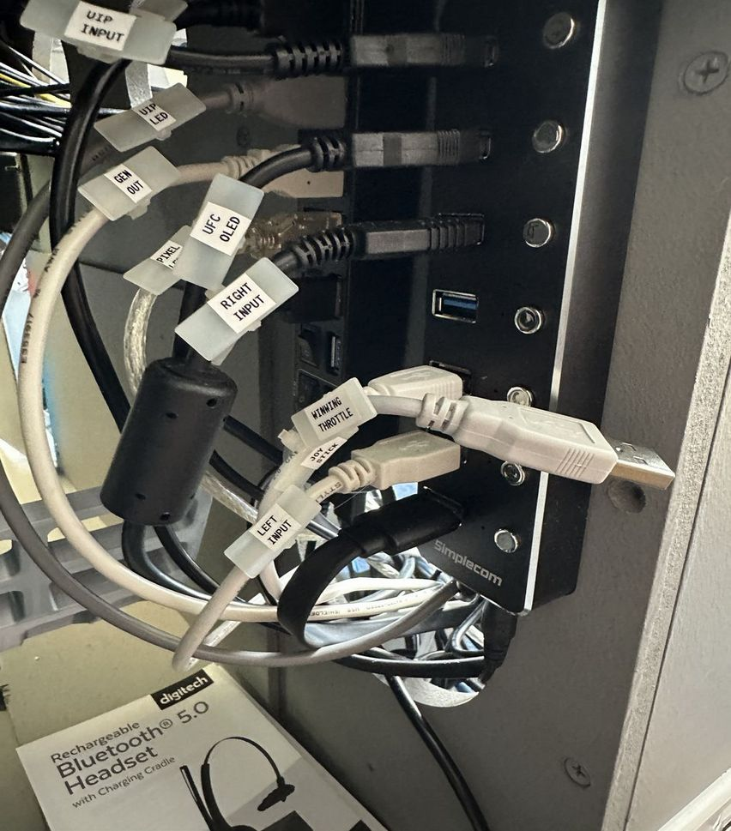
Left Input USB second from the bottom | Bone | Bone | 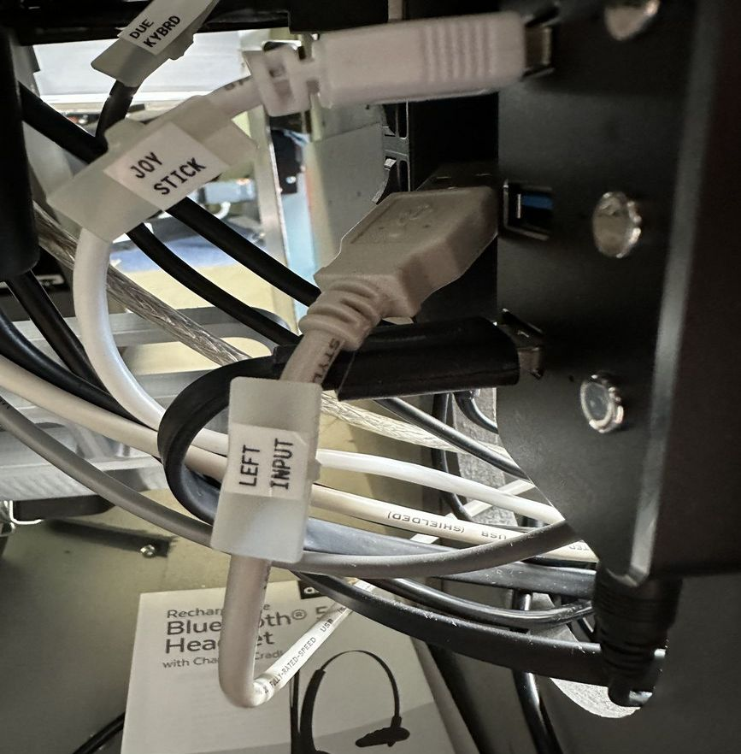
Rear Left Speaker | Black | Red | 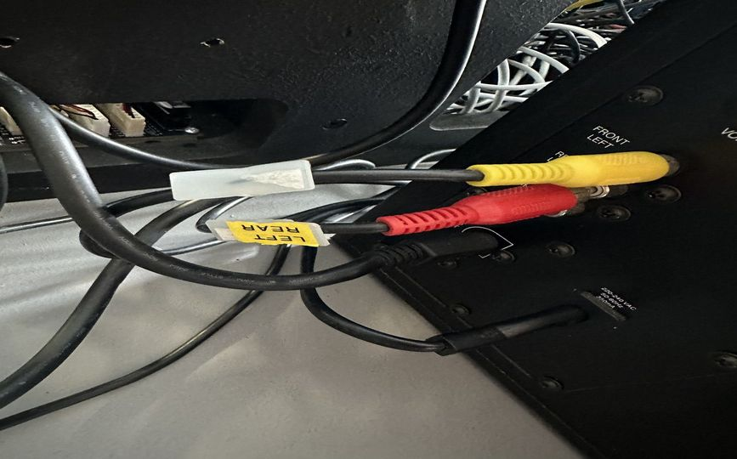  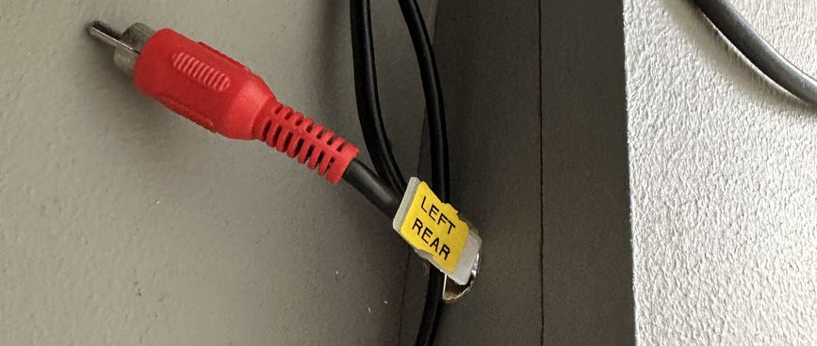
Left NVG PWM Dimmer  Bottom connector of PCB Distribution PCB. | Black outer – white blue inner | Green | 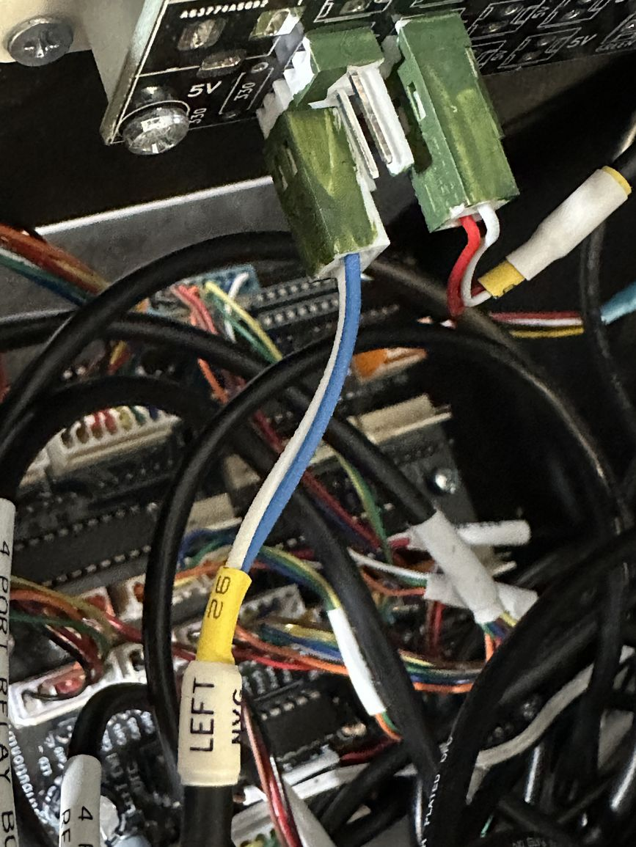
Left Panel Backlighting  Bottom connector on power distribution board | Black | Black | 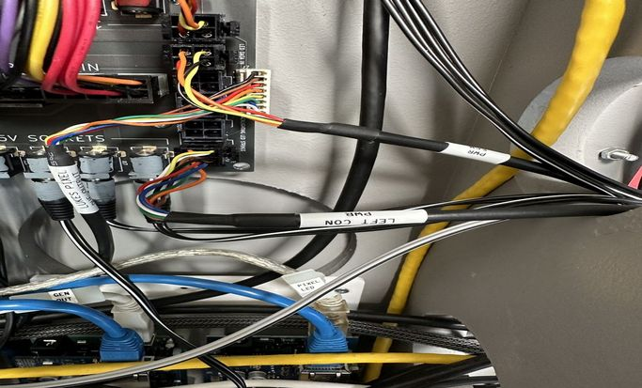
Master power from power distribution board  There is also a test lead stored in the pit for controlling power when the port console is not attached. | Grey - Black | Bone | 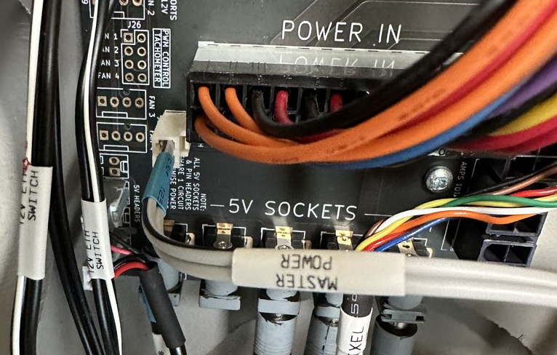
Left Console and Left Console Flood. Before and after removal  The row of connectors closest to the wall is for console backlighting – used for gauges and the Winwing Throttle (modified from original Winwing backlighting).  The row of connectors with the Red/Black cable is for flood lighting. |  |  | 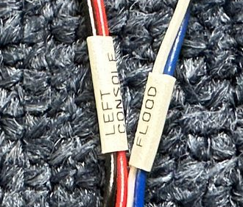  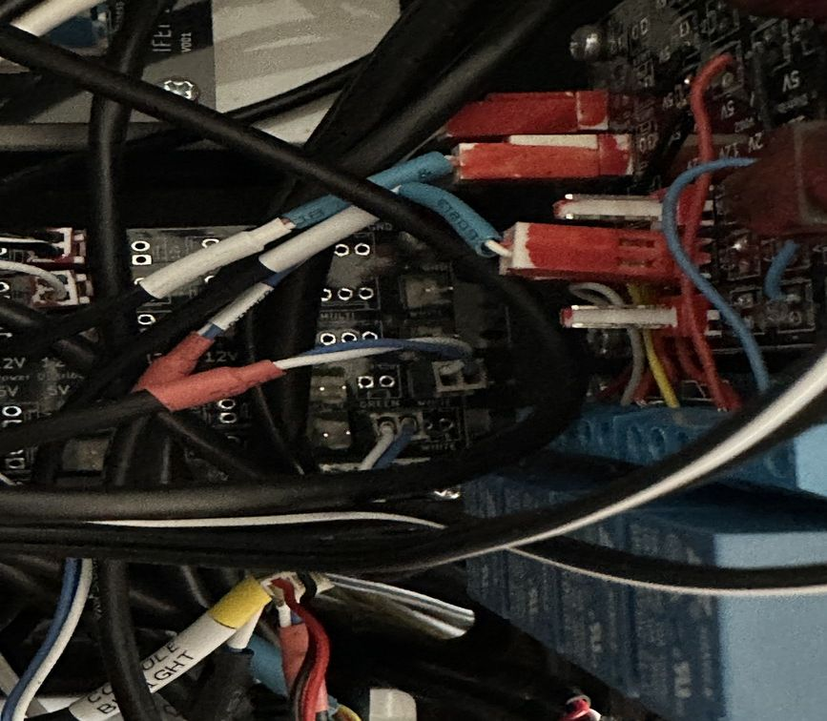  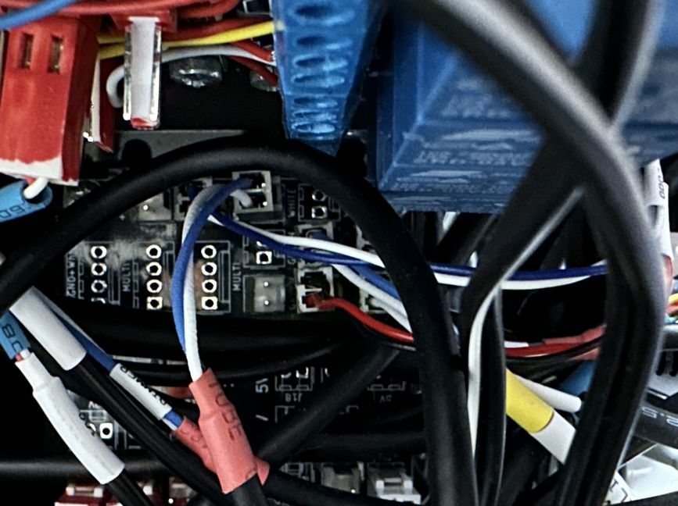
Left 12V  Top right hand 12V connector on power distribution. | Black | Red | 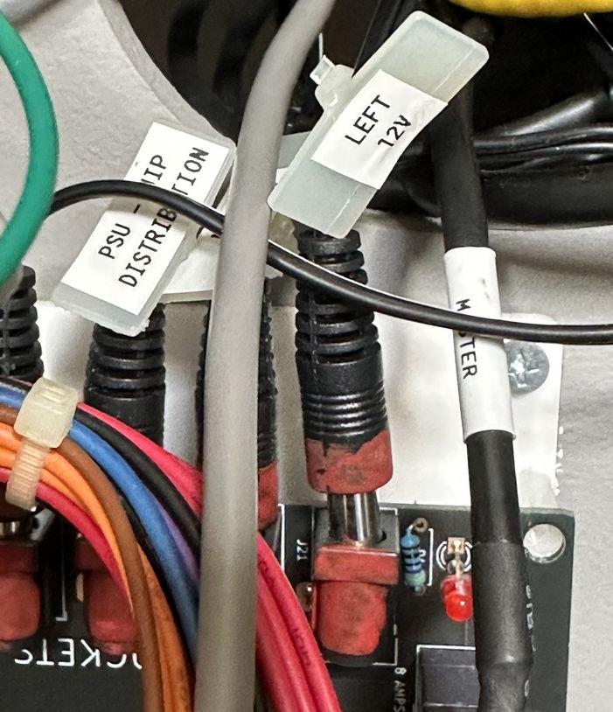
Left Stepper Servo  The Servo is for the Trim, and Stepper for the Brake Pressure. | Black | Black, Yellow connectors, 3 pin for servo (upper part of PCB), 4 pin for Stepper (lower section of PCB) | 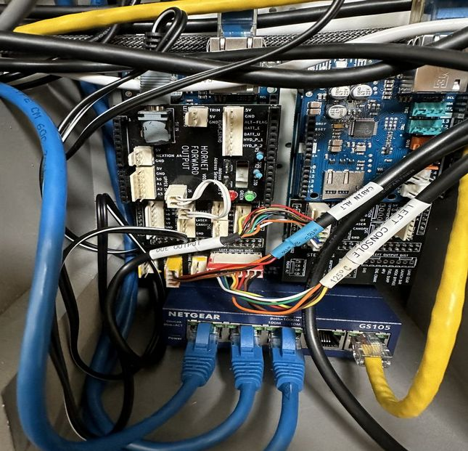  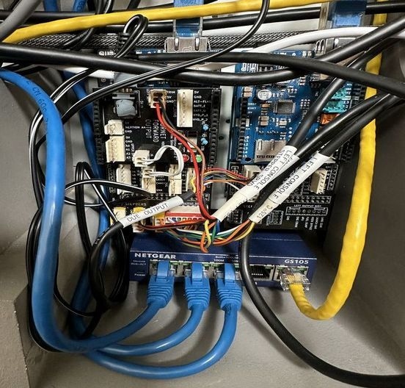
Port formation | Black | Green 4 way | 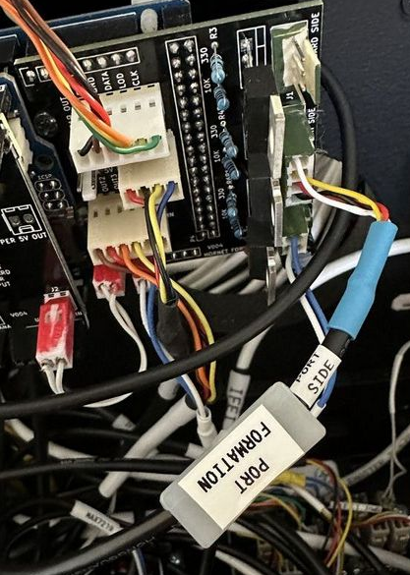
Left Console Digital Out | Black | Red 8 Way | 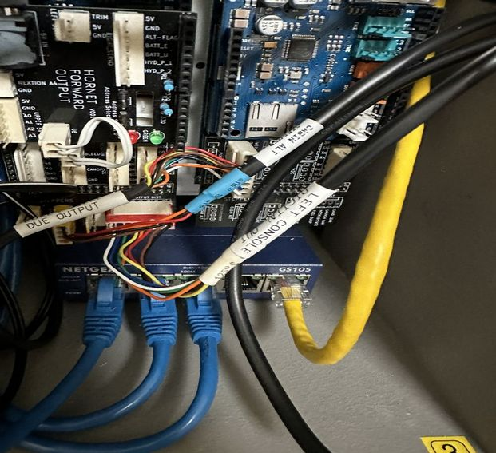
Left Console Led | Black | Orange | 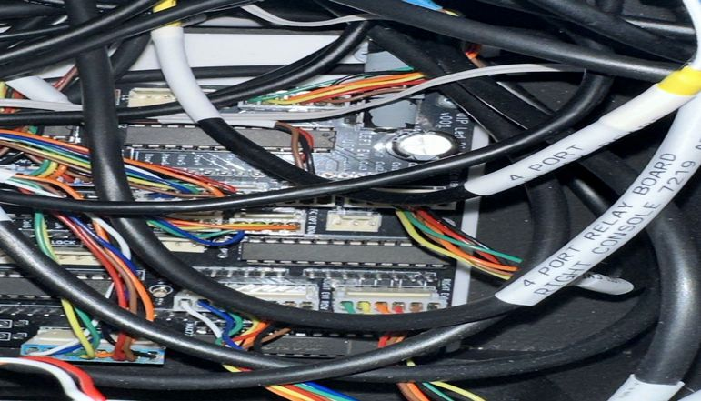  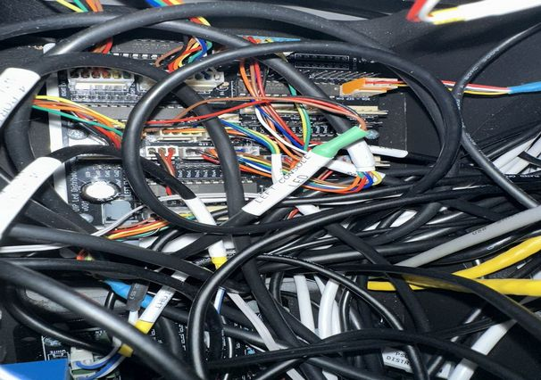

Remove the two bolts in the forward section | 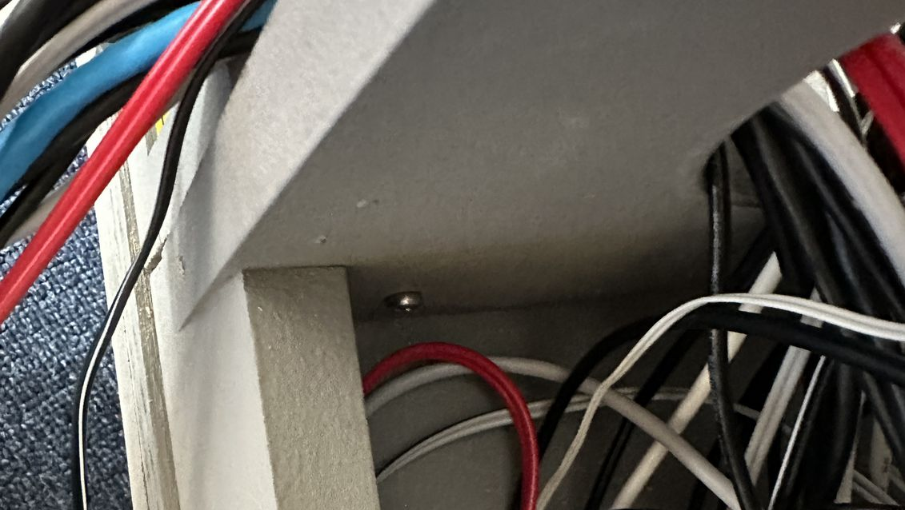  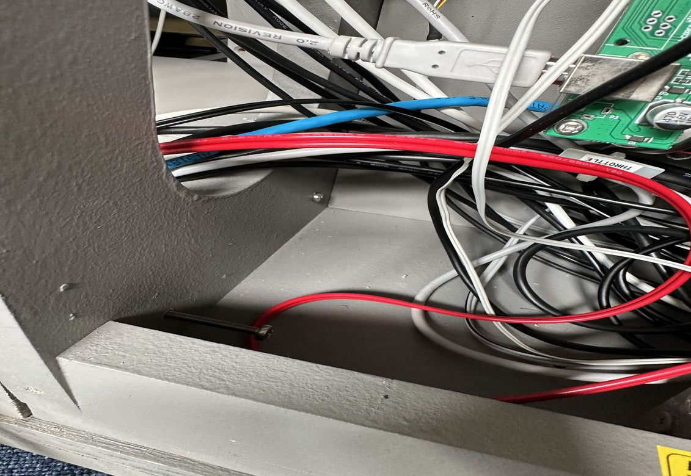
Unscrew the screw in the rear compartment | 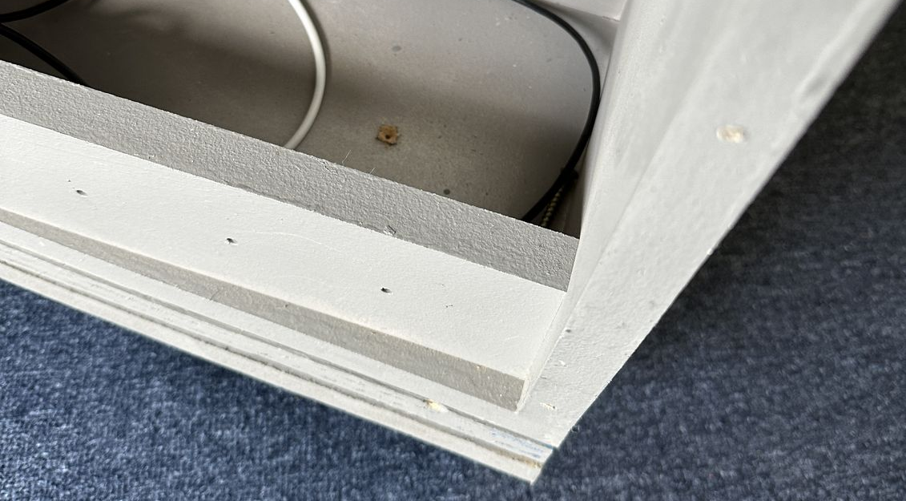

Left Console can now be removed
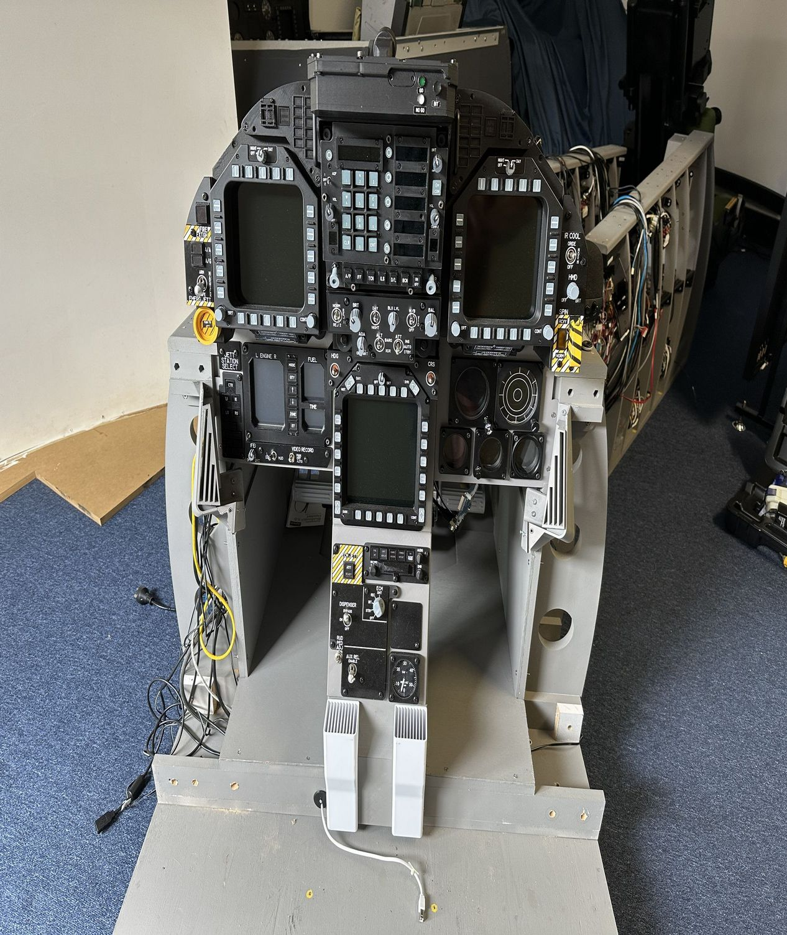

Remove UIP
It is probably better to remove the ECM panel and the AMPCD before removing the UIP to reduce the likelihood of damaging the AMPCD monitor.

Disconnect Right DDI  Cable path is across the UIP, down the port side hole in UIP, through the top hole in bay 3 and then along the lower path to the forward cable entry | Black | HDMI | 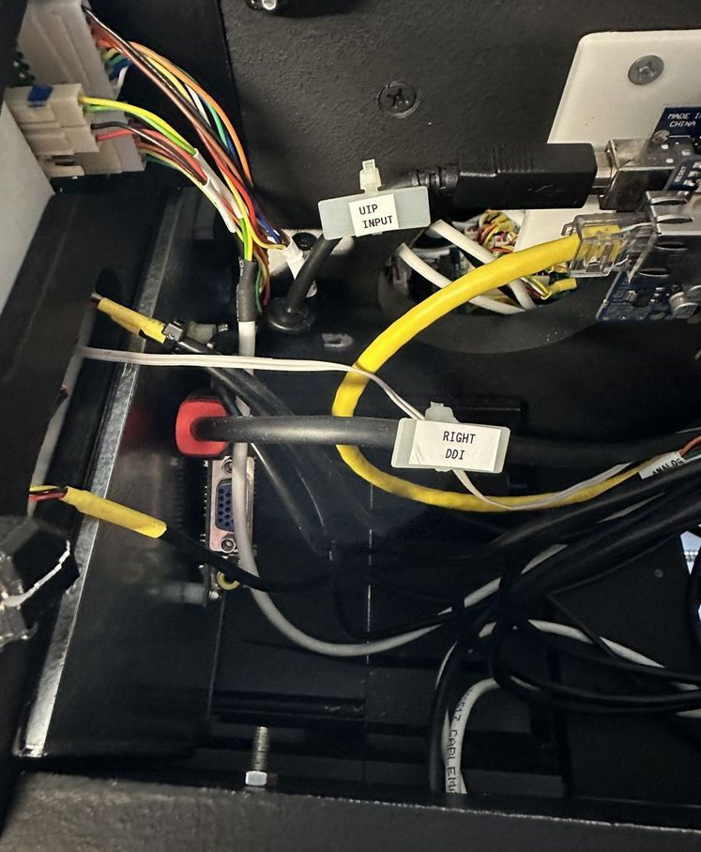
Left HDMI. Cable path is down the port side hole in UIP, through the top hole in bay 3 , through the hole in the rear brace of bay three, back in through the lower hole (to take up come cable slack) and then along the lower path to the forward cable entry | Black | HDMI | 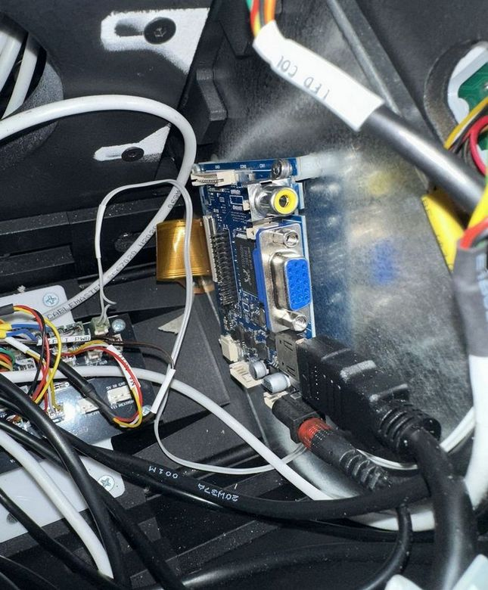
UIP Upper Output Ethernet  Located in port bay of UIP.  Cable path is down the port side hole in UIP, through the top hole in bay 3 , through the hole in the rear brace of bay three, back in through the lower hole (to take up come cable slack) and then along the lower path. Connects to Port 4 of the Bay 2 Switch. | Yellow |  | 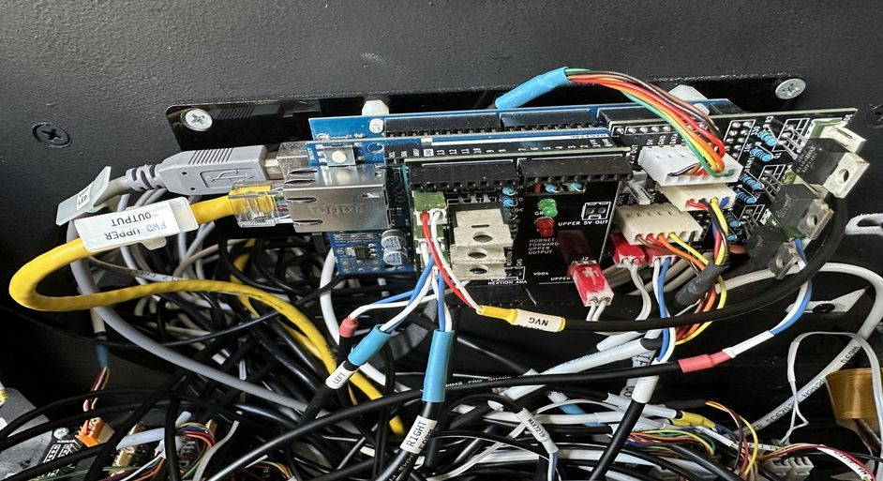  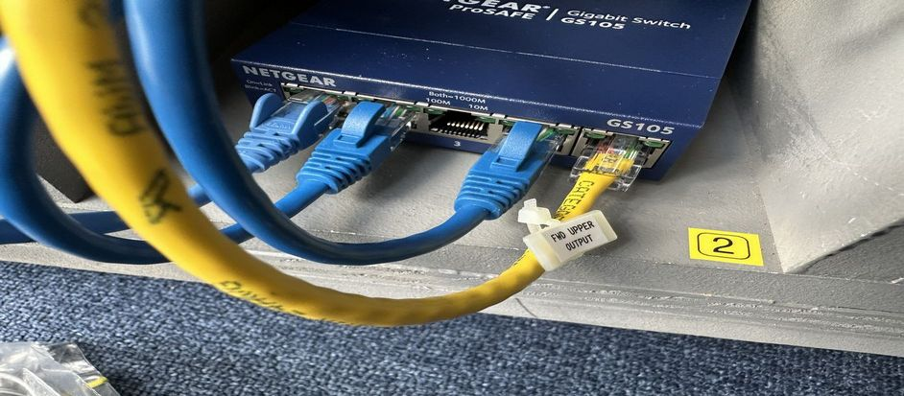
UIP Forward Input.  Located in Starboard bay in the UIP.  Cable path is across the UIP, down the port side hole in UIP, through the top hole in bay 3, through the hole in the rear brace of bay three, back in through the lower hole (to take up come cable slack) and then along the lower path. Connects to Port 4 of the Bay 3 Switch. | Yellow |  | 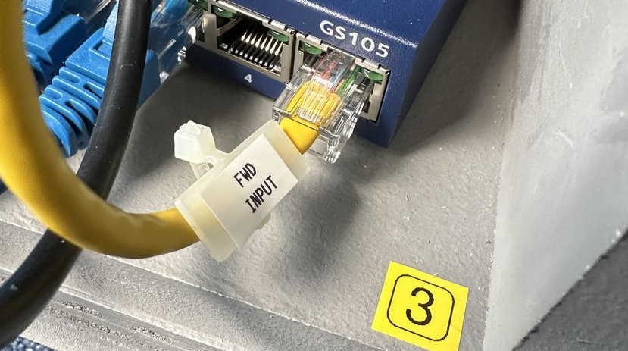  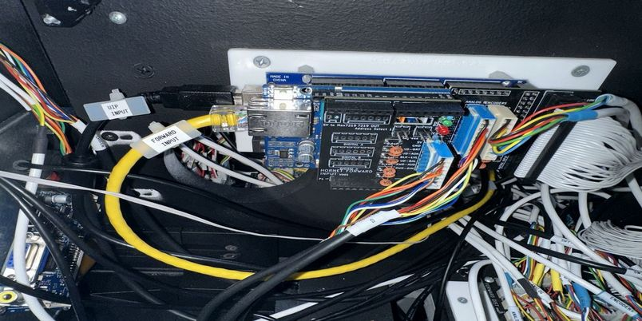
UIP Input USB  Cable path is across the UIP, down the port side hole in UIP, through the top hole in bay 3, and then along upper holes in port side to the USB Hub.  Connects to the upper port of the forward USB hub. | Black |  | 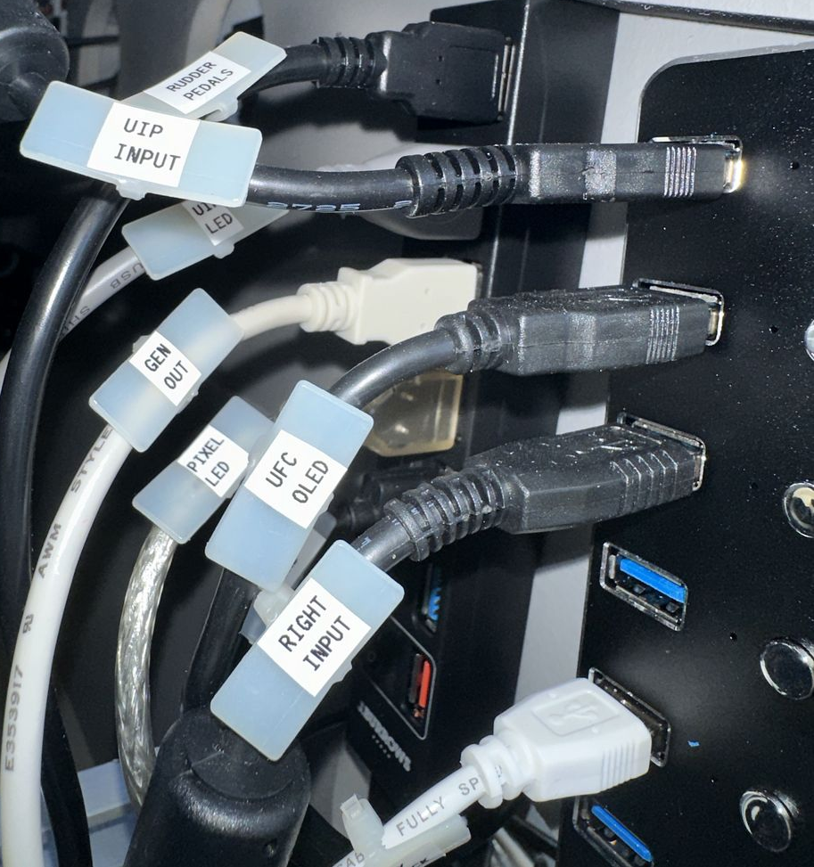  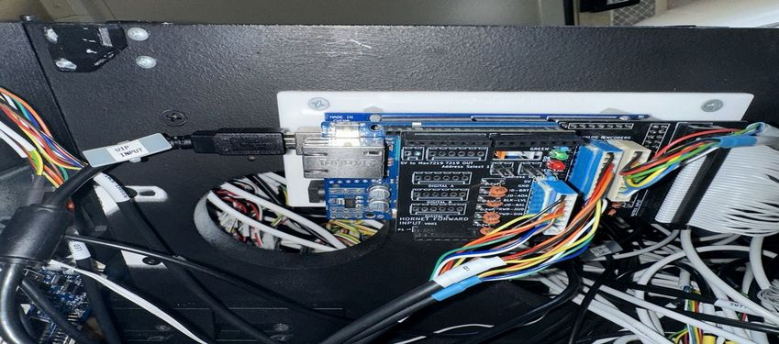
UIP Output/Led USB  Cable path is down the port side hole in UIP, through the top hole in bay 3, and then along upper holes in port side to the USB Hub.  Connects to the second from the top port of the aft USB hub. | Purple/Grey |  | 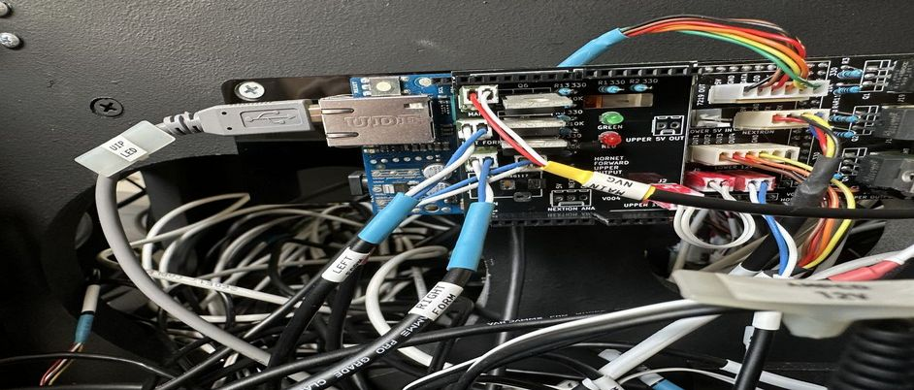  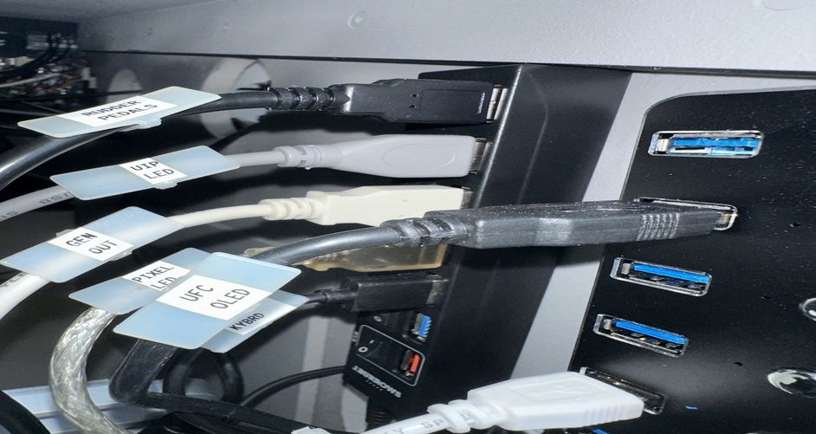  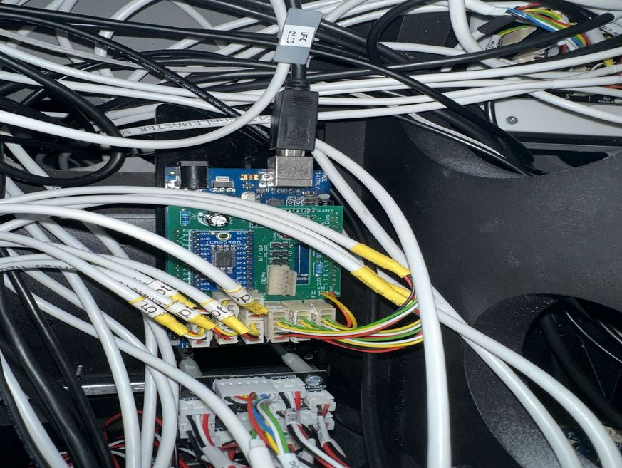
UFC OLED  Cable path is down the port side hole in UIP, through the top hole in bay 3, and then along upper holes in port side to the USB Hub.  Connects to the second from the top port of the forward USB hub.  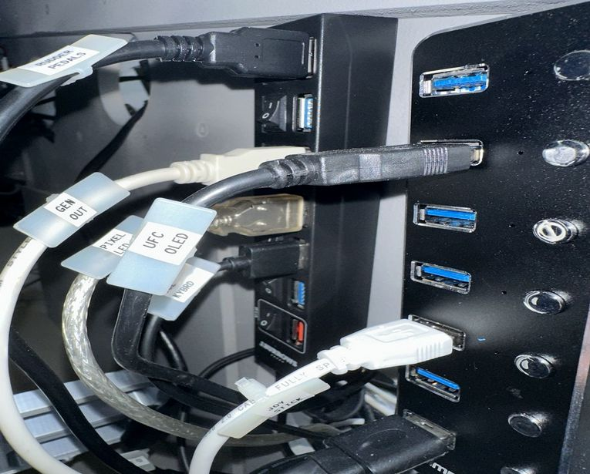 | Black
Left Formation from upper PWM.  Left formation connects to the second from the top connector.  Cable path is down the port side hole in UIP, through the top hole in bay 3, and then along upper holes to bay 1  Right formation connects to the lower connector.  Cable path is across UIP, down the starboard side hole in UIP, through the top hole in bay 3, and then along lower holes to bay 1 | Black – Blue-White inner | Green | 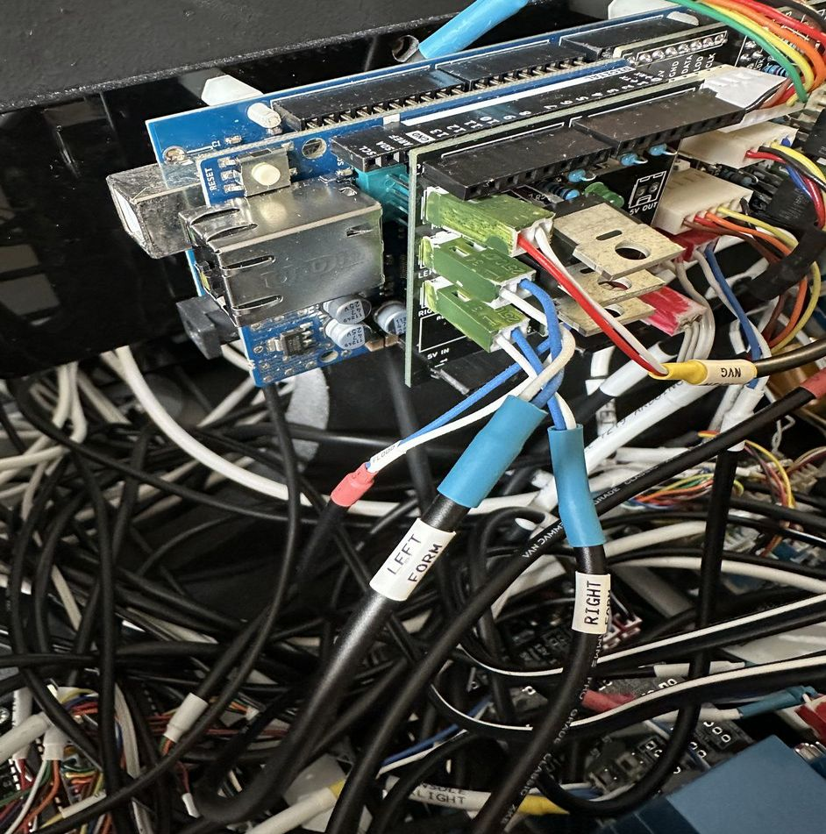
UIP 12V Distribution  Connects to the power distribution PCB in the port side bay of the UIP.  Connects to the middle 12V connector at the top of the LIP power distribution panel. | Black | Red | 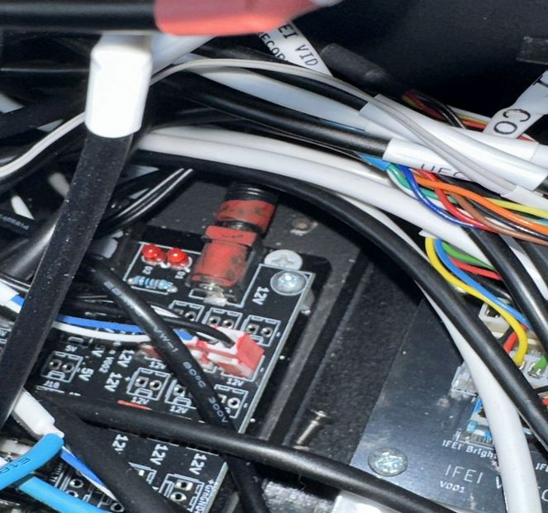  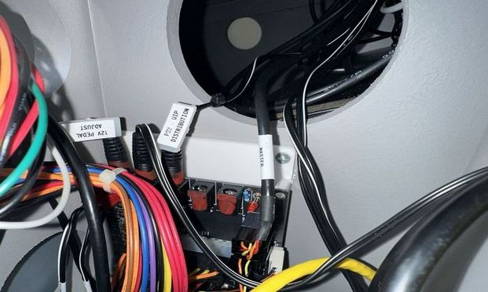
UIP 5V Distribution  Cable path is down the port side hole in UIP, through the top hole in bay 3, and then through the upper hole in the aft of bay three and back through the lower hole (to take up cable slack).  Connects to the right most lower 5V connector on the primary power distribution PCB. | Black | Grey | 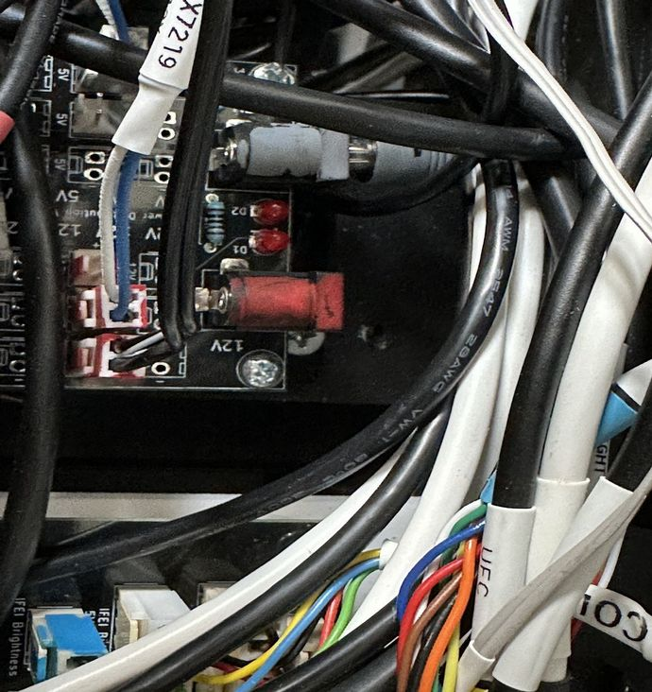  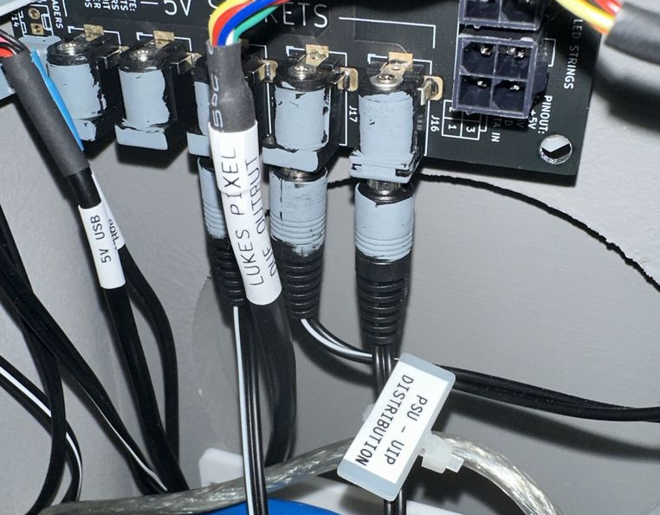
5V Max7219  The Max7219 PCB is located in the port side bay of the UIP.  A small amount of slack is taken up by running the cable into bay 4.  Connects to the lower 5V connectors, second from the right. | Black | Grey | 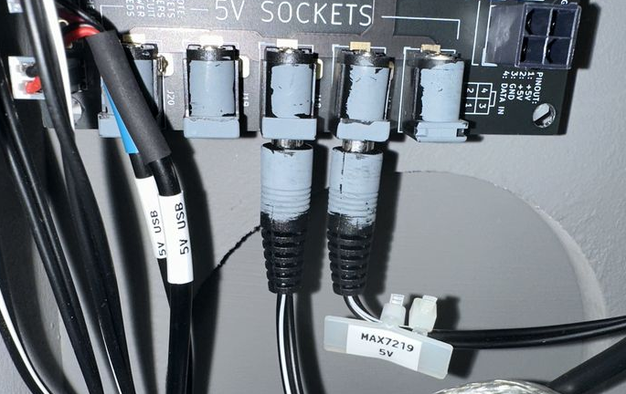  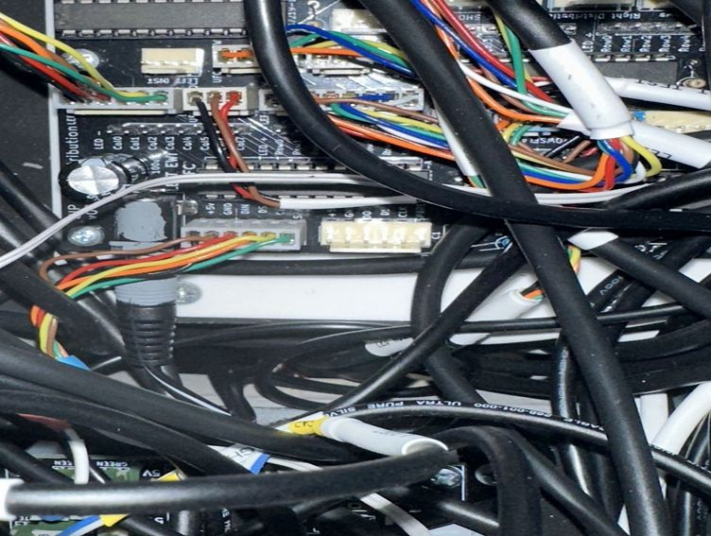
UIP Panel Backlight  Upper port of Primary Power Distribution PCB.  Runs to lower connector of Master Arm PCB. | Black | Black | 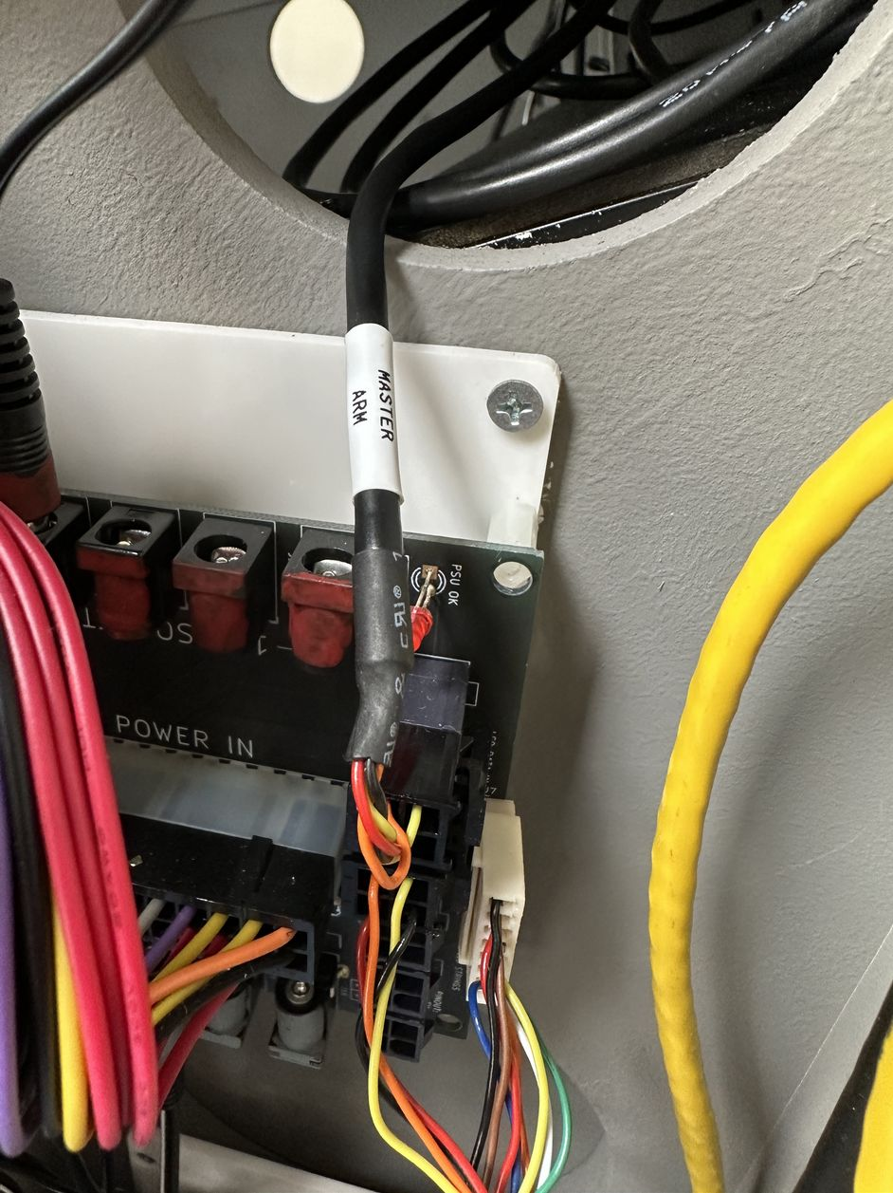
IFEI Cables  Note the Nextion analog port is not used. | Black | Unpainted and Blue. | 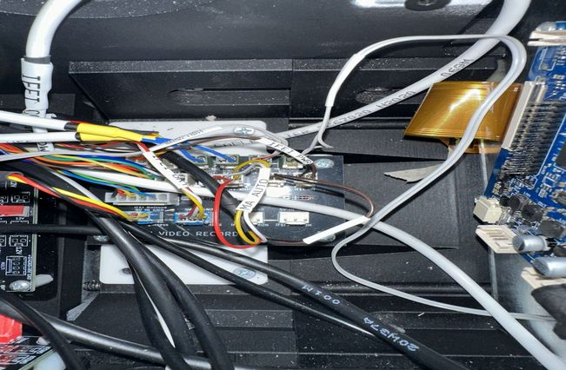  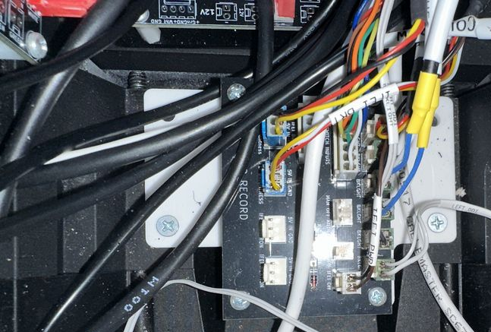  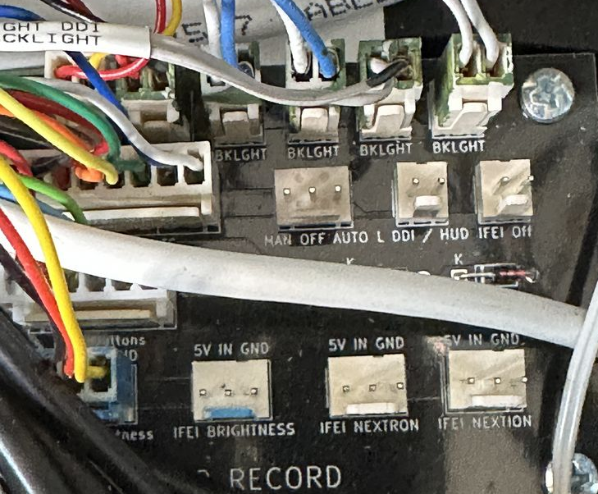  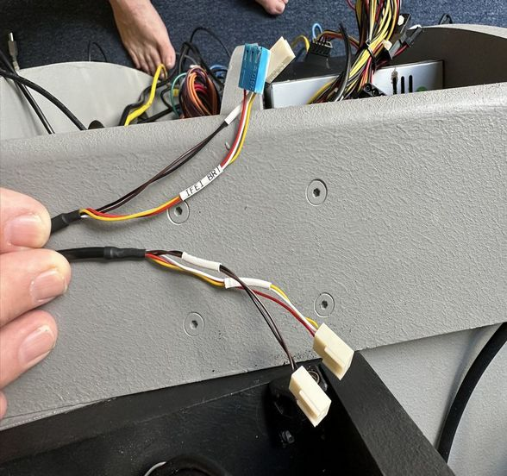
RWR Control Analog | White | Blue | 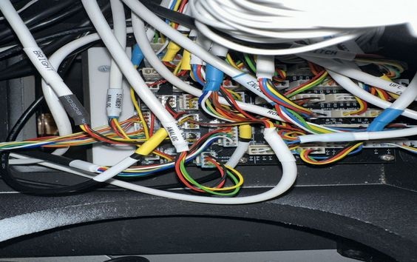  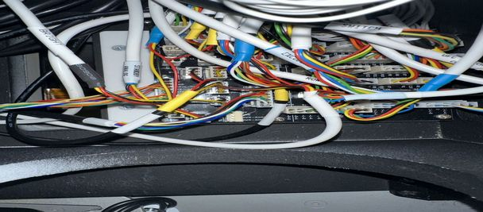
AMPCD Analog  Note that the Standby Pots and Encoders are terminated on the Arduino mounted behind the stand by panel. | White | Blue | 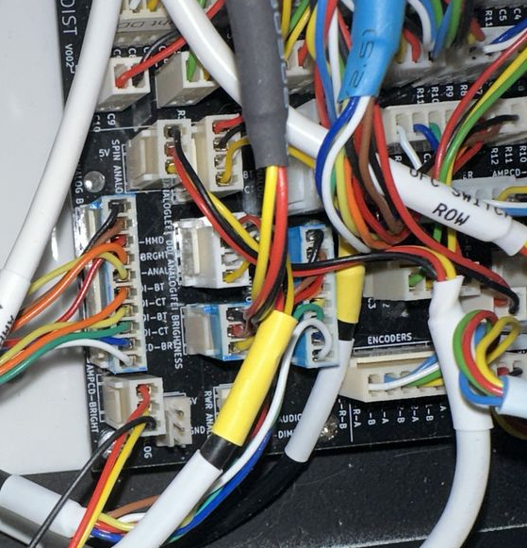  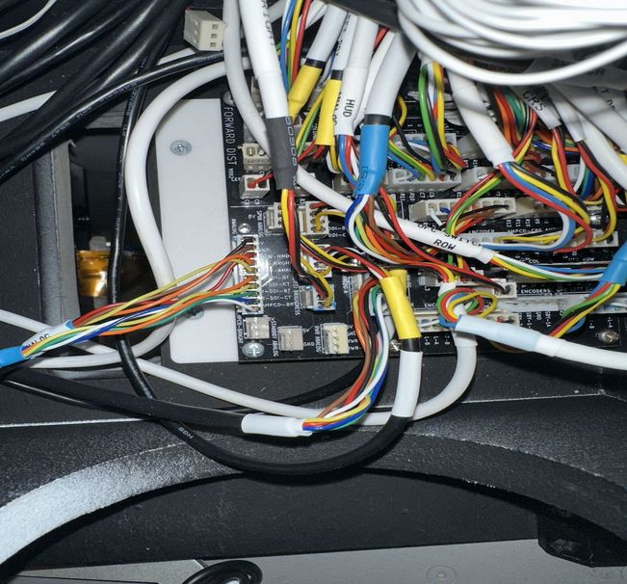
AMPCD CRS | Black | Unpainted | 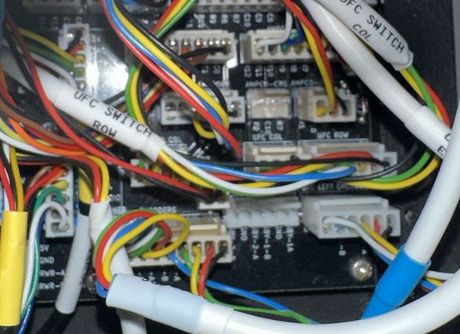  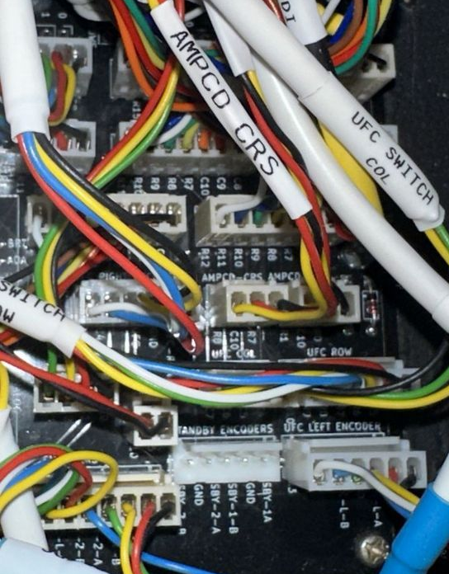
AMPCD Switch Col |  |  | 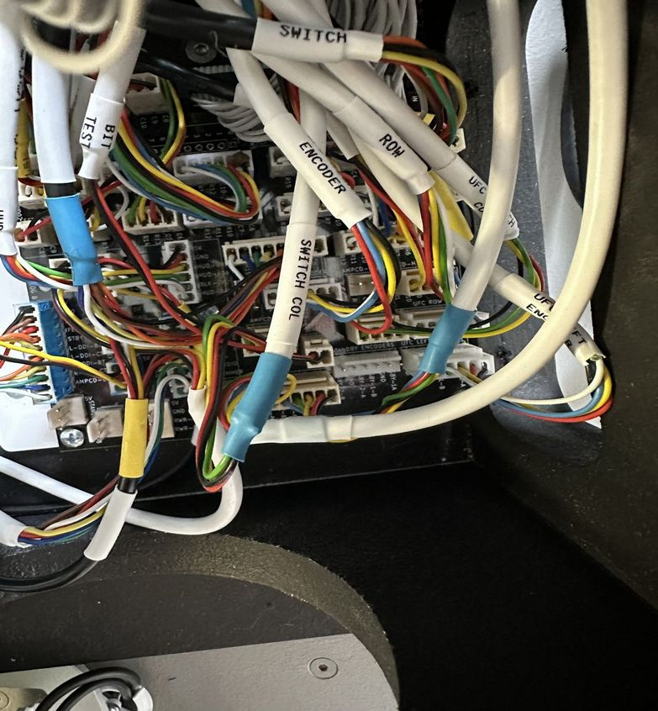  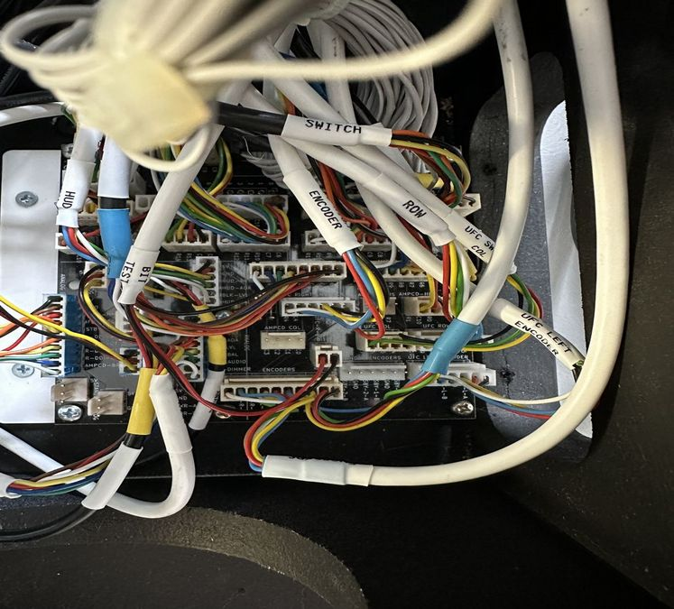
AMPCD Heading |  |  | 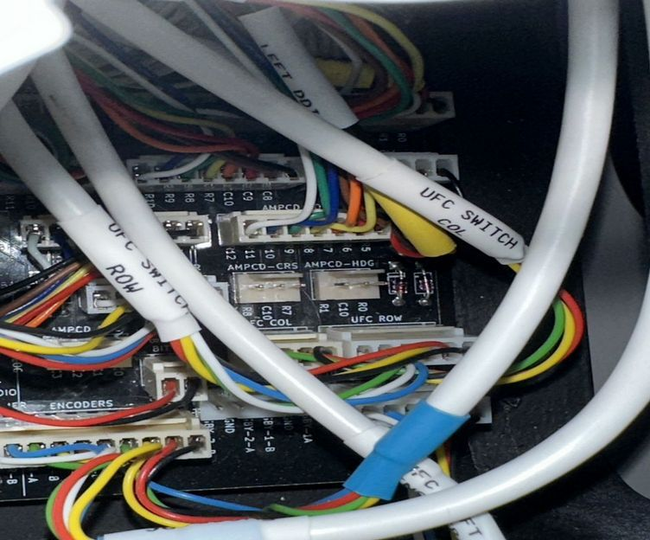
RWR Controller Switch |  |  | 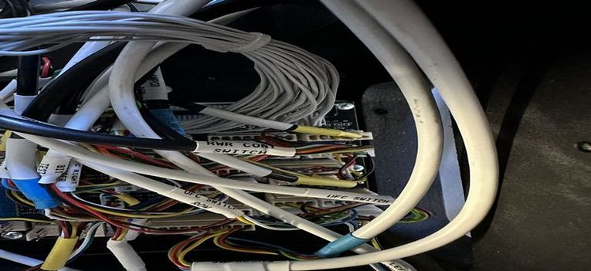  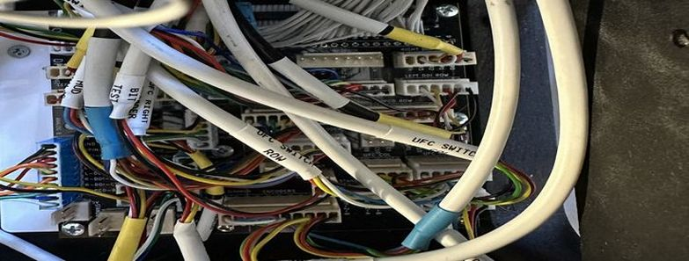
AMPCD Switch Row |  |  | 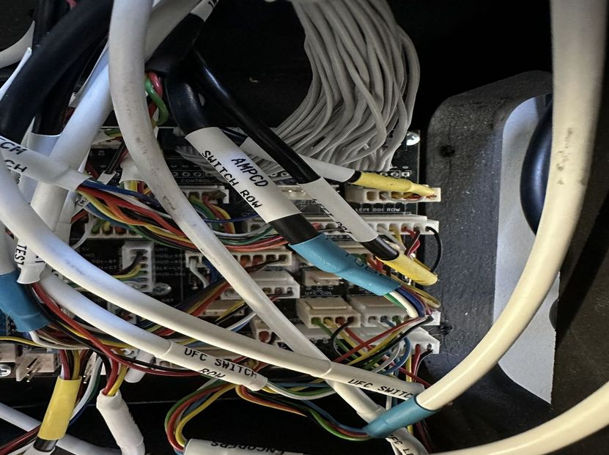  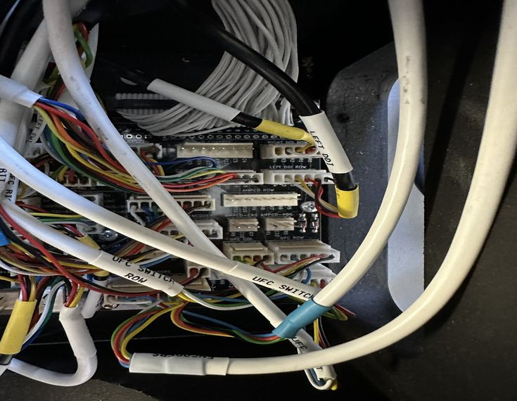
ECM Switch |  |  | 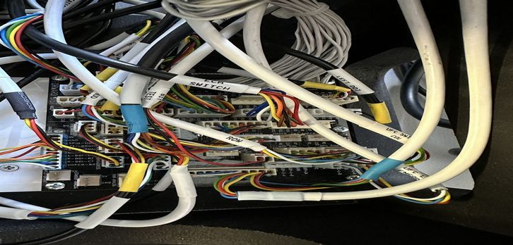  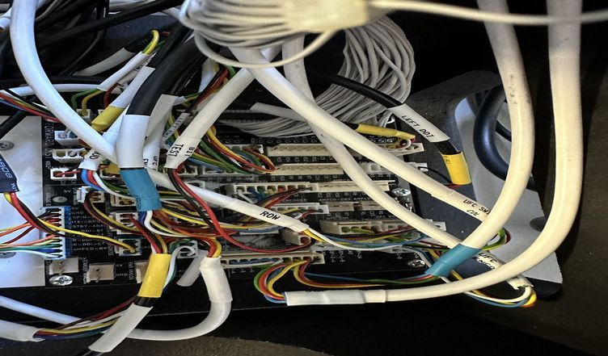
RWR Control LED |  |  | 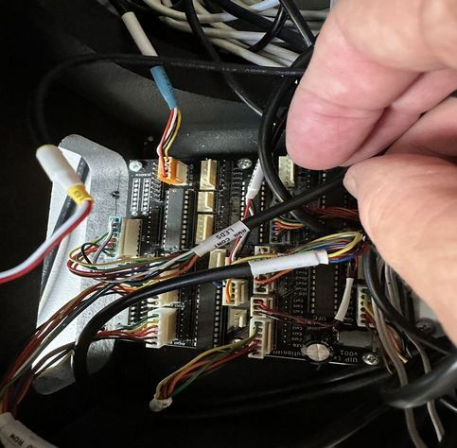  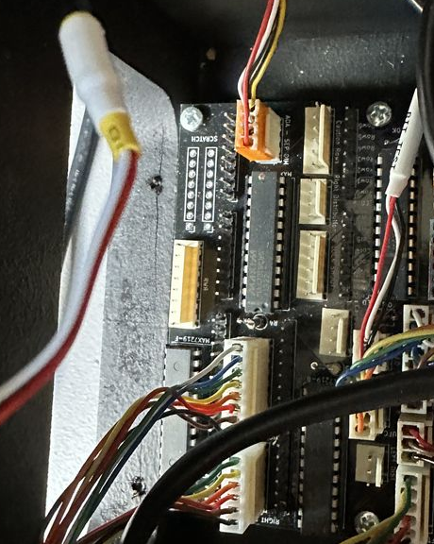
Flaps Gear LEDs | Black | Orange (was originally painted Blue | 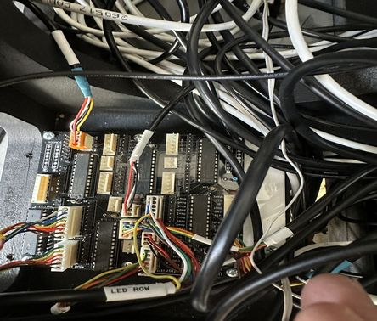  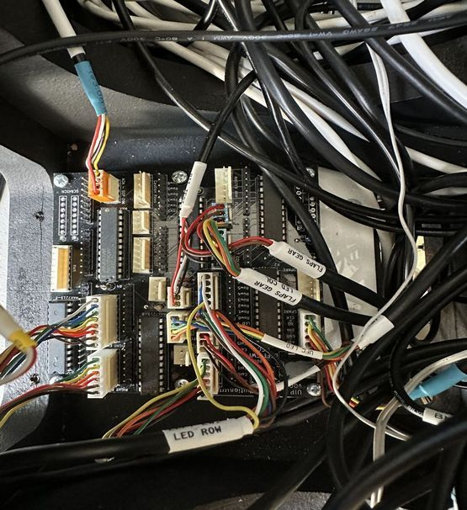
Jet Station Select Switch |  |  | 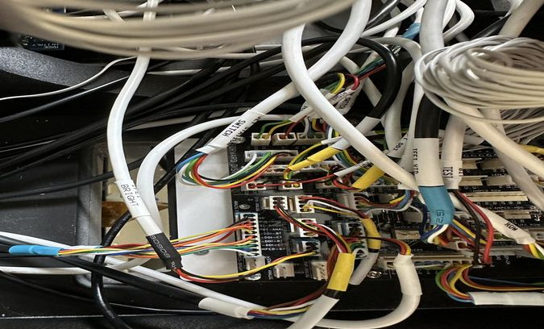  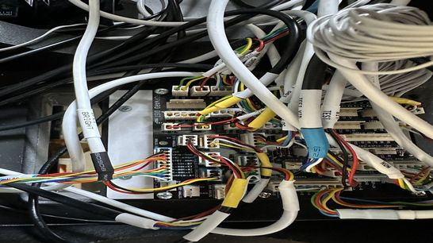
IFEI Col-Row | White | 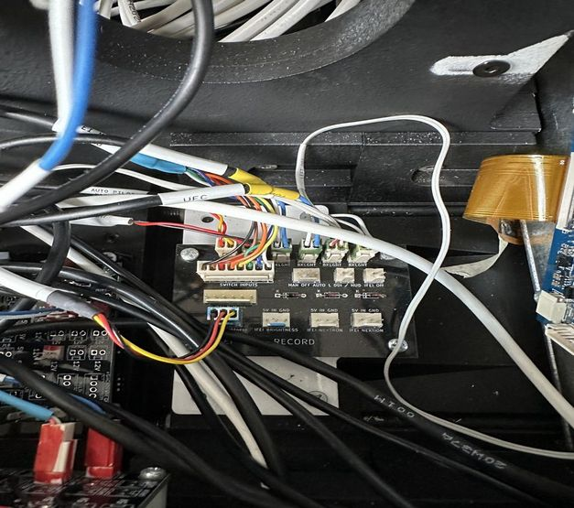  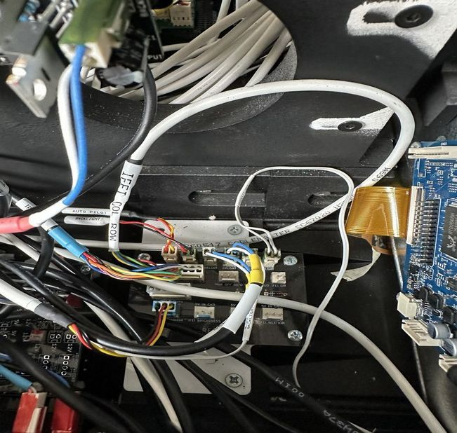
Flaps Gear Backlight |  |  | 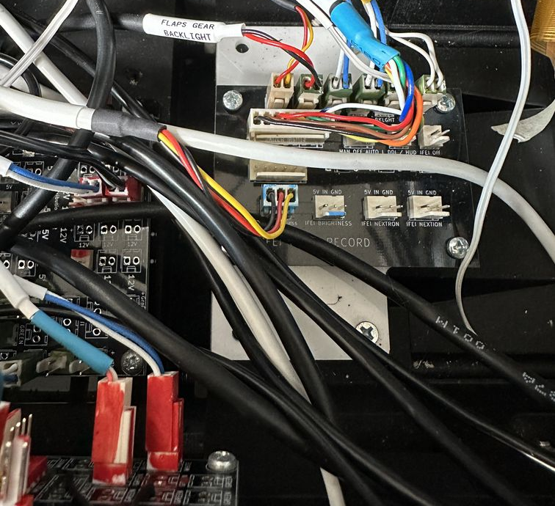  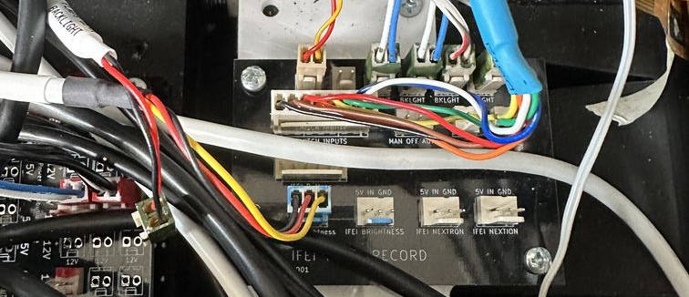
Nextron RS232 |  |  | 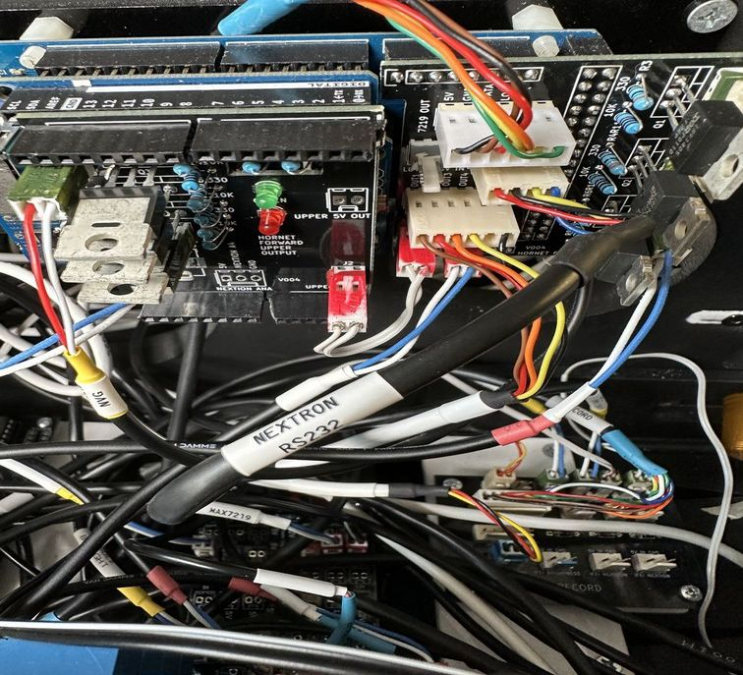  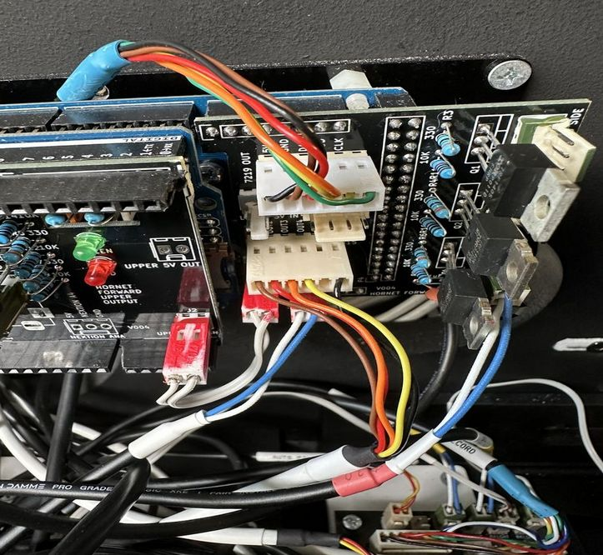
LIP Backlight |  |  | 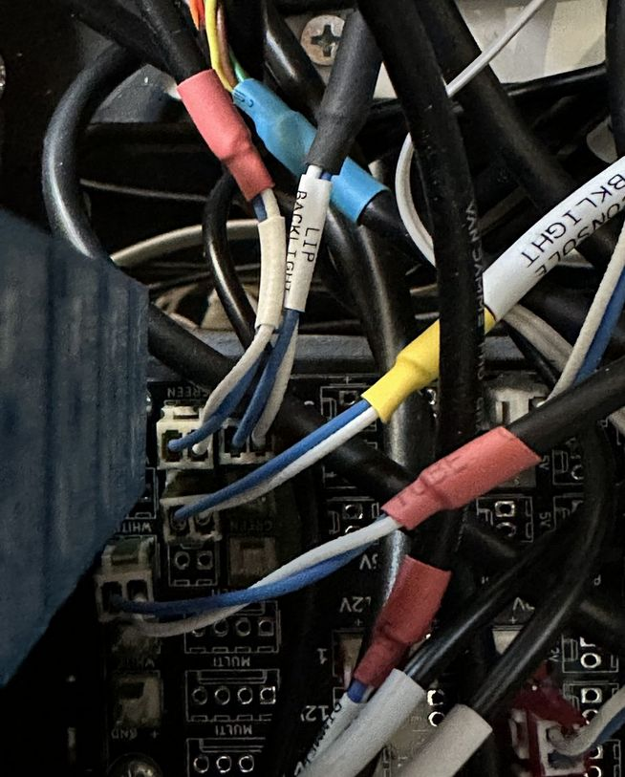  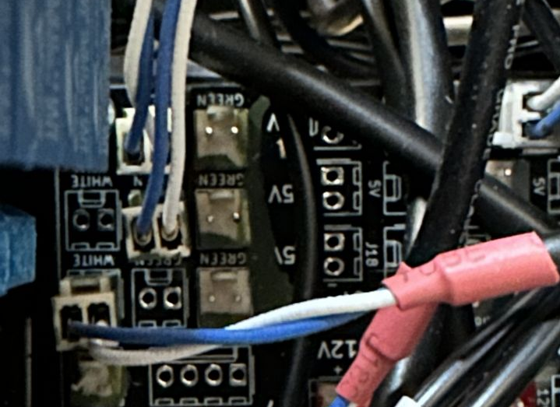
AMPCD Monitor 12V  The forward connector on the 12V switched rail located on the port side of the port bay in the UIP. | Black |  | 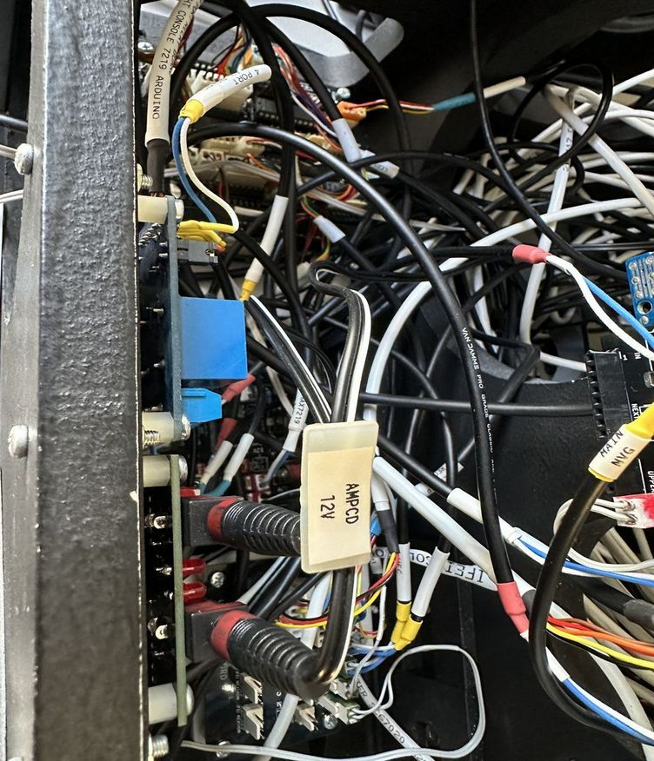
Remove two screws holding the Input Distribution Board and the Max7219 board. |  |  | 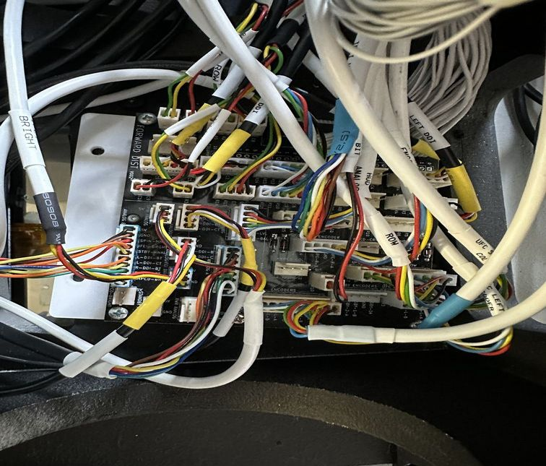  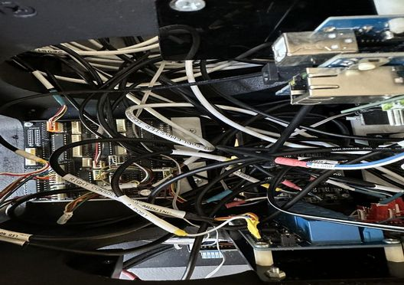
Remove the Eight Bolts attaching the UIP to the LIP, lifting the Max7219 and Input Distribution boards. |  |  | 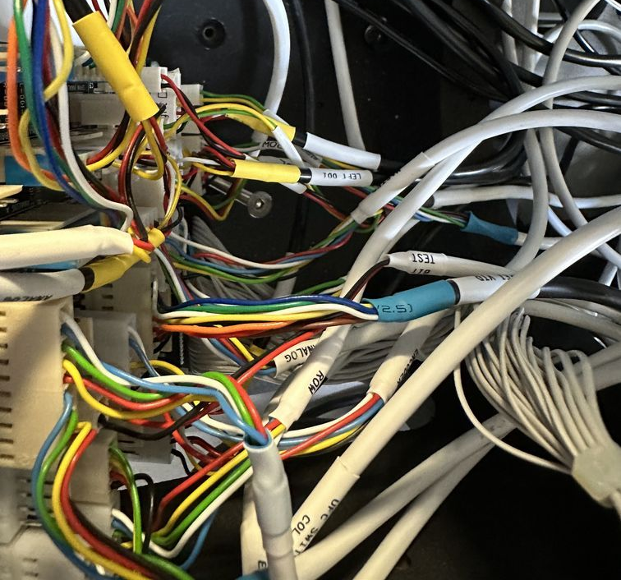
Lift the UIP vertically and CAREFULLY to avoid damaging the AMPCD monitor. |  | 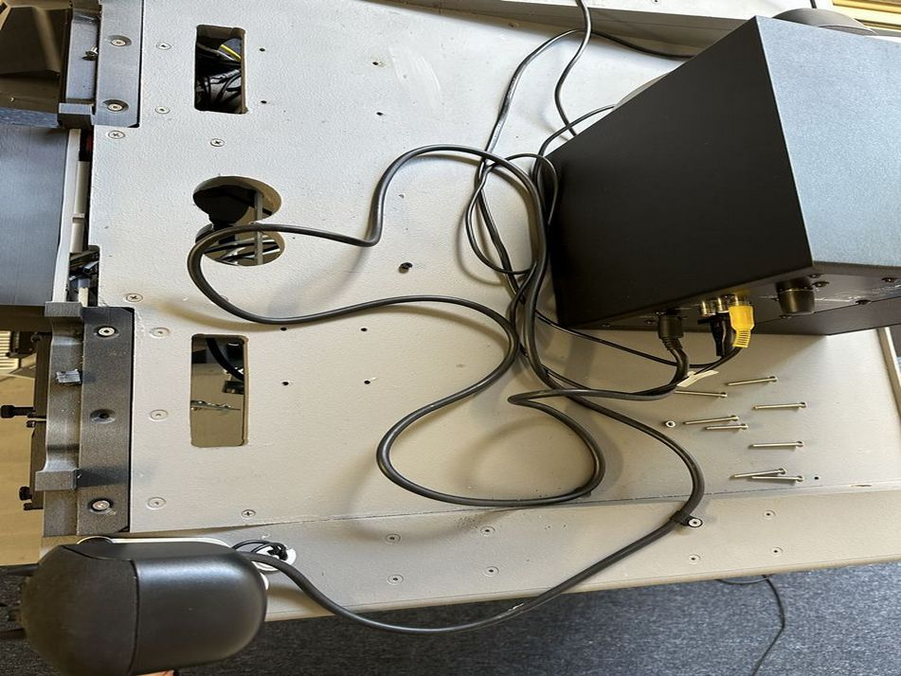  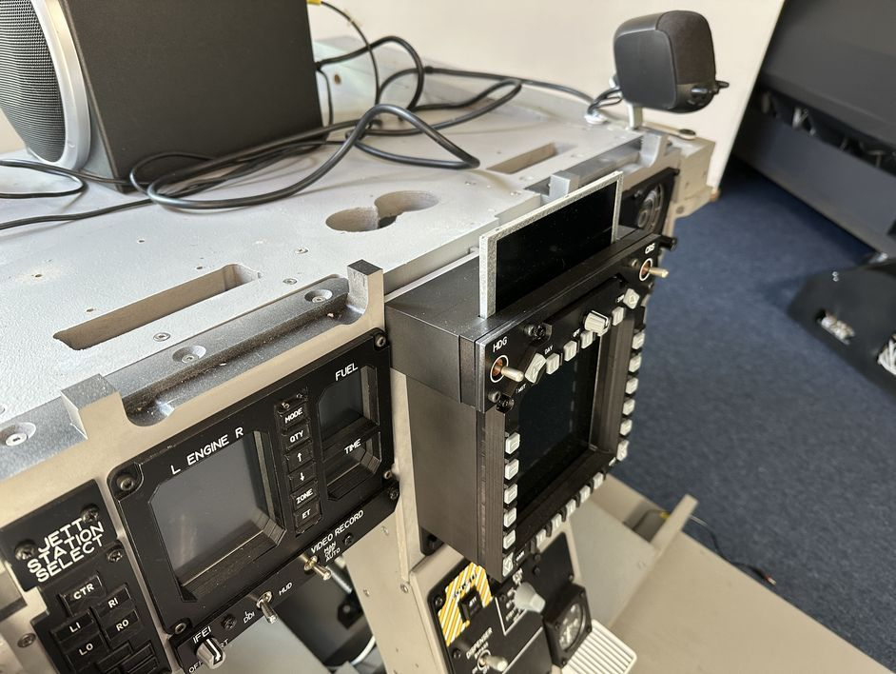

Remove ECM
Probably best to do this before removing UIP to reduce risk of damage to AMPCD monitor.
Unscrew the single bolt on the port side, and two bolts on the starboard side. |  |  | 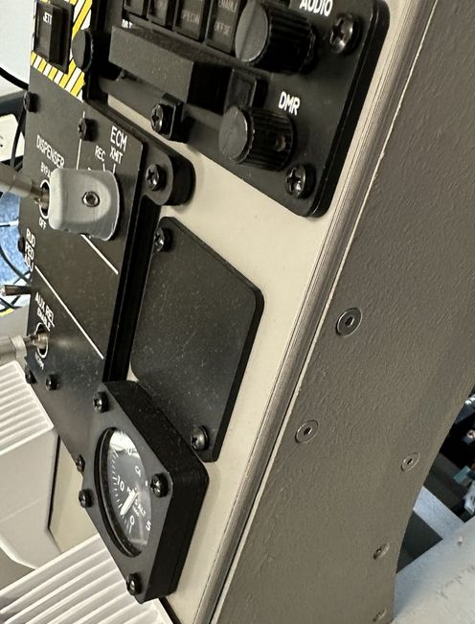  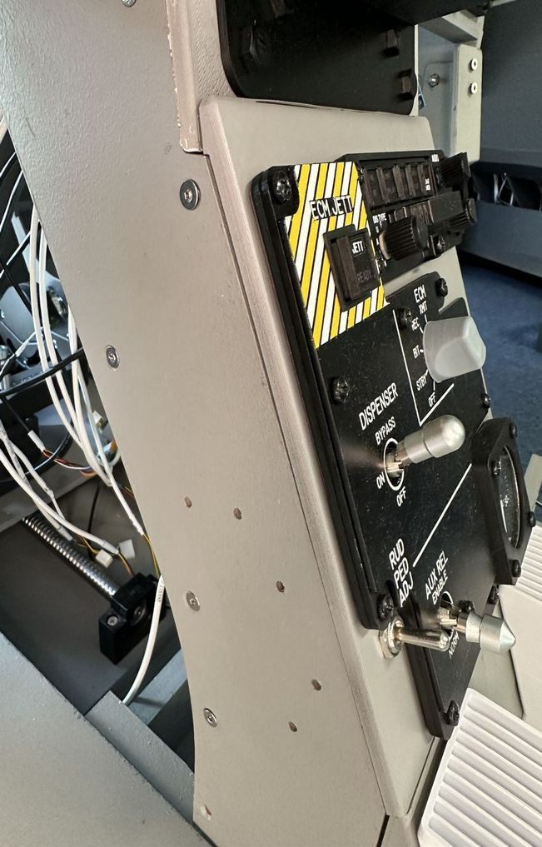
Remove two front panel bolts on port side, and three front panel bolts on starboard side. |  | 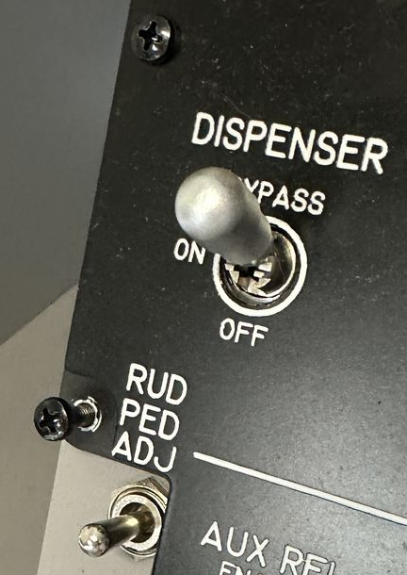  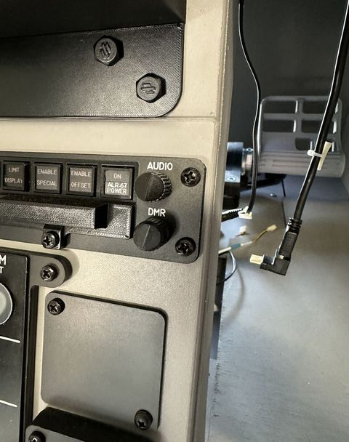  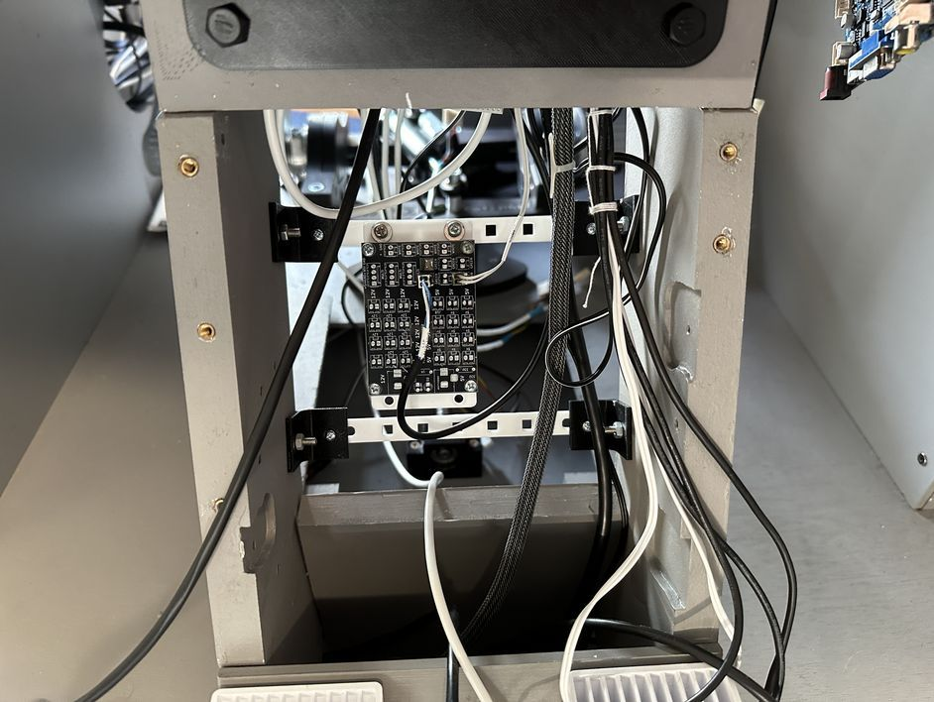
The ECM panel can now be removed. Unplug the Seat Adjust  This cable goes to the Seat Adjust PCB at the very forward section, underneath the rudders. | White | Red | 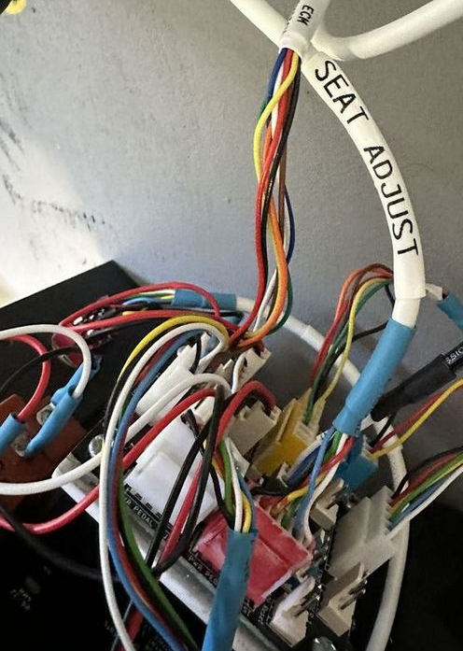
Unplug the Cabin Alt Stepper | Black | Yellow | 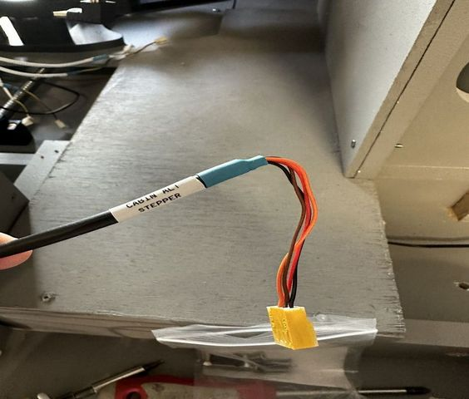
Disconnect the ECM PWM backlight |  |  | 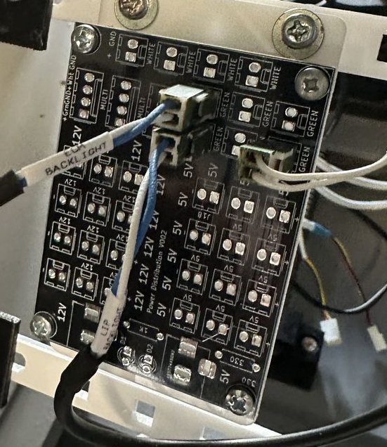
Disconnect the Panel Backlighting.  The blacklight lead comes from Power Distribution to ECM. It then connects through to IFEI. | Black | Green | 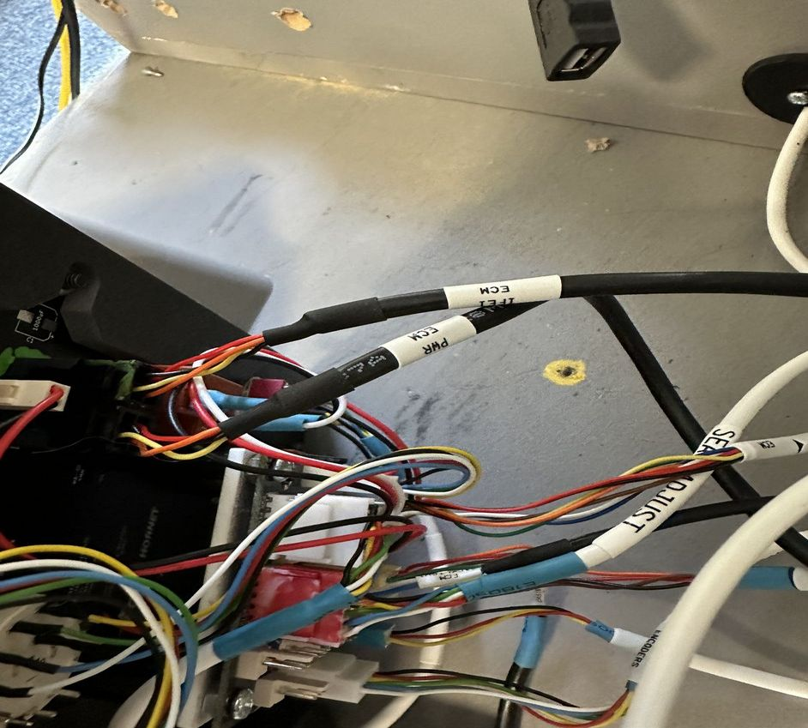
Remove the two bolts at either side of the lower vent. Remove the vent. |  |  | 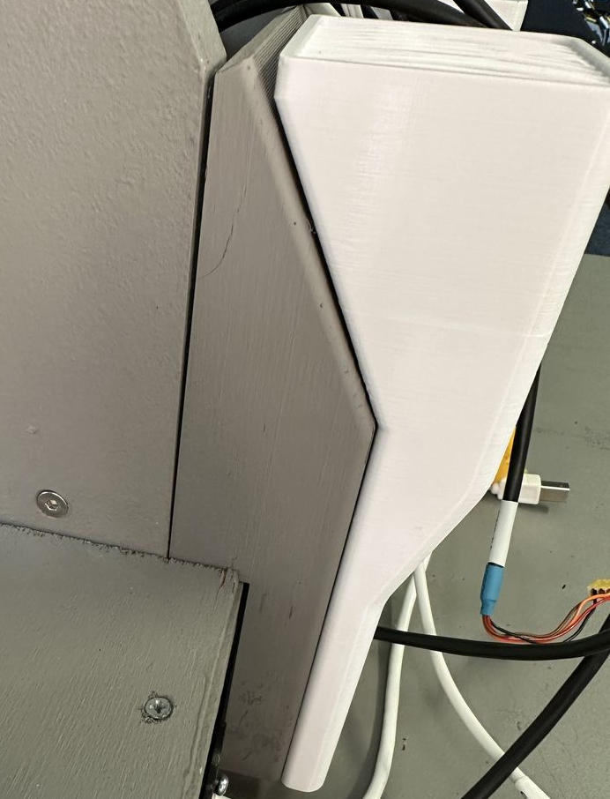
Unscrew the two bolts of the AMPCD. |  |  | 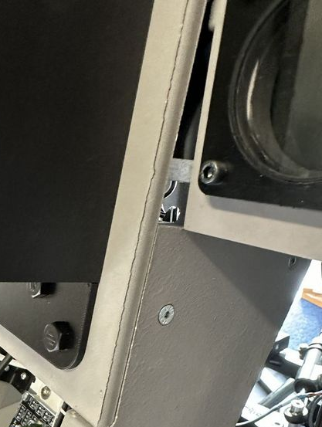
While lifting the AMPCD assembly out, disconnect the PWM dimmer (its a short lead) |  |  | 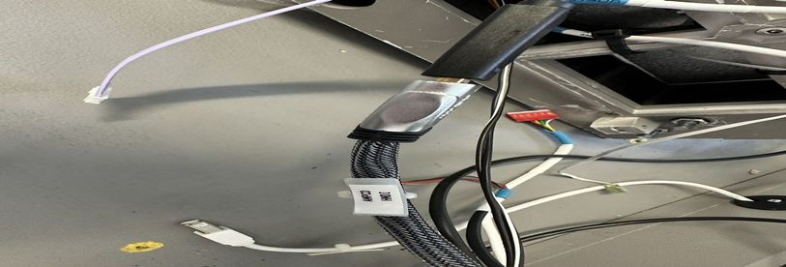  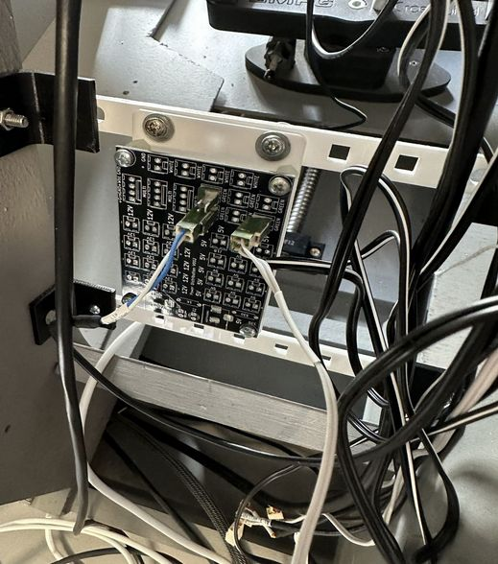
Unplug the AMPCD HDMI

Unplug the 12V AMPCD supply | Black | Red | 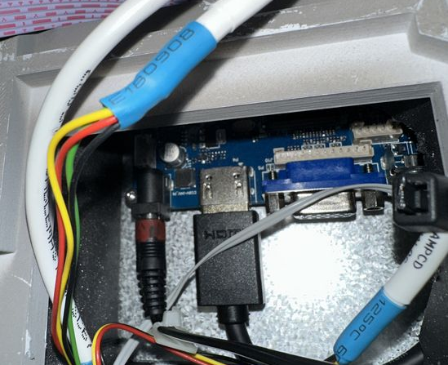
The following connect to the AMPCD, Switch Rows, Switch Columns, Analog, CRS, HDG |  |  | 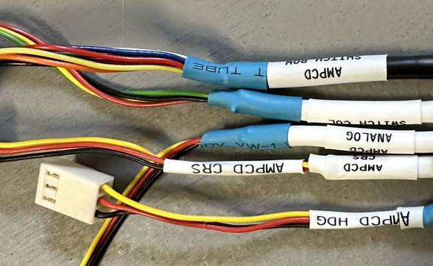
 |  |  | 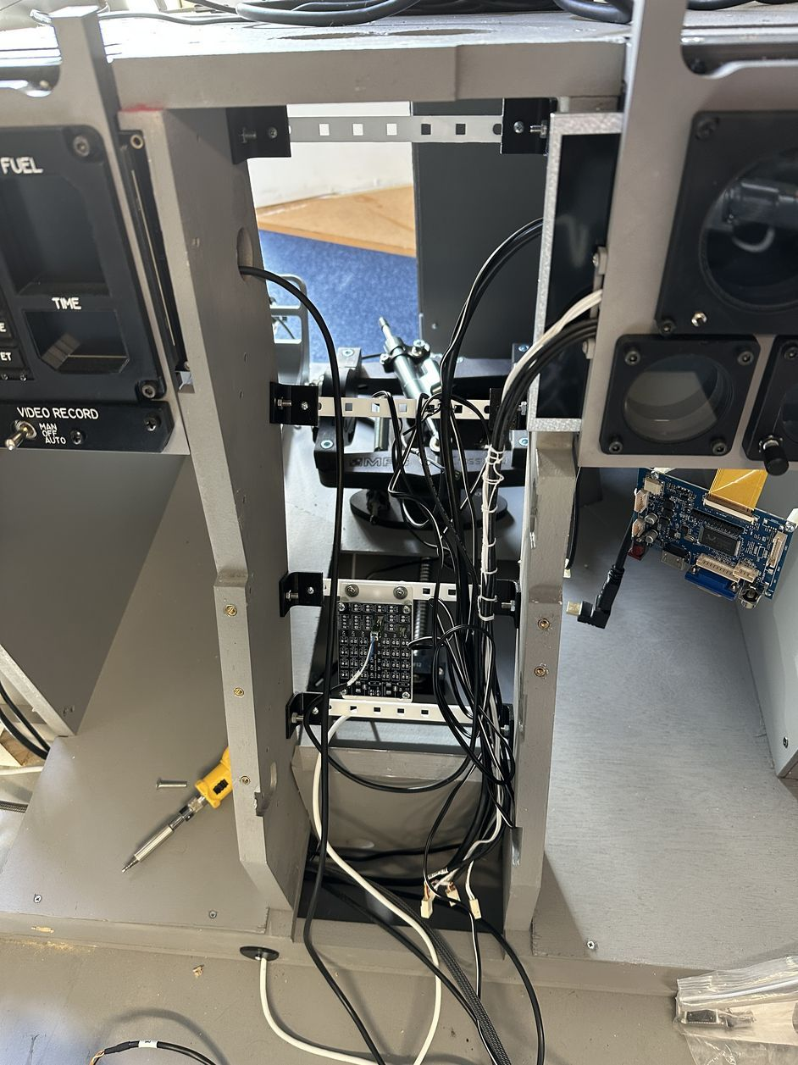

Remove Standby Instruments
Remove two screws on starboard side |  |  | 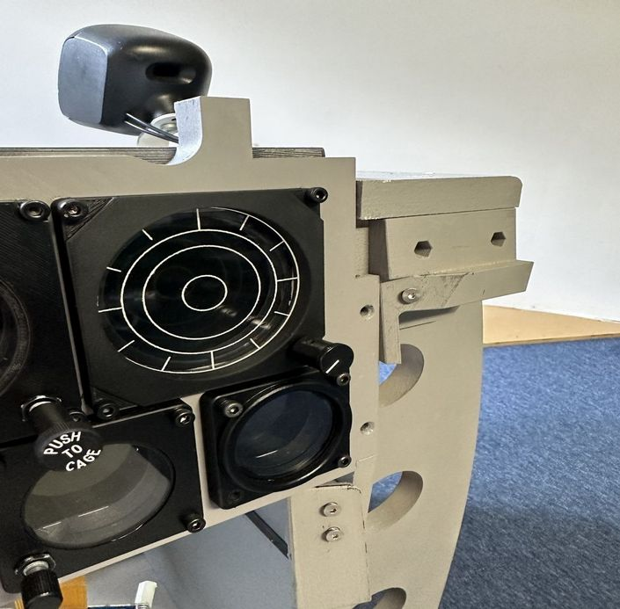
Remove three screws on the top rail. Warning the assembly is no longer supported, at this point, you should hold it when removing the last bolt. |  |  | 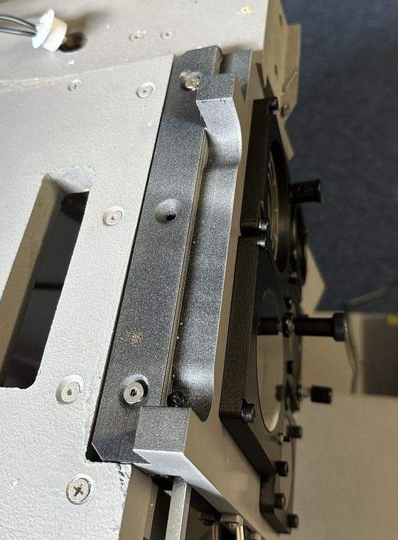
Disconnect HDMI and Power (with the stepper instruments, the voltage is now 5V). |  |  | 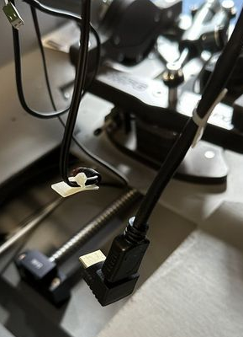
 |  |  | 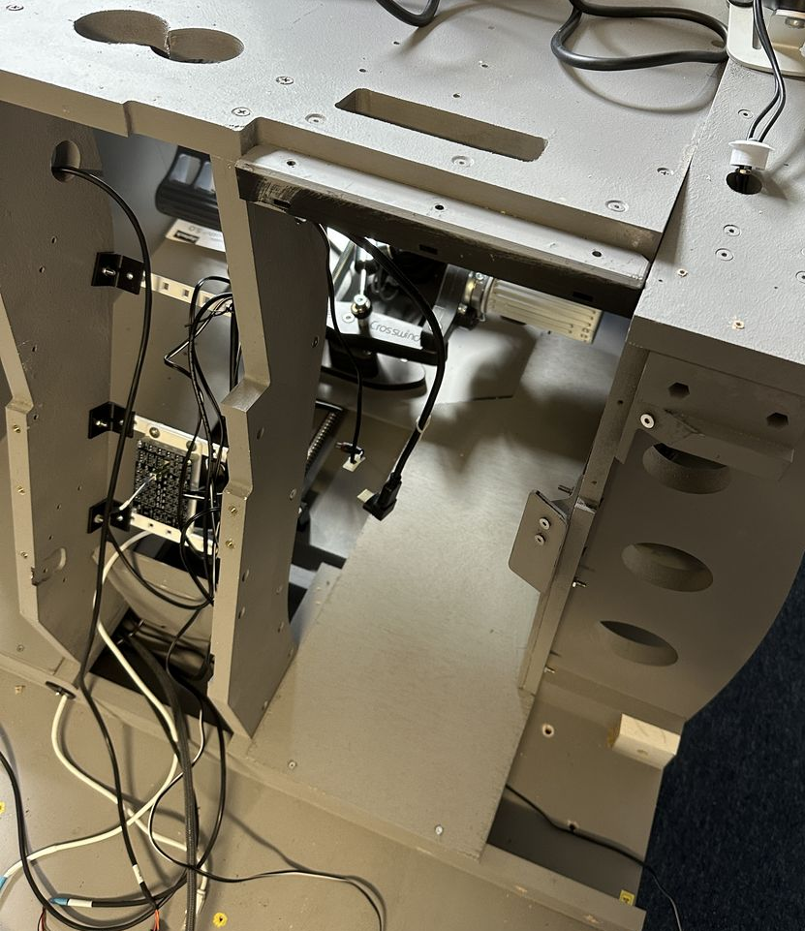

Removing the IFEI
Remove the port side vent- three bolts.  Unscrew the two screws on the port side of the IFEI  Remove the three screws at the top, the are just sitting in place. Support the IFEI assembly when removing the last screw. | 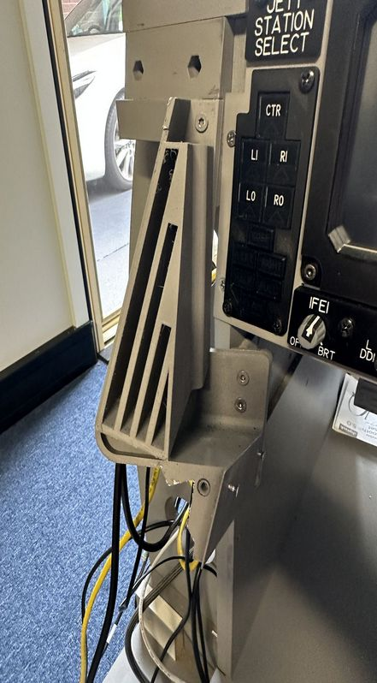  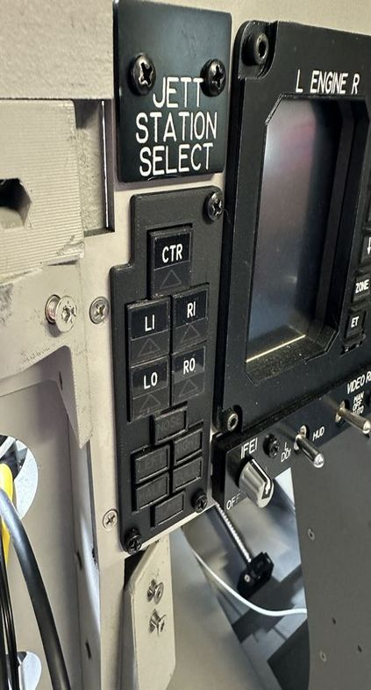  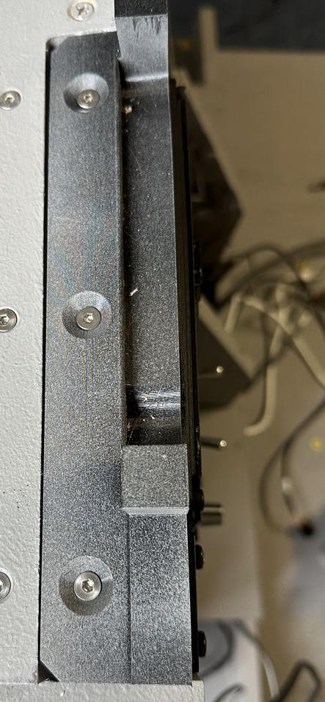
Disconnect the panel backlighting lead (connects to ECM panel) | Black |  |  | 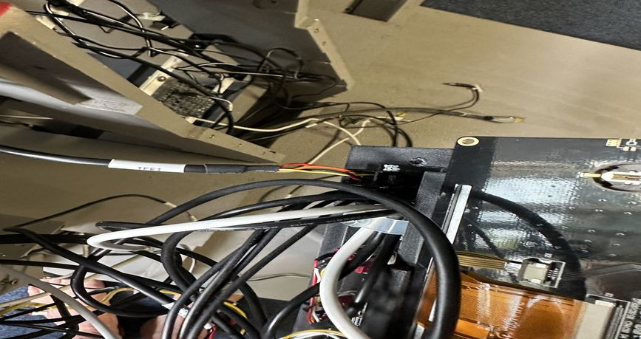
Remove four screws attaching the top of the LIP  The port side screw need to the red locator is slightly smaller than the others to stop splitting. |  |  |  | 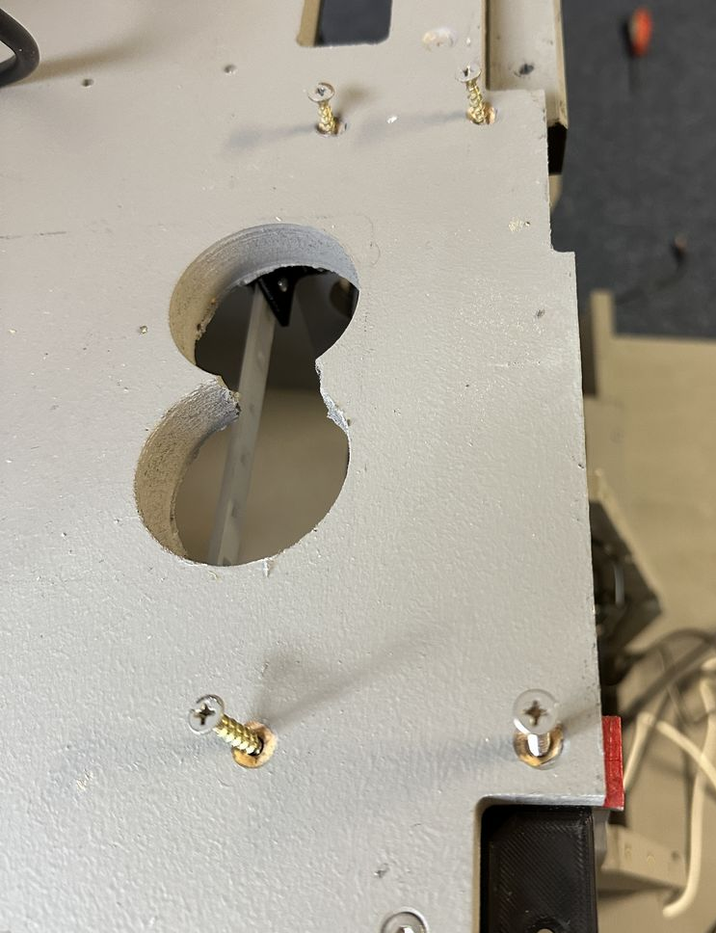
Remove the cable support tray.  Two screws port side, single screw starboard side. | 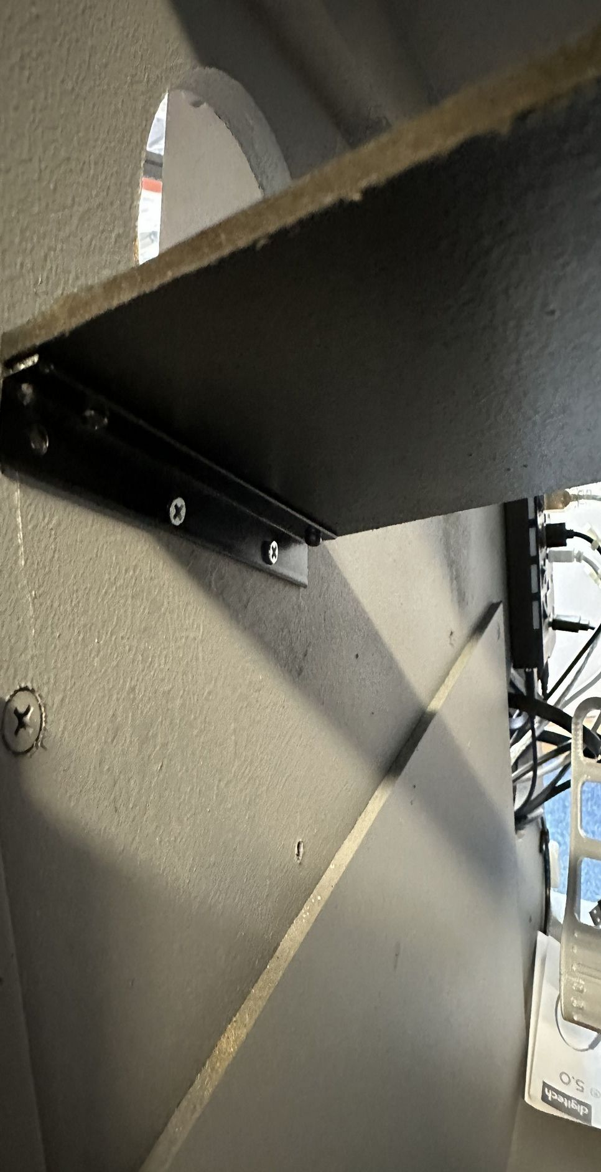  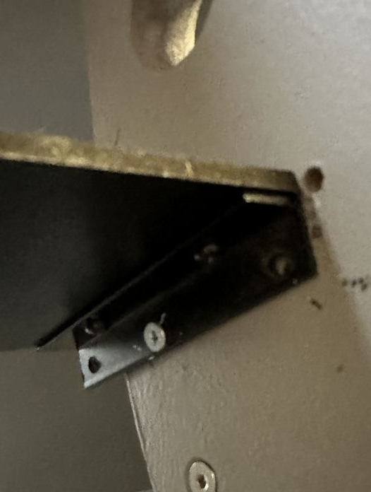
Remove cable ties attaching cables to guides. | 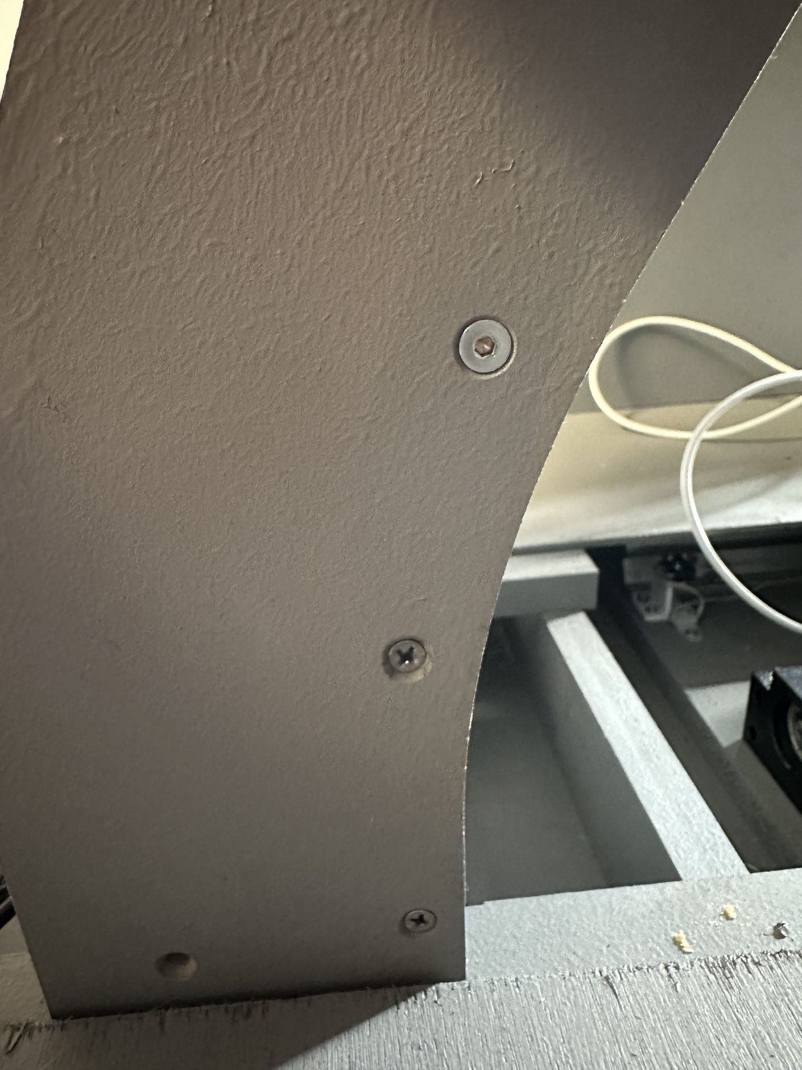  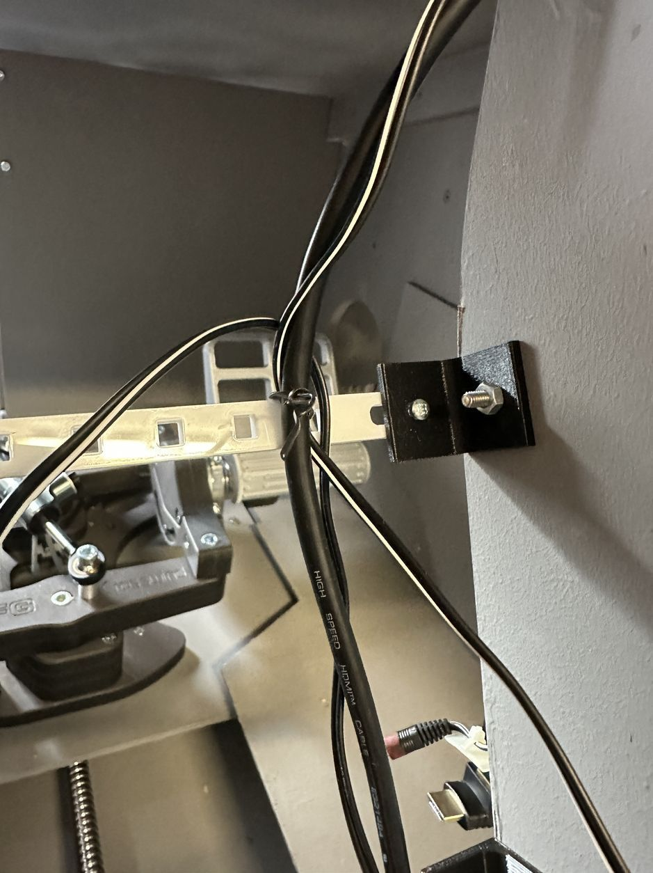
Remove Joystick USB cable.  The cable path is under the foot rest, along the lower holes on port side.  The Joystick is connected to the third from the bottom port of the forward USB Hub. |  |  | 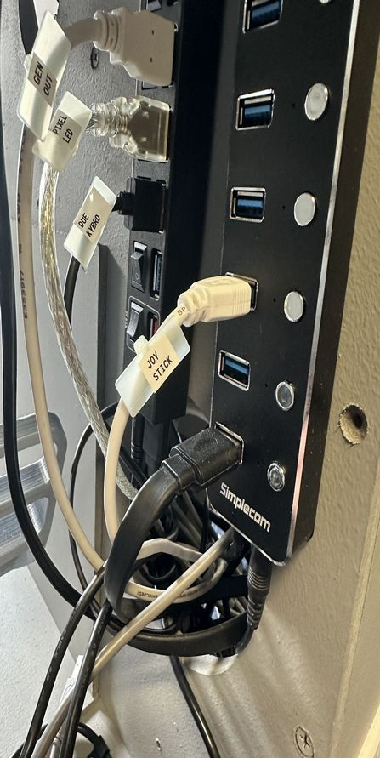  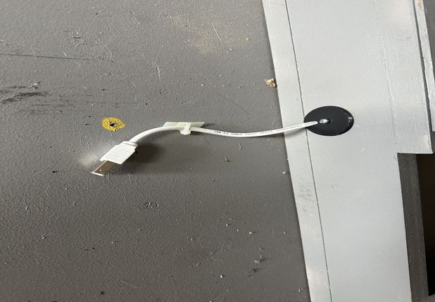
Disconnect the sound system.  The speakers are held in place with cable clamps.  The power cable exits on the port side. |  |  |  | 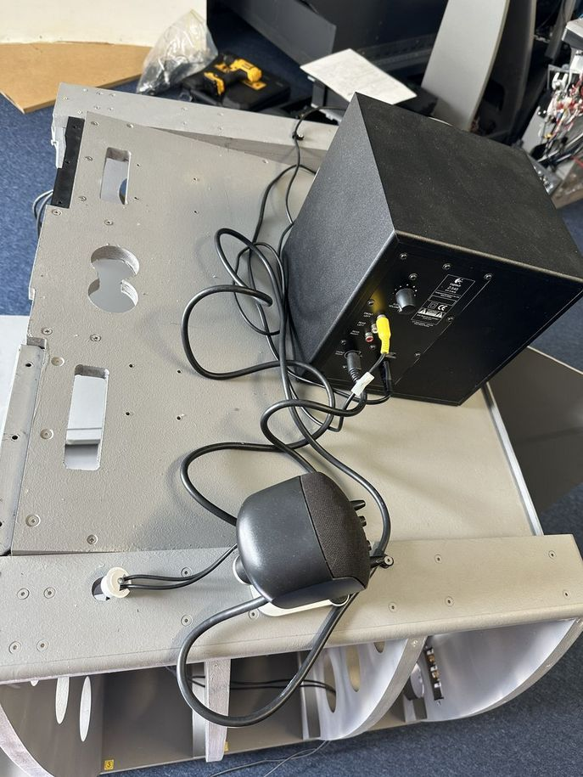
 |  |  |  | 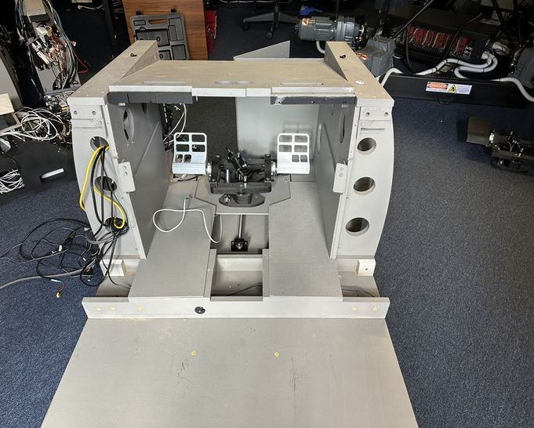
Remove Side panels from foot wells.  Three bolts/screws per side. | 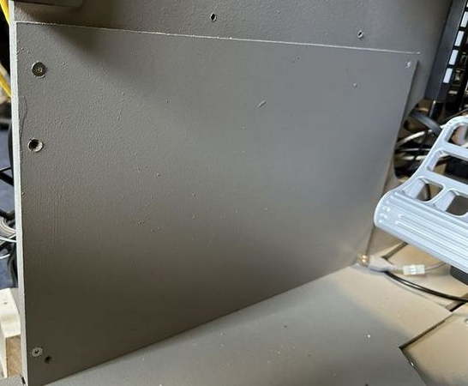  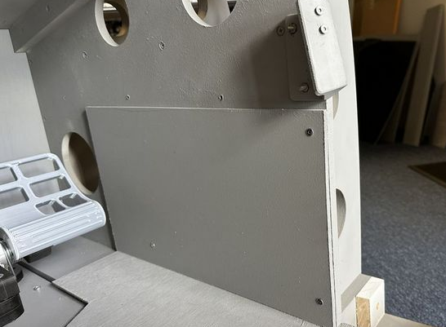
Remove foot plate.  Two screws per plate. | 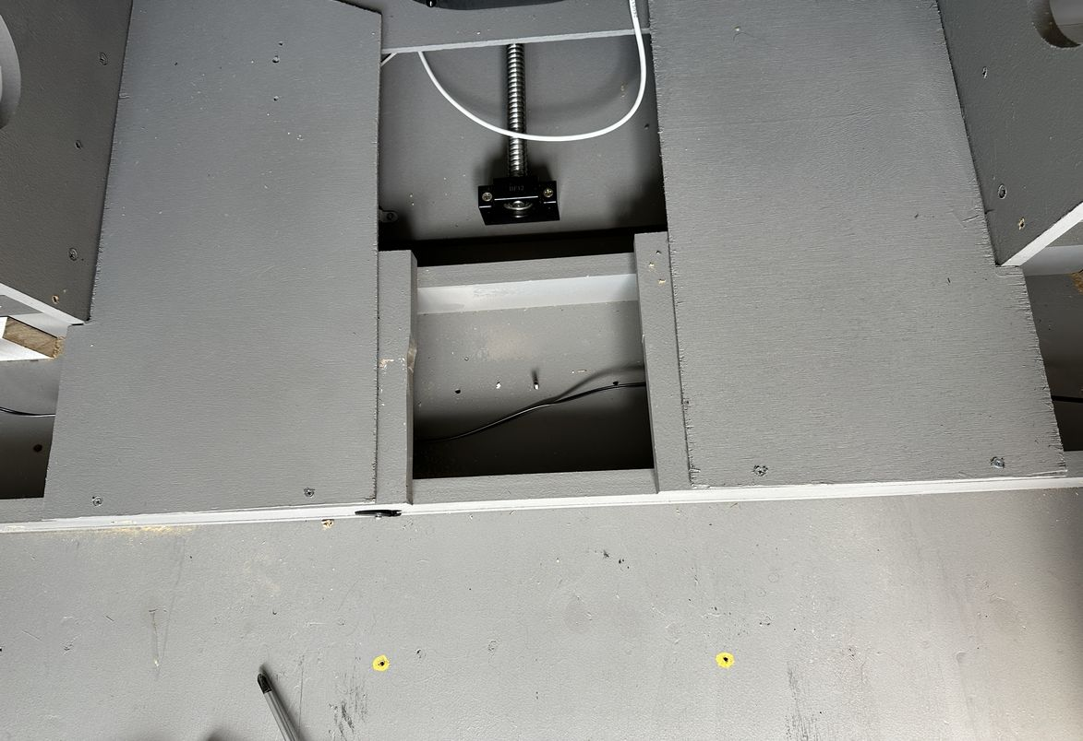
 | 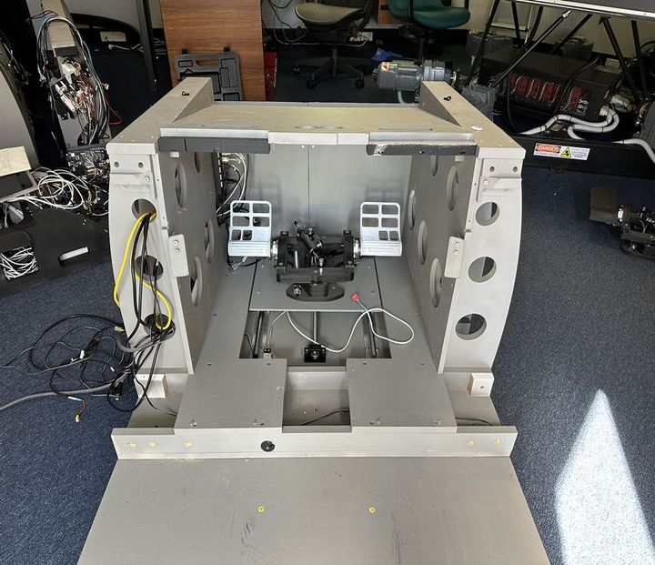
ECM Backlighting cable attaches to second connector from the top. |  |  |  | 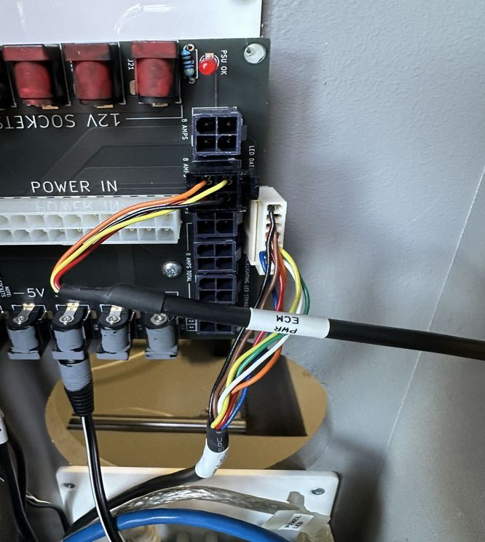
Pixel Led from Primary Power Distribution PCB to Pixel Led Arduino located aft side of Bay 3 |  |  |  | 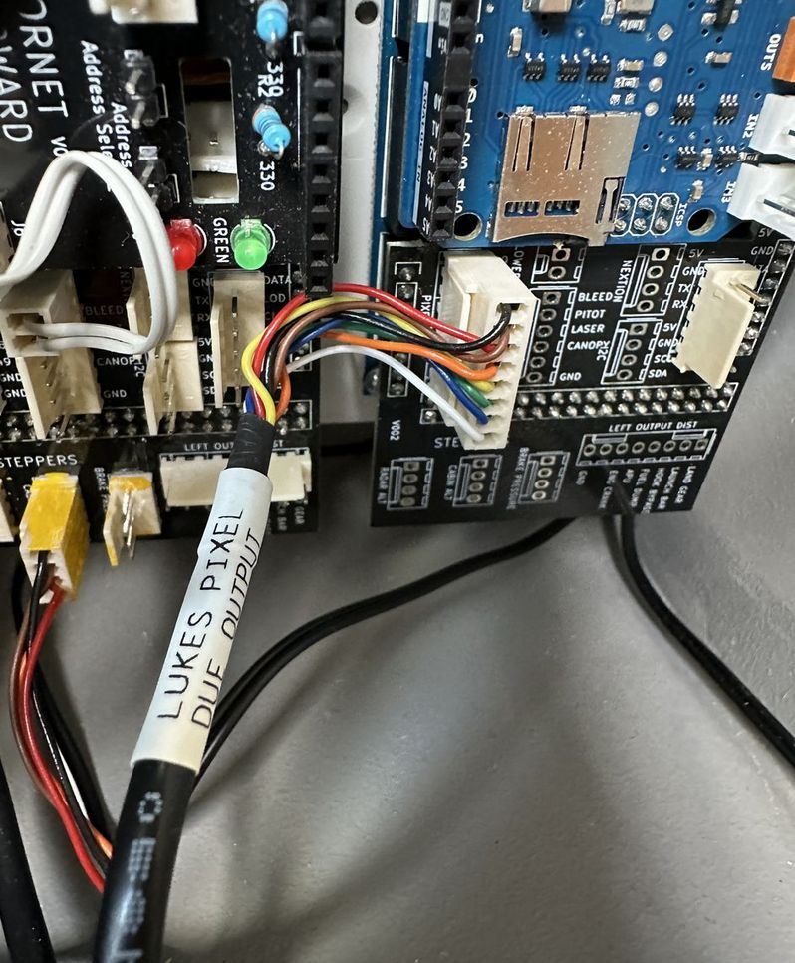  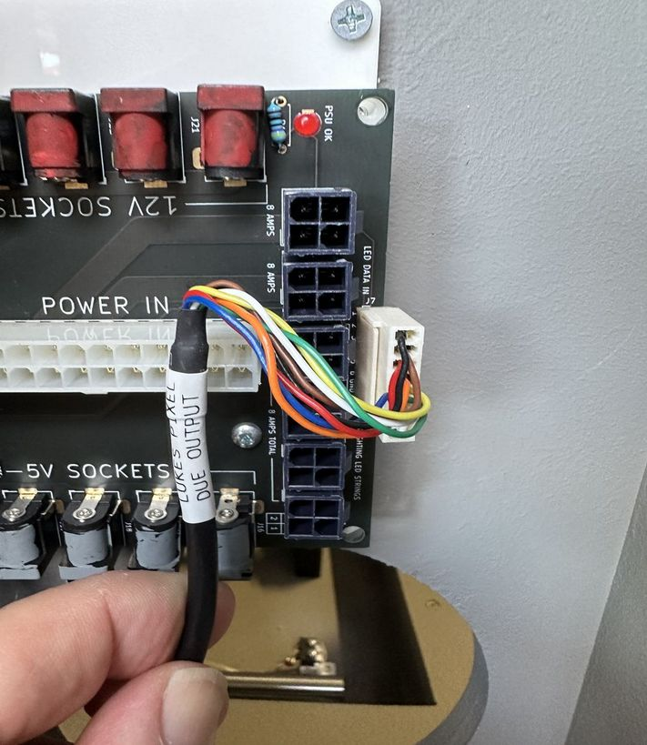
Cabin Pressure Altimeter on ECM panel to General Output Arduino located forward side of Bay 3 |  |  |  | 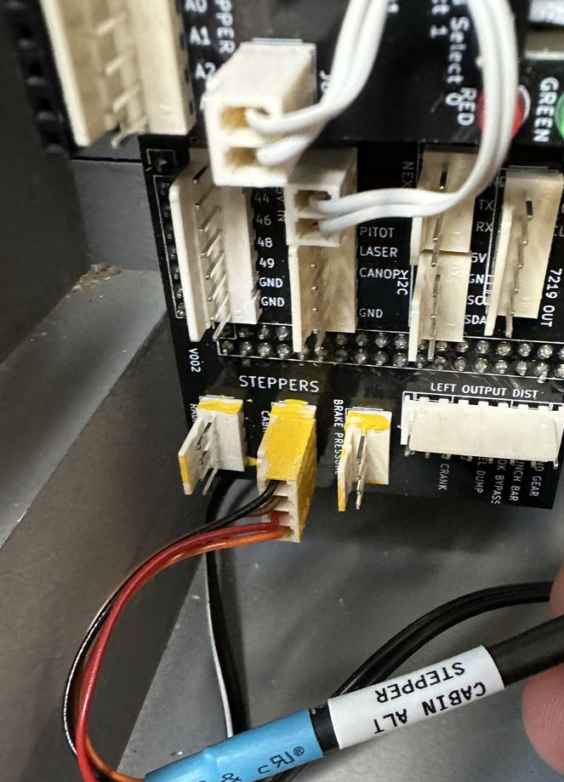
Bay 3 Pixel Led USB and Ethernet.  Ethernet to SW Bay 3-2  Pixel LED USB to Aft USB Hub, fourth slot from the bottom. | 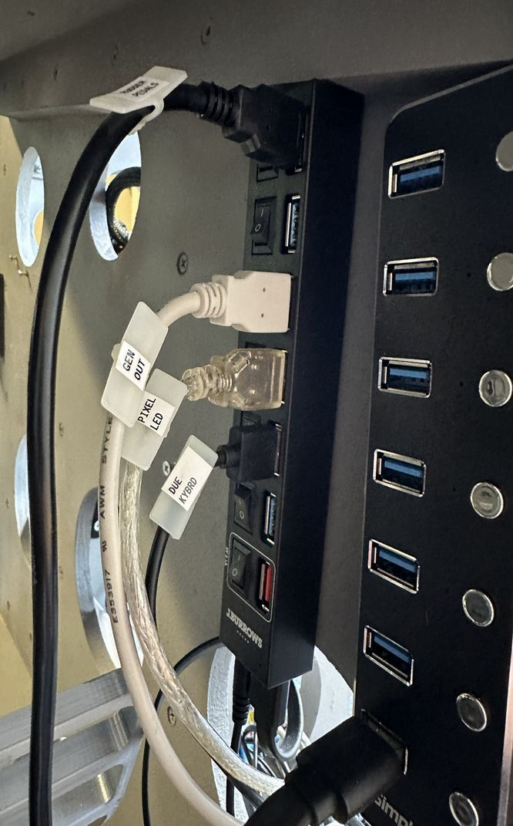  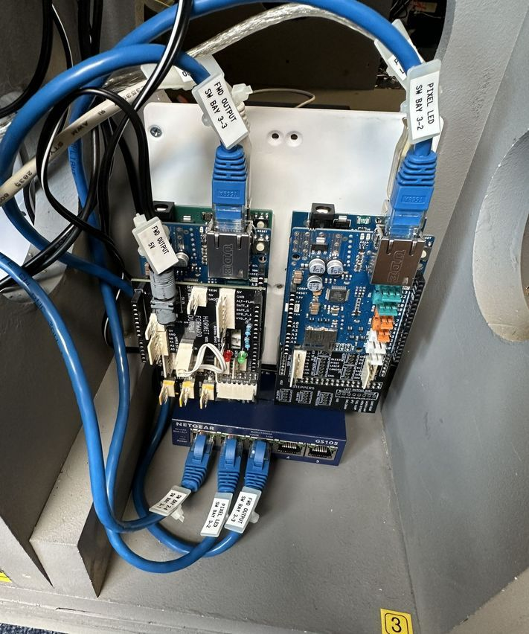
Bay 3 General output Arduino.  5V to third from the left on Power Distribution PCB.  USB to Aft UDB Hub, third form the top.  Ethernet to SW Bay 3-3 | 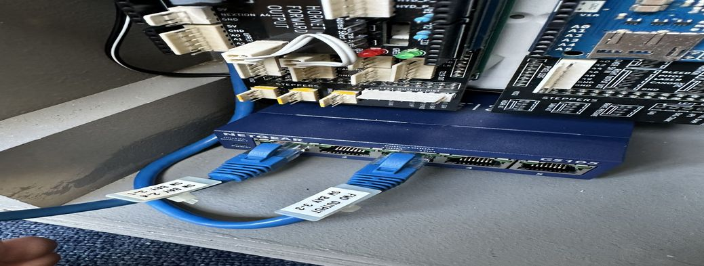  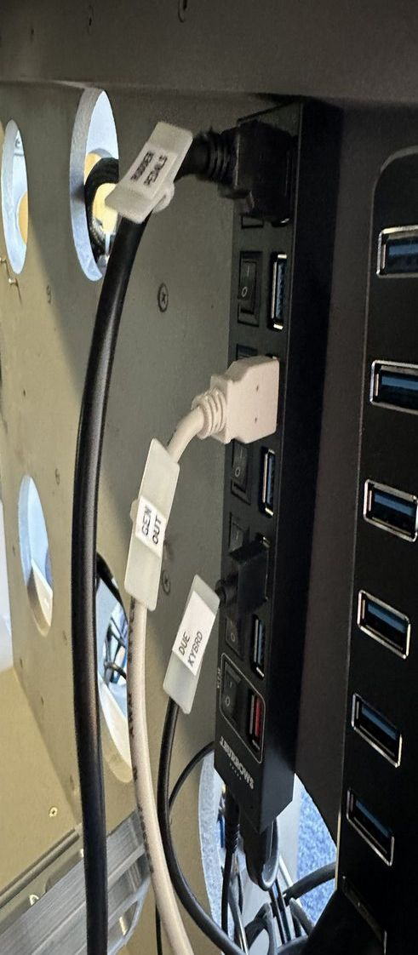  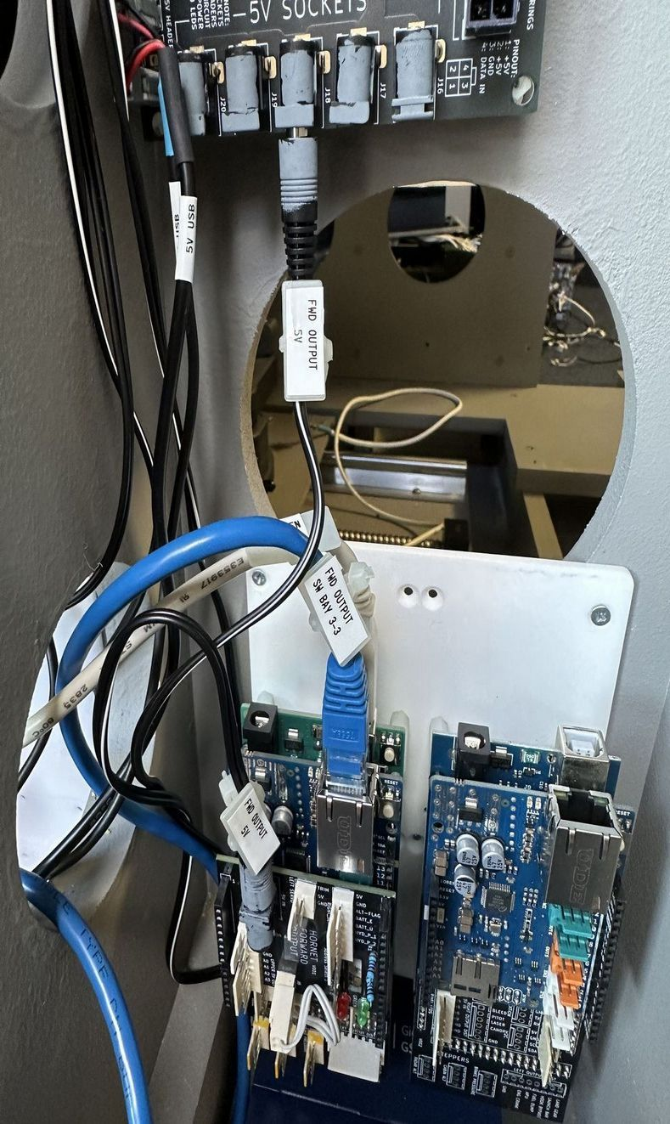
Ethernet  Bay 3-1 to Bay 2-4  Bay 2-1 to Forward External Connector | 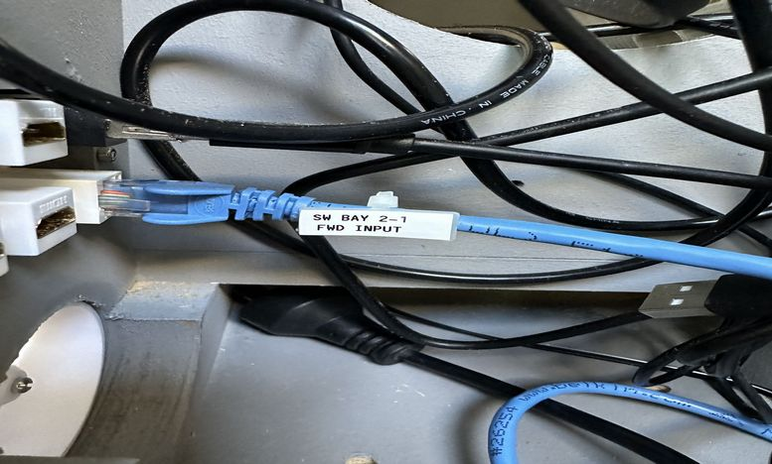  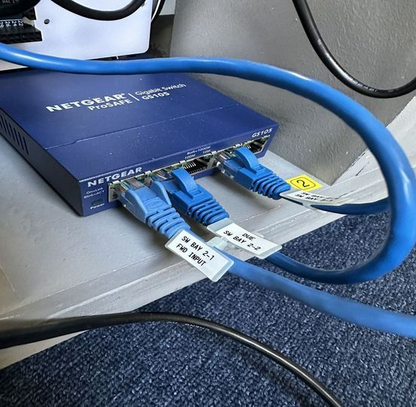  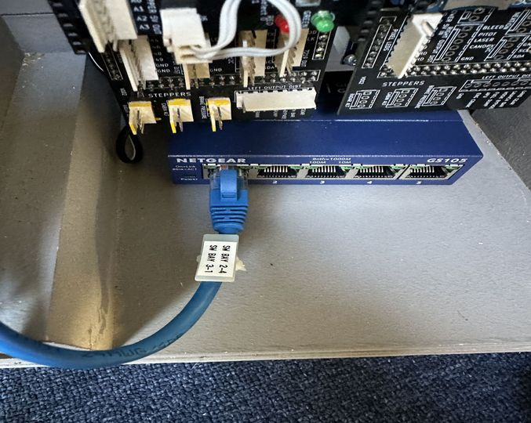  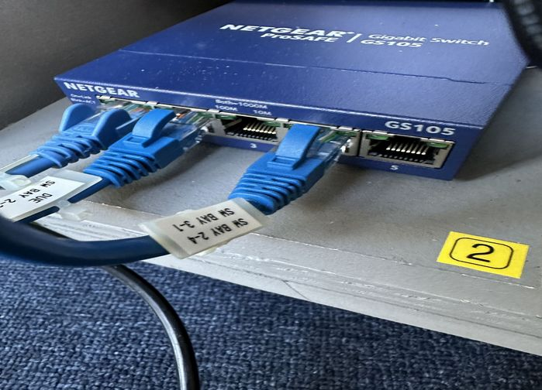
Ethernet Switch, USB Hub, and Rudder Motor power supply connections. |  |  |  | 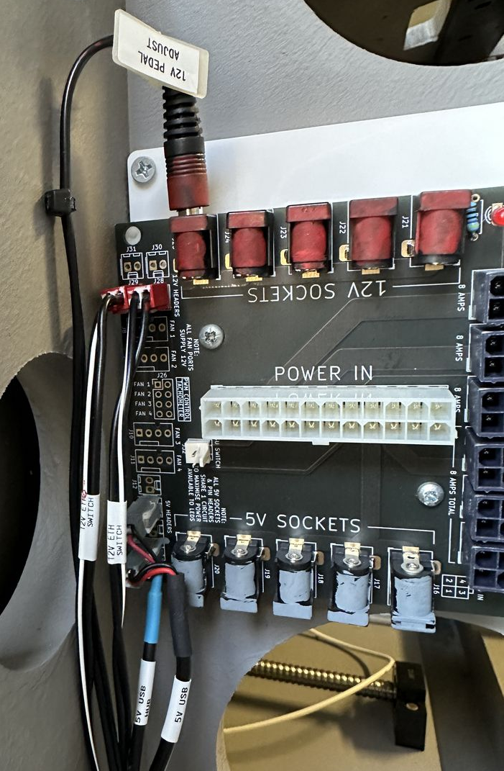
Due Ethernet  Connected to SW Bay 2-2 |  |  |  | 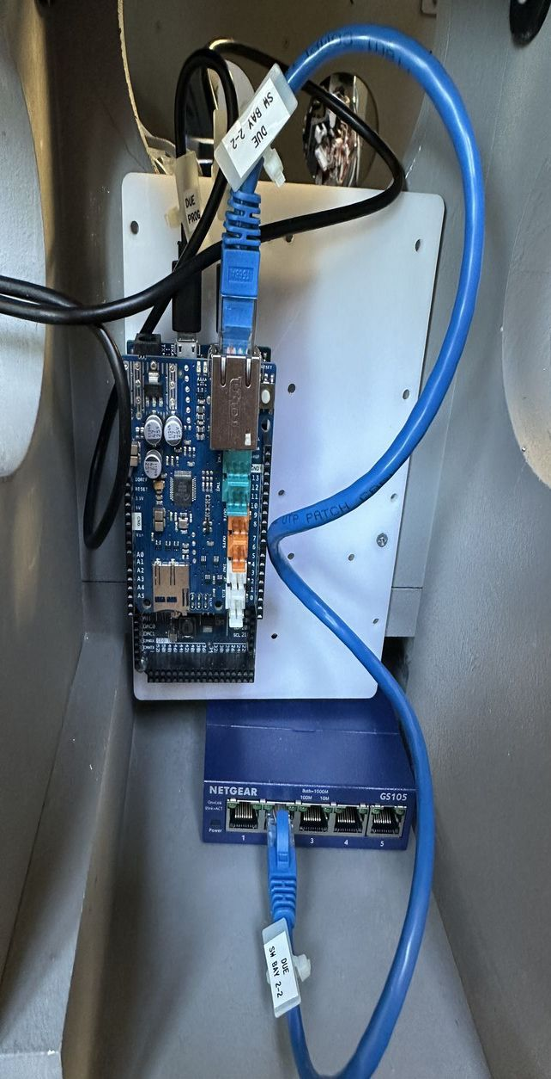
Due USB Keyboard to Aft USB, third from the bottom.  Interestingly Due Programming Port is not connected to anything, unsure as to reason. |  |  |  | 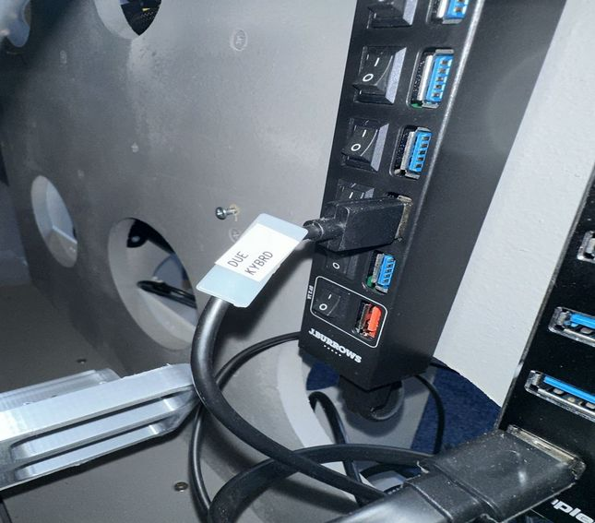  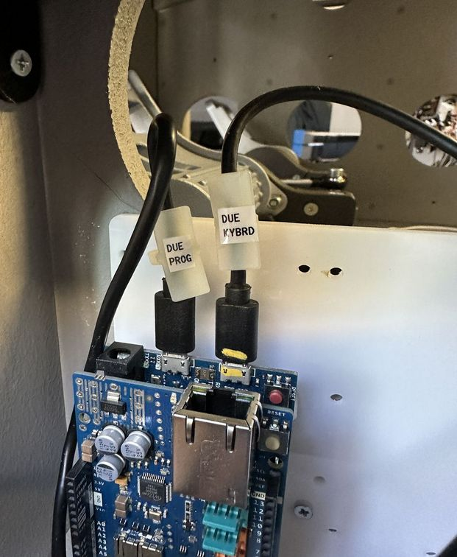
Rudder Pedals.  Aft USB Top port. |  |  |  | 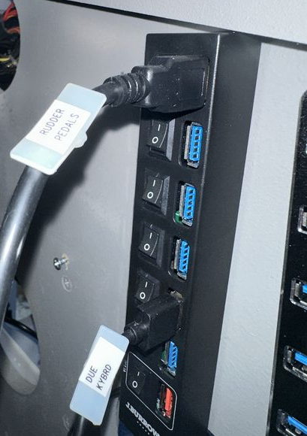
USB Hub to USB Hub  Aft USB input to Forward USB bottom port. |  |  |  | 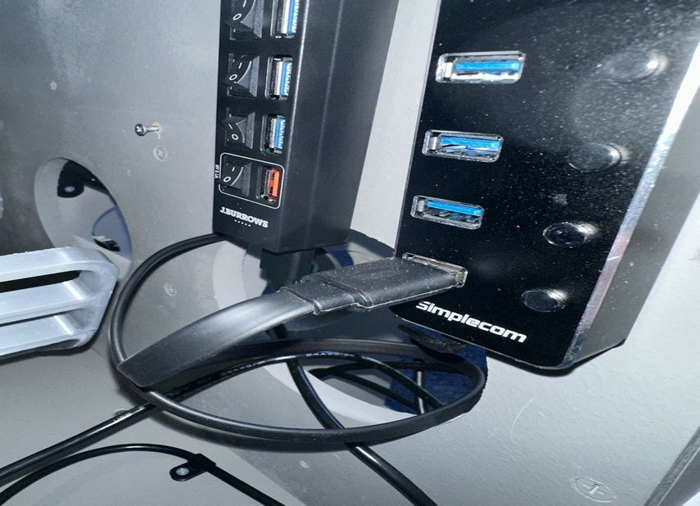
Forward USB Input to External connector. |  |  |  | 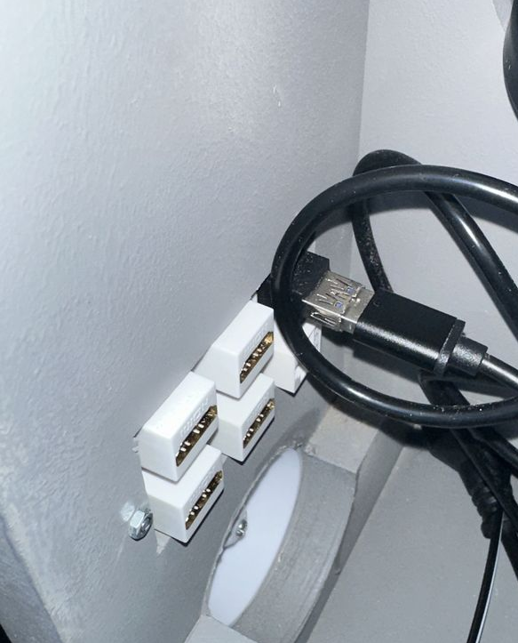

Component Disassembly

AMPCD

Cut the cable ties holding switch inputs, backlighting and analog inputs  Port Side Cable slot  - Switch Row  - CRS  Starboard Side has  - Analog  - HDG  - Switch Col |  |  | 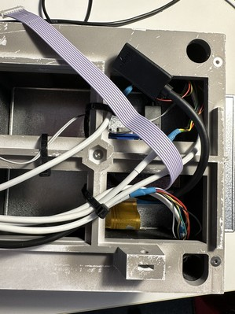
Remove 4 bolts holding CRS HDG facelate  Remove 2 top counter sunk bolts. |  |  | 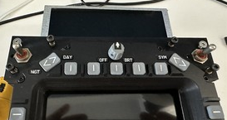
Remove lower 4 small bolts holding the button faceplate assembly.  Place a sheet of paper in front of the screen to reduce likelihood of scratches  Place a nut and bolt in one of the lower holes to keep the assembly together while lifting out.  With the monitor face up lift up the top assembly guiding the cables. Raise port side first, then the starboard sideand then the screen can be removed. |  |  | 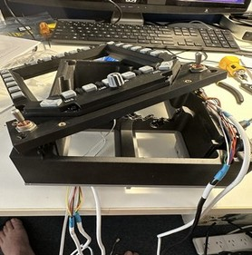  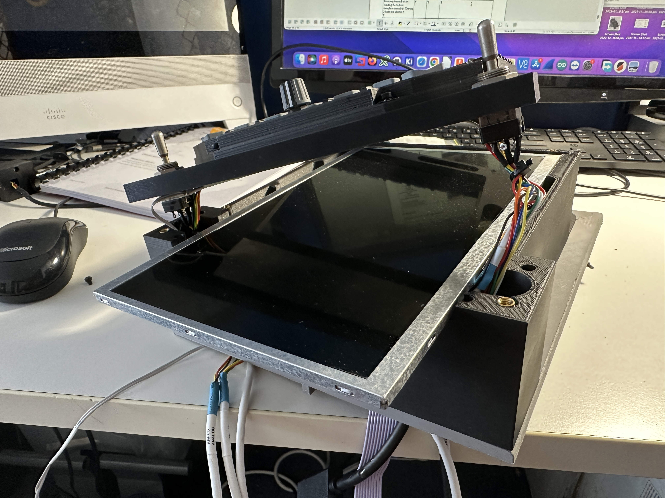  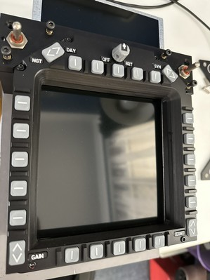
Remove the top 2 smaller bolts holding the upper faceplate in place.  Place the unit face down on a surface and reattached the lower 2 bolts to keep the assembly together (unless you enjoy putting buttons back in place – aka pickup 52. |  |  | 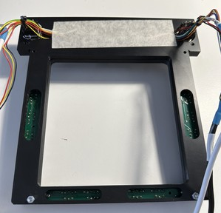
When adjusting buttons, loosen or tighten screws, do a quick check of button actions and then a final check without installing the screen. Remove the lower two nuts holding the assembly together as a very last step. |  |  | 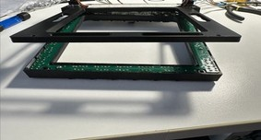
Reassembly – slot cables in and place assembly on top of frame  Test buttons before installing screens. |  |  | 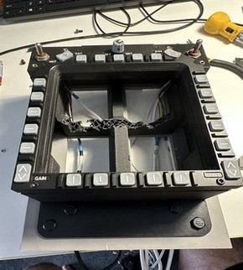
 |  |  | 

